Faculty Senate meeting in KSUC 300 at 3:30 pm on 28th March
MINUTES
- e-Core update – Humayun Zafar, Saul Alamilla and Brad Barney

- eCore is the University System of Georgia’s online college core curriculum. eCore was established as part of the Complete College Georgia initiative, which aims to make college more accessible and affordable in our state. eCore courses are taught by instructors from SACSCOC accredited institutions within Georgia, and are fully transferrable within the USG as well as other regionally accredited schools. eCore online courses are available at KSU since 2010.

- KSU is conducting a longitudinal study with analysis and interpretation of eCore student data that answers the question about the downstream performance of eCore students. Early data for how well does e-Core prepare students to persist in their coursework relative to in-person or online instruction at KSU. If the analysis reveals that eCore students do not perform as well in downstream courses as students who took their lower-level courses online or face-to-face, then data-driven improvements can be made that may strengthen student performance.

- President’s Address: Dr. Papp

House Bill 859:
- Georgia’s “Campus Carry” legislation, House Bill 859 passed both chambers of the state legislature and is now sitting on the desk of Nathan Deal. The governor had earlier expressed support but recently issued a statement requesting changes to some parts of the bill. If it is vetoed, if is likely to resurface next legislative session. Georgia’s campus-carry bill has been universally opposed by USG community. Chancellor Huckabee and 29 university presidents publicly opposed the bill.

House Bill 859 would allow Campus Carry:
- Except in buildings or property used for athletic sporting events and student housing including, but not limited to, fraternity and sorority houses.
- Only allows licensed carriers to carry on campus
- Allows guns in sensitive places like the university’s day cares and in highly unpredictable forums like student-disciplinary hearings.

Faculty Comment: Faculty are disappointed in the official KSU reaction to the arrest of KSU faculty member at the Capital without consulting the KSU faculty member directly.

Dr. Papp’s Response: The official letter from KSU in response to the arrest of KSU faculty member was time sensitive and written as neutral as possible, given limited information. We consulted with police officers, third party witnesses, and faculty colleagues before issuing the statement.
Faculty Comment: Would the details of the consultations with the attorney be shared?
Dr. Papp’s Response: Yes, insofar as I am legally able.
Faculty Comment: The KSU administration reserve neutrality until more information can be shared from all parties.
Papp’s Response: An effort was made to remain neutral. Flora Devine’s office has made contact with Faculty Member.
Faculty Comment: Guns would discourage teaching sensitive topics and potentially lead to certain topics being dropped from the curriculum altogether. Students and faculty also might not discuss potentially controversial ideas, which is the tradition of academic freedom of higher education.

Faculty Comment: My Department often host children on campus and the campus should be a safe climate.

Faculty Comment: Campus Carry will make it challenging to recruit and retain faculty and students. Faculty have threaten to leave KSU if Bill becomes law.

Faculty Comment: We need a better policy for how faculty manage potentially volatile student interactions in classroom, office spaces, etc. Campus Carry allows for brandishing. Not to mention elevated rates among students of depression, suicide, drug and alcohol abuse, etc.

Faculty Question: In light of public protest what do we tell faculty and students?

Dr. Papp’s Response: Call your legislature and let them know your views, individual voices have influence.

BUDGET:

We have a flat budget, better than most comprehension and state institutions. Students: For the last years 3% increase of tuition. This year 0% increase in tuition. Faculty: There is a 3% increase for salary pool. FY 2017, 3% for merit based increase. Largest raise pool since 2008!

Annual State of the University address:
Monday, April 25th at 9:00AM in the Dr. Bobbie M. Bailey Performance Center, Kennesaw Campus

Tuesday, April 26th at 9:00AM in the Dr. Bobbie M. Bailey Performance Center, Kennesaw Campus

Tuesday, April 26th at 12:30PM in the Ballroom of the Joe Mack Wilson Student Center, Marietta Campus

- Grievance Procedure – Ron Matson
Motion: Modification to 4.4.3. KSU Faculty Conflict Resolution Procedures (from 2015-2016 Faculty Handbook) grievance committee

- Attendance Policy – Sandra Pierquet

Motion to change attendance policy:
If a student is performing satisfactorily in a course (i.e., C or better) and will not exceed the number of acceptable absences as stated in the course syllabus, the student will be given an opportunity during the same term to make up the work missed during absence(s) due to participation in a university-approved activity,

Discussion:
Q. How many activities can students do in a semester?
A. No limit

Vote: 34 yes and 1 no

Motion approved.

- Substantive Change – Susan Paraska

Motion to accept changes made to update Substantive Change Policy.
Vote: 36 yes, 0 no
Motion Approved

- Gateways to Completion – Val Whittlesey, Scott Reese:

Facilitating a faculty-driven process for implementing G2C. G2C provides KSU with an institution-wide, data-driven, evidence process to address high failure rates starting with five gateway courses, with the intent of increasing to other general education and lower division courses.
- KSU has ambitious goals for increasing undergraduate student retention, progression, and graduation rates.
- Integral part of KSU’s Complete College GA plan submitted to the USG Board of Regents.
- Integrates with KSU’s Reimaging the First Year initiative.

- Senate Elections – Humayun Zafar
We will hold elections for
- Vice president 2016/7 and President–Elect 2017/8
- Secretary 2016/7
- Marietta representative 2016/7
- Kennesaw representative 2016/7
at the Faculty Senate meeting on 18th April. Any senator can stand for any of these positions. Please send your self-nomination to me by 11th April.

If no one nominates themselves for a post then existing officers continue in that post.

4.4.3. KSU Faculty Conflict Resolution Procedures (from 2015-2016 Faculty Handbook)

- Overview

Kennesaw State University is committed to the prompt and fair resolution of the concerns of the faculty. The Faculty Conflict Resolution Procedures described below have been formulated to help members of the Faculty resolve interpersonal workplace disagreements. No person’s status with Kennesaw State University will be adversely affected in any way as a result of using these conflict resolution procedures. Any attempt to retaliate against a person for participating in conflict resolution under these procedures will be subject to disciplinary action, up to and including termination. These procedures do not in any way restrict the right of aggrieved Parties to seek resolution of their grievances, either through the courts, or through agencies of the State or Federal government.

Except when conduct is alleged to violate established policies and procedures, a grievance review will not be available to dispute claims about:
- investigations or decisions reached under Kennesaw State University’s Title IX/Sexual Misconduct or Non-Discrimination Policy (See KSU Office of Diversity and Inclusion),
- promotion and tenure decisions (See Kennesaw State University Faculty Handbook Section 3.5 – General Expectations for Tenure, Promotion, and Post-Tenure Review),
- performance evaluations (See Kennesaw State University Faculty Handbook Section 3.7 – Faculty Review Process),
- hiring decisions (See Kennesaw State University Faculty Handbook Section 4.1.5 – Filling Vacant Faculty Positions and Faculty Search and Screening Process),
- changes to administrative appointments (See KSU Faculty Handbook Section 1.1)
- administrative changes to student grades,
- salary decisions (See Kennesaw State University Faculty Handbook Section 4.2 – Compensation & Benefits),
- transfers or reassignments (See Kennesaw State University Faculty Handbook Section 4.1.7 – Redirection and Reassignment of Filled Faculty Positions),
- removal of a faculty member or non-renewal of a contract of a non-tenured faculty (see KSU Faculty Handbook Section 4.1.9; BoR Policy Manual 8.3.9.1, 8.3.9.2, 8.3.9.3)
- termination or layoff because of financial exigency or program modification (Board of Regents Policy Manual 8.5.2 – Layoffs or Terminations; 8.3.7.10 – Termination/Layoff of Tenured Personnel due to Program Modification),
- normal supervisory counseling (for example, chair discussing classroom management issues with a faculty; dean discussing handling of personnel issues), and
- Scholarly misconduct (KSU University Handbook Section 5.2.3).

II. Informal Procedures for Resolving Conflict
While informal resolutions are not required, all faculty are strongly encouraged to work through conflicts informally beginning with the person with whom they have differences. As necessary, a faculty member may also informally resolve conflicts by contacting their immediate supervisor. The supervisor should then arrange a meeting with the faculty member, and all concerned should make a good faith effort to resolve the problem. Good faith efforts to informally resolve the conflict may include conferring with University administrators to evaluate and assist with the informal resolution of the conflict.
If the faculty member’s conflict is with his/her first line supervisor or some other person that the faculty member does not wish to approach directly, the faculty member may talk with their next line supervisor or the Office of the Ombudsman.
The Office of the Ombudsman provides confidential and informal assistance in the resolution of university-related concerns. An Ombuds cannot impose solutions, but can help identify options and strategies for resolution.
Faculty members interested in consulting with the Ombuds are encouraged to contact the office as soon as possible, but may seek informal assistance at any point in their attempts to resolve a conflict or grievance.
If the conflict cannot be resolved through the efforts outlined above, then a faculty member may pursue a formal grievance review and resolution as described below.
III. Formal Procedures for Resolving Grievances

A grievance is a written complaint. A grievance review will be available to handle claims that a person has been harmed by any action that violates the policies of either Kennesaw State University or the Board of Regents of the University System of Georgia. These procedures assure that any faculty member within the University community who has a complaint will have access to an internal process that provides fairness to all Parties involved and that has as its objective the resolution of the conflict.

These procedures are not intended to discourage faculty from attempting to resolve a conflict themselves through discussion with the involved parties. These procedures should not be interpreted as a means to eliminate or weaken first-level supervisory or administrative roles of individuals or to prevent them from attempting immediate and impartial resolution of conflicts that develop within their areas of responsibility. While the Ombuds is available to consult with anyone at any time during the formal process, the Ombuds is never a part of the formal process.
Formal Grievance Resolution
In general, all formal grievances should be reviewed at a minimum of two levels if possible, within the complainant’s college/unit including the head of the academic or administrative unit or his/her designee. If the respondent (individual against whom complaint is brought) is the faculty member’s immediate supervisor, then the review process will start at the next administrative level below the level of the Provost. If two levels of review are not possible, then the grievance is reviewed by the Associate Vice President for Faculty prior to submission to the Grievance Oversight Committee (see “Routing of Formal Grievance Complaint Form” and flowchart below). A complainant (aggrieved faculty member) must file a formal written grievance using the Grievance Form, by the last day of the next semester (fall and spring semesters only) of the event that has given rise to the grievance. Within 21 calendar days of receipt of the grievance, the complainant’s immediate supervisor must investigate and provide a written response to the complainant’s grievance including sources of information used to make a decision. The investigation may include:
- meeting with complainant, respondent (and any other necessary parties to develop an understanding of the grievance,
- reviewing appropriate written policies and procedures, and
- consulting with the appropriate University administrators, as needed, for advice and clarification of any policies or procedures.
The complainant will have 10 calendar days from the date of the decision letter to appeal to the next level within the complainant’s employment unit. The next level supervisor will review the grievance, investigate and provide a written response within 21 calendar days. The investigation may include:
- meeting with complainant, respondent and any other necessary parties to develop an understanding of the grievance,
- reviewing appropriate written policies and procedures, and
- consulting with the appropriate University administrators, as needed, for advice and clarification of any policies or procedures.
If a complainant wishes to appeal after completion of the employment unit’s review of the matter, a petition for review (the completed Grievance Form) must be submitted to the Grievance Oversight Committee through the Associate Vice President for Faculty within 10 calendar days of the date of the final decision letter of the head of the academic or administrative unit or his/her designee. A copy of the petition for review will be provided to the respondent(s).
To ensure that the petition clearly identifies pertinent issues, the Grievance Form must be completed in its entirety which will include the following:
- Name of complainant and complainant’s job title
- Name(s) of the respondent(s)
- The nature of the problem or complaint; all relevant documentation must be included at this time;
- The communication that has taken place between the complainant and the respondent (informal resolution);
- The communication that has taken place between the complainant and his or her academic department head, supervisor and/or second level supervisor concerning the matter;
- Responses from supervisor(s);
- The reason the complainant disagrees with that response;
- The complainant's suggestion for proper resolution of the matter;
- Identification of any witnesses who may have relevant information regarding the complaint; and
- Signature of complainant and date.
Pursuant to Section IV of this policy, the Associate Vice President for Faculty will constitute the Grievance Hearing Committee within 15 calendar days of receipt of the petition for review. Within 14 calendar days of the establishment of the Grievance Hearing Committee, the Associate Vice President for Faculty will convene the initial organizational meeting of the Grievance Hearing Committee. The Chair of the Grievance Hearing Committee will schedule a meeting to review the petition for review within 10 calendar days of the initial organizational meeting, unless reasonable cause is documented to the parties as to why it should take longer than the prescribed time frame.
The respondent will have an opportunity to identify witnesses and provide documents to the Grievance Hearing Committee. A copy of the documents will be provided to the complainant.
A complainant who wishes to address the Grievance Hearing Committee orally must make the request in the written petition. If no oral presentation is requested, the review will be based upon the written record. The Grievance Oversight Committee has the right to call a hearing if they deem necessary. If a hearing is called, it must be conducted within 21 calendar days, unless reasonable cause is documented to the parties as to why it should take longer than the prescribed time frame.
When a hearing is called, the following procedures will apply:
1. The Grievance Hearing Committee chair will notify complainant and respondent of the date, time, and place of the hearing.
2. The hearing will be recorded via audio recording. Tapes and records of the hearings may be subject to disclosure under the Georgia Open Records Act. Archives will be kept in Faculty Affairs.
3. The petition will be heard by members of the Grievance Hearing Committee.
4. Members of the Grievance Hearing Committee will be excused from service on a particular case under the following circumstances:
- If they have a personal or professional relationship with any party to the case which would prejudice them from rendering an objective judgment in the case.

- If the case involves a student, faculty member or staff member in the same department or unit as a member of the Grievance Hearing Committee.

- In the event a committee member is excused from service on a particular case, the Faculty Senate, Chairs’ and Directors Assembly, or Deans’ Council will select an alternate from the appropriate constituency to serve on the committee for that case.

5. If an oral hearing is to be held, the complainant making the appeal shall present first in the hearing; respondent(s) shall present after the complainant.
6. The respondent against which the appeal is directed will be afforded the opportunity to attend and participate orally in the hearing if one is granted.
7. The Grievance Hearing Committee has the discretion to limit the presentation time of all parties; time limits will be determined in advance of any testimony and the same time limits will apply to all parties.
8. A faculty member may utilize an advisor of his/her own choosing to assist and advise the faculty member; however, attorneys are not authorized to participate in hearings before the Grievance Hearing Committee. Any Kennesaw State University faculty member may participate as an advisor in Grievance Hearing Committee hearings because of the faculty member’s designation as a Kennesaw State University faculty member. The advisor is for advice and moral support. The advisor is not a witness and will not make statements to the Grievance Hearing Committee or present evidence at the hearing.
9. The Grievance Hearing Committee may invite witnesses identified by either party or any other witnesses that they deem necessary to participate by meeting with the Grievance Hearing Committee; if they prefer they may respond in writing to the Grievance Committee's request for information.
10. The Grievance Hearing Committee has the discretion to accept any additional information from either party as they deem necessary, and to request additional information from other university sources.
11. If an oral hearing is to be held, the chair of the Grievance Hearing Committee will choose the option that the complainant and respondent appear (a) separately, or (b) together. Parties will not be permitted to cross-examine each other during the hearing. Formal legal rules of evidence do not apply in the hearing.
12. The complainant has the burden of proving by the preponderance of the evidence that he/she has been wronged. If, at the conclusion of a review, the Grievance Hearing Committee is unable to reach a decision, the complainant fails to carry this burden and the finding should be in the respondent’s favor.
Grievance Hearing Committee Findings
When the Grievance Hearing Committee has received the information it deems necessary to render a recommendation in a case, it will determine by majority vote what the Grievance Hearing Committee’s findings and recommendations will be. Absent good cause, the findings and recommendations must be transmitted to the Provost, complainant and respondent(s), complainant and respondent’s supervisor, within 14 calendar days of the conclusion of the hearing or committee meeting.
Decision of the Provost
Within 21 calendar days, the Provost, or his/her designee, will review the Grievance Hearing Committee’s findings and render a written decision to resolve the formal grievance. The provost has the discretion to conduct further investigation. The complainant or respondent may appeal the Provost’s (or designee’s) decision to the President within 10 calendar days. The findings must be transmitted to the complainant, respondent(s), complainant and respondent’s supervisor, Chair of Grievance Hearing Committee.
Decision of the President
If the complainant or respondent appeals, the President or his/her designee will review the Provost’s decision and Grievance Hearing Committee’s findings in rendering Kennesaw State University’s final decision. The president or her/his designee has the discretion to conduct further investigation into the complainant’s grievance. The President will normally furnish a decision to the complainant and respondent, complainant and respondent’s supervisor, Chair of Grievance Hearing Committee, and Provost within 30 calendar days after receiving the Provost’s decision and Grievance Hearing Committee’s findings. If the President’s review of a case requires longer than 30 days, the President will notify the parties of the delay.
Discretionary Review by Board of Regents
Pursuant to Board of Regents Policy 8.6, a faculty member aggrieved by the President’s final decision in the matter may apply to the Board’s Office of Legal Affairs (“Legal Affairs”) for a review of the decision. Review of the decision is not a matter of right, but is within the sound discretion of Legal Affairs. If granted, the discretionary review shall be limited to the record from the institutional appeal process. Any petition to Legal Affairs must be submitted in writing to Legal Affairs within a period of 20 calendar days following the decision of the President. Legal Affairs will determine whether the application for review shall be granted.
IV. Formation of a Grievance Hearing Committee
The Associate Vice President for Faculty will constitute a Grievance Hearing Committee of five committee members after consulting the shared governance body(ies) ( Faculty Senate, Council of Academic Deans, and Chairs and Directors Assembly) of the complainant and respondent, ensuring that members of the Grievance Hearing Committee do not have a conflict of interest with the involved parties. The appropriate shared governance bodies will recommend to the Associate Vice President for Faculty the names of up to eight potential Grievance Hearing Committee members. The complainant and respondent can strike one each of the recommended Grievance Hearing Committee members. If either or both decline to strike a potential Grievance Hearing Committee member, the Associate Vice President for Faculty will randomly choose the five members. The Associate Vice President for Faculty will also select one alternate Grievance Hearing Committee member from the recommended pool of potential Grievance Hearing Committee members.
Organizational Meeting

The Associate Vice President for Faculty will proceed to make all arrangements for a formal hearing before a Grievance Hearing Committee and assure that all materials submitted are available to the Complainant, the Respondent(s) and Grievance Hearing Committee members in advance of the formal hearing. The initial organizational meeting of the Grievance Hearing Committee will be within 14calendar days from the date of selection of the Grievance Hearing Committee. Upon convening the Grievance Hearing Committee, and in the presence of both the Complainant and the Respondent(s), the Associate Vice President for Faculty will give a brief charge to the Grievance Hearing Committee, specifying the allegations and summarizing the University policy. The Grievance Hearing Committee will elect a Chair by majority vote. The meeting will then be turned over to the Grievance Hearing Committee Chair who will preside over all the meetings of the Grievance Hearing Committee until the review is completed. The Associate Vice President for Faculty will remain available to respond to procedural questions but will not be present during the hearing.

V. Amendment Process
These Conflict Resolution Procedures can be altered and/or amended only if presented in writing to the Faculty Senate, Council of Academic Deans, and Chairs and Directors Assembly, and approved by an affirmative vote of the majority of the Senate. The Grievance Oversight Committee has the responsibility of reviewing these procedures and recommending appropriate changes. No amendment or alteration will be in effect until it has been approved by the President.
VI. Grievance Oversight Committee (part of KSU University Handbook)
Grievance Oversight Committee (ad hoc, called as needed) — assigned to the Faculty Senate and advisory to the Faculty Senate and the Provost/VPAA .

Purpose:
The committee, in collaboration with the Provost/VPAA and the Ombuds, has the responsibility of evaluating the effectiveness of the Conflict Resolution Policy and recommending changes in the policy to the Faculty Senate and other shared governance bodies.

Membership:
1. TF 3: three faculty senate representatives, elected by the Faculty Senate.
2. AD 2: one chair elected by the Chairs and Directors Assembly;
one dean or assistant/associate dean, elected by the Deans Council.
3. Legal Affairs: one representative
4. EEO: one representative

Term: 2 years, overlapping
VII. Flow Chart
- This route is used when both the complainant and respondent are teaching faculty. The chair and dean to whom the form is submitted is/are the chair and dean of the complainant.

- This route is used when: a) the complainant is a teaching faculty and respondent is an assistant/associate chair or department chair/school director or vice versa; b) the complainant is an assistant/associate chair and the respondent is a department chair/school director or vice versa; or c) when both the complainant and respondent are chairs/school directors. The dean to whom the form is submitted is the dean of the complainant.

- This route is used when: a) the complainant is a teaching faculty and respondent is an assistant/associate dean or dean, or vice versa; b) the complainant is a chair and the respondent is a dean or vice versa; c) when the complainant is an assistant/associate dean and the respondent is a dean or vice versa; or d) when both the complainant and respondent are deans.

Informal Grievance Procedure Formal Grievance Procedure

Complainant submits
complaint form to Chair
Complainant
appeals to Dean
If not resolved
,
Complainant
submits request to AVP for Faculty
to convene Grievance
Hearing Committee
Grievance Hearing Committee
presents finding to Provost
Provost makes decision and
informs all parties
If not resolved
,
Complainant
submits application for
Discretionary Review to BoR
Complainant and
Respondent talk
Supervisor may
be brought in
to facilitate
Ombuds Office
can be involved
to facilitate
Resolution
reached
Complainant submits
complaint form to Dean
Complainant submits
complaint form to
AVP for Faculty
For Faculty
:
1
For Chairs
:
2
Complainant appeals
to AVP for Faculty
For Deans
:
3
If not resolved
,
Complainant
submits appeal to President

Attendance Policy – Sandra Pierquet

(From Attendance Policy in 2015-2016 Undergraduate Catalog, http://catalog.kennesaw.edu/content.php?catoid=24&navoid=2171#attendancepolicy)
Attendance in classes, laboratories and lectures is important. All students are expected to attend these activities in accordance with their schedule of courses. The instructor determines the attendance policy for each course. All instructors will provide the students, at the beginning of each semester, a clear statement regarding their policies in handling absences. Instructors will also be responsible for advising their students regarding the academic consequences of absences.
Students must not be absent from announced quizzes, laboratory periods or final examinations unless the reasons for the absences are acceptable to the instructors concerned. Students should also understand that they are responsible for all material covered during their absences and that they are responsible for the academic consequences of the absences. Students who are absent because of their participation in university-approved activities, such as field trips and extracurricular events, will be permitted to make up the work missed during their absences.

Substantive Change – Susan Paraska

.

Gateways to Completion Val Whittlesey, Scott Reese

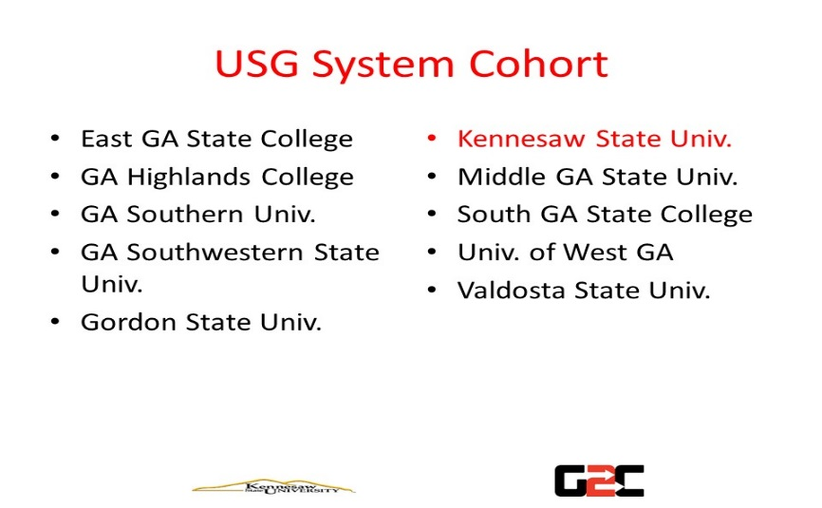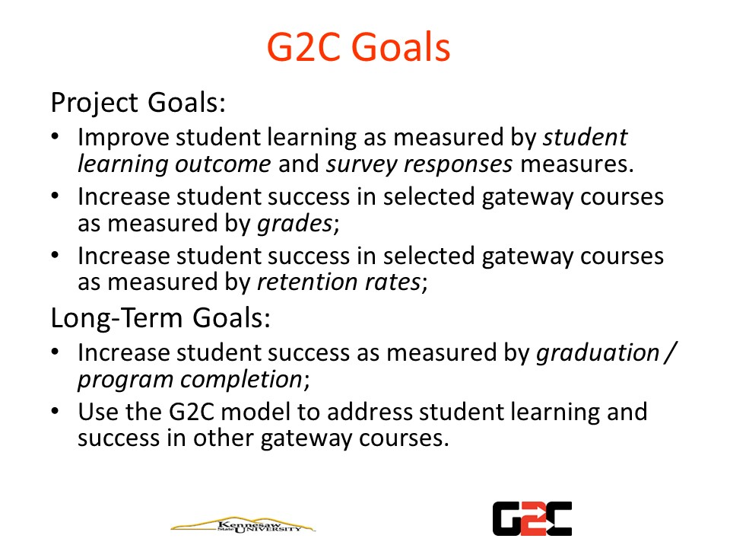
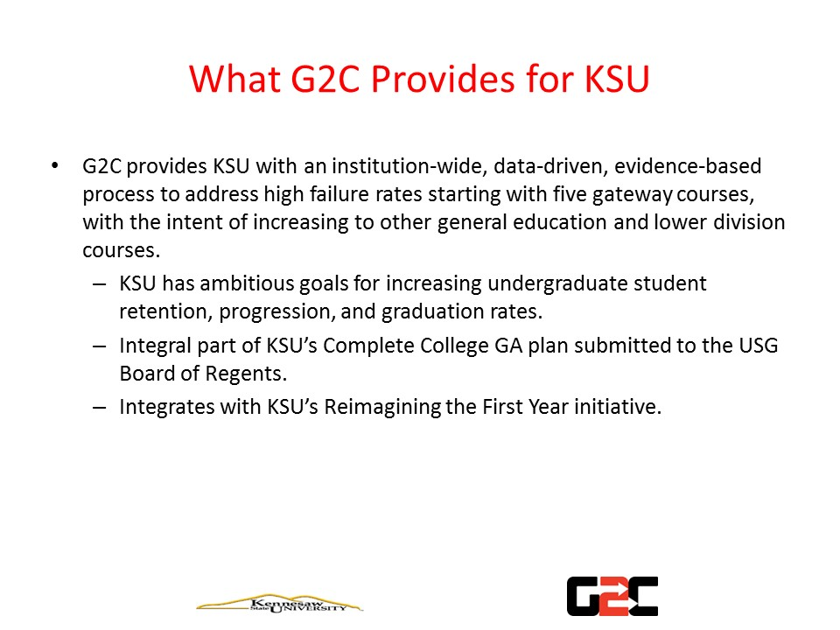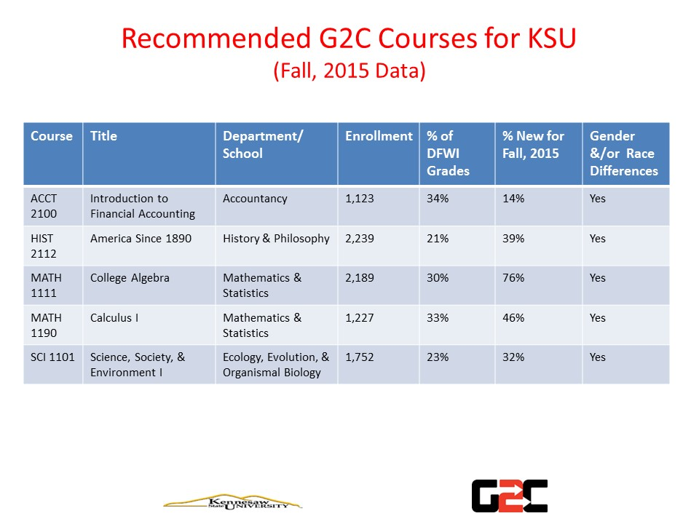

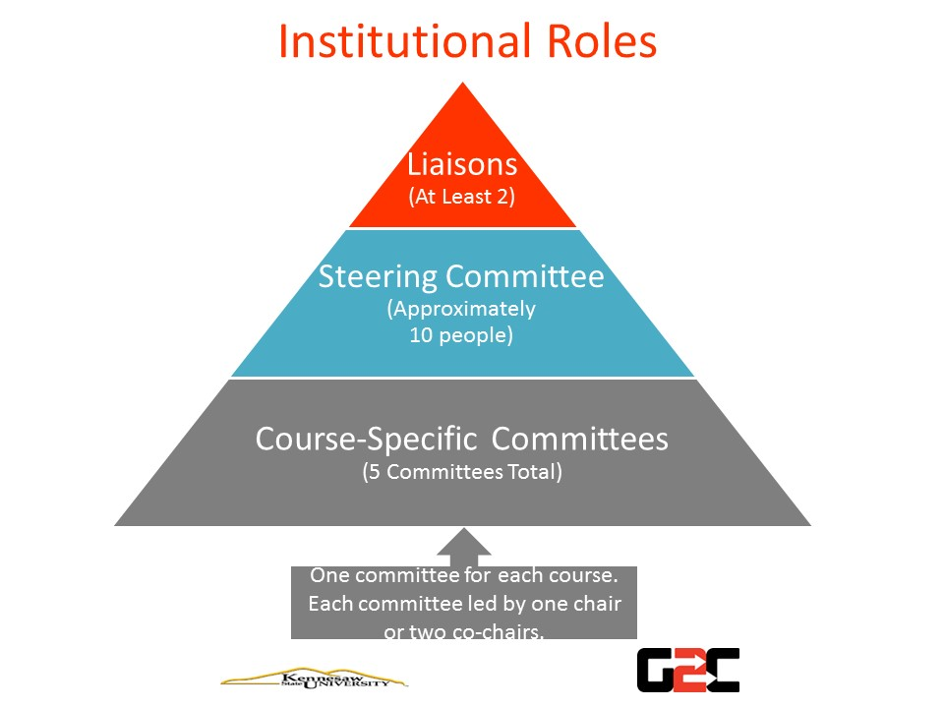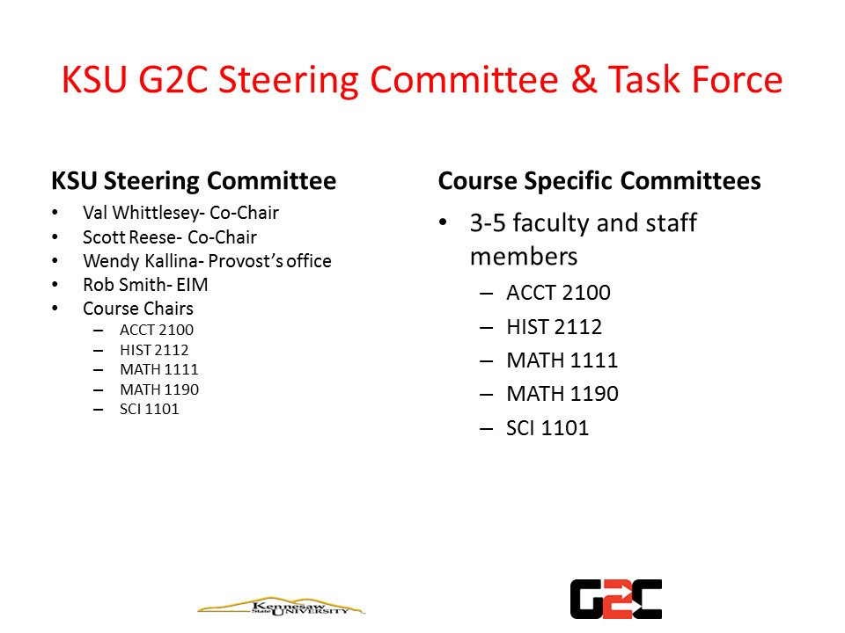
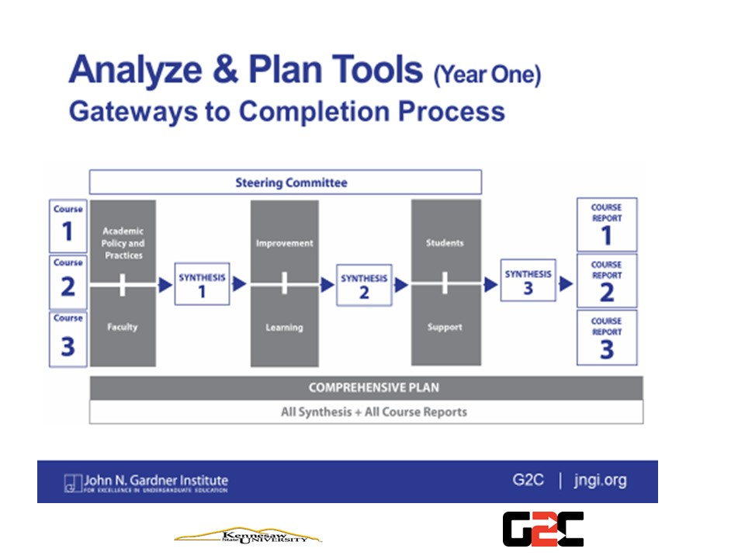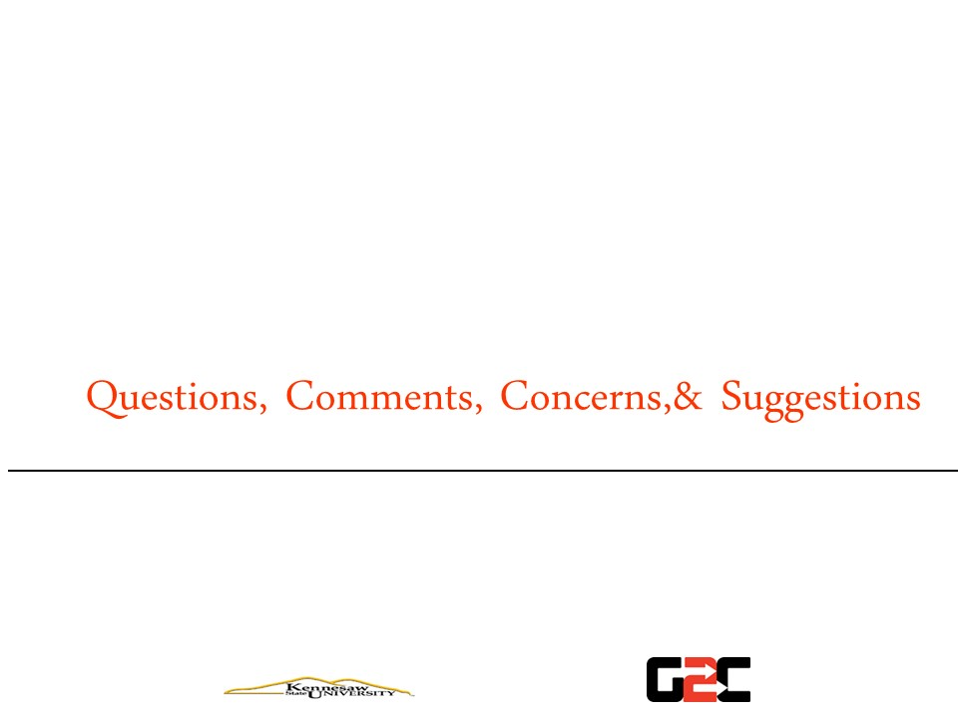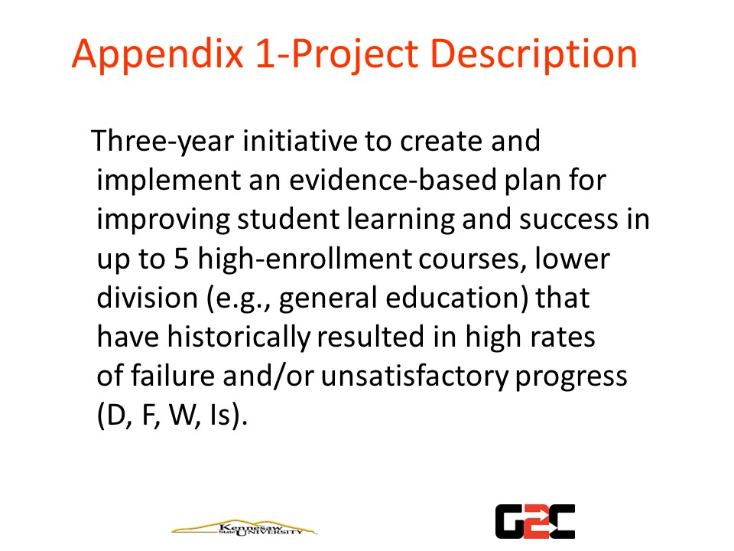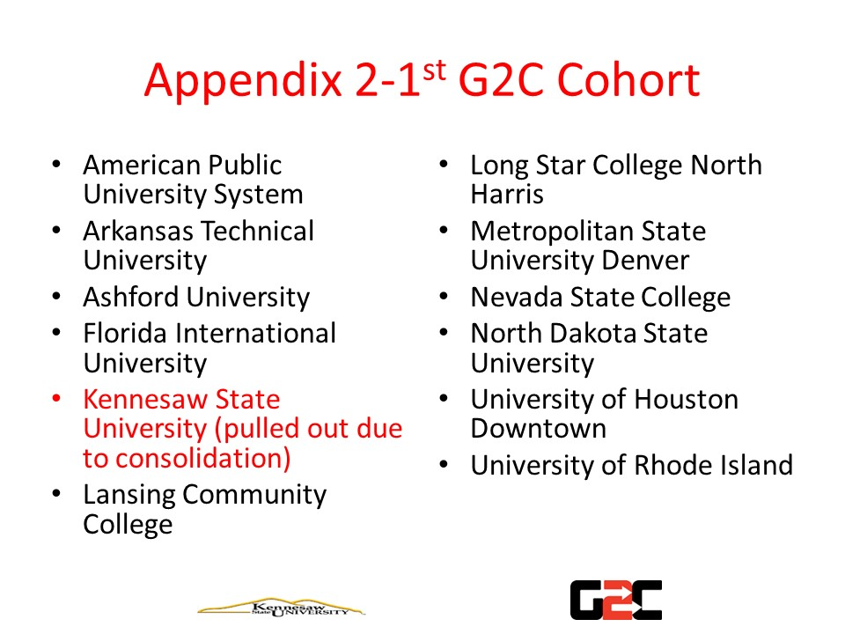

UPCC & GPCC process changes – Val Whittlesey

3.7. Undergraduate and Graduate Curriculum Review and Approval Process

Curriculum is the collective responsibility of the faculty. The curriculum development and review process will be guided by the policies and goals of the university, colleges, and departments. Proposed changes and reactions to those proposals should be communicated to all interested parties and multiple viewpoints should be considered.
Faculty may initiate proposals by completing and submitting the appropriate course/program proposal forms. These forms are available online at http://www.kennesaw.edu/upcc/forms.html (for all undergraduate proposals forms) and http://www.kennesaw.edu/gpcc/forms.html (for all graduate proposal forms).

There are two categories of proposals, each with a different set of reviewing levels. (In the description below, UPCC denotes the university-wide Undergraduate Policies and Curriculum Committee, and GPCC denotes the university-wide Graduate Policies and Curriculum Committee).

Category 1. Proposals for Directed Study and Special Topics courses require approval by the:
1) Department chair
2) Department curriculum committee (if special topics course)
3) Education Abroad Director (if study abroad course)
4) Honors Program Director (if honors course)
5) Registrar

Category 2. All other course and program proposals require approval by the:
1) Department curriculum committee
2) Department chair
3) College curriculum committee
4) College dean
5) Education preparation council (if education courses and programs)
6) Education dean (if education courses and programs)
7) General education council (if general education course)
8) UPCC or GPCC
9) Dean of graduate college (if graduate courses or programs)
10) Technology enhanced learning administrator (if online or hybrid curricula)
11) Provost/VPAA and President.

Rejection of a proposal at any of its designated levels of review precludes adoption of the proposal in its present form and must be accompanied by a written explanation of the rationale behind the rejection. This explanation is to be distributed by the rejecting level of review to all earlier levels of review and to the initiator of the proposal.

The UPCC or GPCC will receive course and program proposals from colleges and departments and insure their compliance with university policies and goals. These committees will maintain in writing and make available upon request a list of major criteria used in evaluating proposals. Initiators of proposals under review will be invited to discuss those proposals at scheduled meetings. Committee recommendations will be sent to the Provost/VPAA and President for their action and to the Executive Committee of the Senate for its use in monitoring the activities of these committees. The UPCC and GPCC will also make policy recommendations regarding the curriculum development and review process to the senate. The General Education Council will assign one of its own members to serve concurrently as a voting member of the UPCC.

Each college curriculum committee will include representatives from all the departments in the college. It will maintain in writing and make available upon request a list of major criteria used in evaluating proposals. Initiators of proposals under review will be invited to discuss those proposals at scheduled meetings. Input will be solicited from departments within the college that may be affected by substantive proposals under review. Each college curriculum committee chair should attend (or send a designee to attend) meetings of the UPCC and/or GPCC as applicable to relay input from departments within the college that may be affected by substantive proposals under review from other colleges.

Each department curriculum committee will maintain in writing and make available upon request a list of major criteria used in evaluating proposals. It will discuss substantive proposals with the department before passing those proposals on to the chair. It will share with the department the written explanation of the rejection provided by any level of review.

RESPONSE FROM NINE MEMBERS OF THE DEPARTMENT OF ENGLISH REGARDING PROPOSED CHANGES
TO THE REVIEW PROCESS FOR LECTURERS
About this document: The texts appearing below were written in response to a request for feedback over our departmental electronic mailing list. Although all the responses received are included here, they may not be representative of opinions within the department. Information that would identify the writer has been removed unless a writer wished to be known. Information not relevant to the Faculty Senate discussion has also been removed, as has some commentary that concerned identifiable individuals. Finally, tenure status is indicated, although lecturer status is not (that is, whether the individual is a Lecturer or a Senior Lecturer is not noted); both lecturers and senior lecturers participated in this survey.
Response 1. Against Changes.
H. William Rice, PhD, Chair and Professor
The English Department began hiring lecturers in 2006. At that time, part-time faculty covered the major portions of our general education offerings. We invested heavily in hiring lecturers because we were interested in building a general education program that took seriously the BOR pledge to support core competencies, one of which is writing.
We have hired 30 lecturers since then and have invested heavily in training them and making them a vital part of our department. A central part of this training process is going through the same review schedule members of the tenure track faculty go through. Though they do not get tenure at the end of this process, they are scrutinized by peers in the same way that tenured faculty are. Only through such a process can they become full-fledged members of our department who are trusted with one of the most important jobs we have: teaching students to write. Cutting out the review process moves them in the direction of being temporary faculty. Equally important, it suggests that the majority of our writing courses can be taught by a shifting array of faculty who are not vetted in the same careful manner that other faculty are vetted.
I strongly object to the idea of changing the review process for lecturers. Not only will it undermine the careers of some of the best people we in English have, but also it will compromise our ability to offer quality instruction in one of the core competencies that all USG students are to master: writing.
Response 2. For Postponing the Vote to Allow Increased Clarity.
Lecturer
Objection #1. The speed with which the proposal is proceeding.
Had the motion not been “tabled” during the last meeting of the Faculty Senate, lecturers would have had no input or knowledge of the changes. In the interest of shared governance, there should be a Motion to Postpone until the April Faculty Senate meeting. Postponing the vote
until April will allow the lecturers/Dr. Matson to schedule an Open forum to present an explanation and rationale for the proposed changes to the review process.
Objection #2. Year-after-Year indefinite appointments
After the initial discussion in the Faculty Senate regarding the motion, it was suggested that lecturers would be able to serve year-after-year with no term limit. This proposal seems to be in contradiction with BOR policy 8.3.8.1 and KSU Faculty Handbook policy 4.1.1, both of which suggest that lecturers have to be promoted at the six-year mark or have their contracts become terminal unless they have “demonstrated exceptional teaching ability and extraordinary value to the institution.”
From BOR Policy 8.3.8.1
Senior Lecturers
Promotion to senior lecturer, or initial appointment at the rank of senior lecturer, requires approval by the
president and must be reported as a matter of information to the Senior Vice Chancellor for Academics and Fiscal Affairs when promotions for ranked faculty are transmitted to the University System Office.
Lecturers who have served for a period of at least six years at KSU will either be
promoted to senior lecturer during the sixth year or be terminated from the institution;
only in exceptional circumstances will a lecturer be reappointed as a lecturer after six
years of service to the institution.
Initial appointment at the rank of senior lecturer is
reserved for those with extensive experiences and accomplishments.
“Reappointment of a lecturer who has completed six (6) consecutive years of service to
an institution
will be permitted only if the lecturer has demonstrated exceptional teaching
ability and extraordinary value to the institution
. The reappointment process must follow
procedures outlined by the institution (BoR Minutes, February 2007).”
From the KSU Faculty Handbook 4.1.1
Given the above policies, it is unclear how a lecturer could have indefinite year-after-year appointments, since both polices have vague/unclear criteria for a lecturer’s continued employment after year six if they are not promoted to Senior Lecturer. Therefore, again, there should be a Motion to Postpone until the April Senate meeting. The Motion to Postpone would allow departments/colleges more time to develop criteria that clarify what the criteria would be for a lecturer to have continued after year six if they are not promoted. Second, the postponement would allow departments and colleges to develop clear criteria that explain how one “applies” to be promoted to Senior Lecturer.
In emails from both Dr. Léger and Dr. Matson on Friday 2/19, it was suggested the sole determiner for one’s continued employment after year six is the Dept. Chair/Dean rather than a P and T committee. This has the potential to be very problematic, as it places one’s continued employment in the hands of one person rather than a committee that is assessing the summation of six years’ worth of work. Rather than having the three-year binder or a six-year binder to present their accomplishments, lecturers are left only the yearly reviews, an assessment model that is not as comprehensive as the current policy (or as it should be). The lecturers who were in attendance at the Open Forum who had been through the three-/six-year review process agreed that the process, while time consuming, ultimately made them better teachers.
Finally, KSU Faculty Handbook policy 4.1.1 is also problematic given its language if the motion is passed before the section is deleted from or revised in the handbook. This policy should be a part of the initial changes to the policy that is being voted on rather than something that is separate and “looked at” by Academic Affairs at a later date. Not revising or deleting the

