
th
th
Minutes for Faculty Senate Meeting: January 25 , 2020 (12:30 PM – 1:45 PM) (Revised on Sunday, Feb 14)
Attendance:
Senators: Cristen Dutcher, Jennifer Dickey, Lei Li, William Griffiths, Daniel Rogers, Sanjuana Rodriguez, Chris Sharpe, Paul McDaniel, Diana Gregory, Jeff Yunek, Darina Lepadatu, Irene McClatchey, Daniel Ferreira, Abhra Roy, Steve Collins, Giovanni Loreto, Noah McLaughlin, Michael Van Dyke, Ying Wang, Ann Mills, Laurie Tis, David Buckman, Humayun Zafar, Austin Brown, Jim Davis, Sara Giordano, Mary Beth Maguire, Randy Stuart, Ken Hoganson, Walter Thain, Jaanne Lee, Mohammad Jonaidi, Peter St. Pierre, James Gambrell, Justin Pettigrew, James Wright, Douglas Moodie, Len Li, Jillian Ford, Snehal Shirke, Todd Harper, Md. Faruque Hossain, Hassan Pournaghshband, Nicholas Ellwanger.
Guests and/or administrators: Aaron Howell, Amy Buddie, Tim Blumentritt, Emmie Cass, Christine Zelt, Sheb True, Pam Cole, Thierry Leger, Jeff Delaney, Eric Arneson, Karen McDonnell, Ivan Pulikala, Rita Bailey, Kadian Callahan, Nwakaego Nkumeh, Pete Rorabaugh, Scott Gordon, Linda Marie Golian-Lui, Sabrina Hall, Tim Hedeen, Sylvia Carey-Butler, Rachel Schrauben Yeates.
New Business
a. Online Faculty Senate Meeting Expectations
Agenda
Opening Remarks
1. Welcome – Humayun Zafar (Meeting convened at 12:30)
- Please complete the attendance survey (link in the chat window) if you are a senator or a guest.
- Voting will be carried out electronically (link will be available in the chat window) and will be tracked. Please only vote if you are a senator. A non-senator voting will result in an immediate permanent ban from the faculty senate.
- Use the “Raise your hand” feature in order to be recognized.
- As we move forward with our senate meetings, the FSEC has heard from
its members and agrees on the need to hold to correct parliamentary procedure. Motions will be preferred over discussion items so that we typically have action items on the floor. We would like to point out that there will be less time in our meetings used to announce our business items, so it will be more important than even to be familiar with all documents pertaining to our meeting.
To further promote discussion, the president of the faculty senate will begin by calling for dissenting opinions. If there are no dissenting voices, we will be able to call for a vote directly and increase efficiency in our meetings.

2. Approval of minutes for December 7, 2020, meeting. Minutes approved. Senator Steve Collins, Political Science, motioned; Senator Jennifer Dickey, History and Philosophy, seconded.

3. Remote Learning and Remote Work Motion – Stephen Collins, Political Science

- Senator Steve Collins, School of Government and International Affairs, introduced a resolution for remote learning and work. He noted two important items about the motion. The first item requests that the President advocate for KSU faculty at the USG and to the BOR, knowing that the President does not have the authority herself to move faculty and classes fully online. He noted the sharp rise in cases both at the county and state levels since the Fall 2020 semester (when the plan for the Spring 2021 semester was crafted). The motion notes that when Covid-19 cases drop below the Fall 2020 average, in person instruction can resume for those courses currently taught in that format.
- Senator William Griffins, Mathematics, seconded.
- Senator Daniel Rogers, Psychology, requested clarification on what the President can do. Senator Collins responded that she may advocate to the decision-making bodies downtown, but that she cannot issue a call to move fully online without their consent.
- Senator Noah McLaughlin, Foreign Languages, felt that his faculty would be more receptive if faculty were given the choice to decide whether to move fully online. He noted this would give programs more autonomy in making decisions best suited for their faculty and students. Noah suggested the following change to the motion: “The Faculty Senate urges the USG Board of Regents to allow KSU to move immediately and entirely to remote learning, and asks President Whitten to advocate for this move on the university’s behalf. Furthermore, we ask President Whitten to instruct faculty to work remotely (with the very few exceptions of those faculty whose job functions are impossible to complete remotely)” to “we ask President Whitten to instruct all faculty that they may work remotely.”
- Senator Givoanni Loreto, Architecture, concurred. While faculty in Architecture are largely supportive, they wondered whether if the President might speak to the motion and whether the original call for 50% in-class learning arose from the USG.
- Provost Schwaig responded that the BOR passed a resolution in October that asked universities within the system to try to teach F2F as much as possible with a goal of 50%. (Both the BOR and the USG understand that not all universities can achieve 50% F2F teaching because of issues of space.)
- Senator Lei Li, Information Technology, inquired about staff who rely on F2F classes.
- Senator Griffiths expressed his dissent to Senator McLaughlin’s amendment, noting that he did not want to place other faculty and staff in danger as he feels with the BOR resolution. Senator Jillian Ford, Secondary and Middle Grades Instruction, also noted that faculty should not be forced to teach F2F, nor should students. Senator James Gambrell, Inclusive Education, noted the difficulty he was experiencing with both a spouse and children with compromised systems. Moreover, he is finding himself having to teach more this semester in an odd rotational system than he would with fully F2F or fully online courses. Senator Randy Stuart, Marketing, argued that faculty should not be forced to move back online, if they do not desire this. She also noted that there are many who cannot work remotely. She expressed her opposition.
- Senator Jeff Yunek, Music, noted that faculty should remain open to Senator McLaughlin’s amendment.
- Senator Heather Pincock, Conflict Management, requested 10 additional minutes for the discussion.
- There was discussion as to the degree that the author of the proposal could speak to the proposal once he or she has introduced it. The Parliamentarian noted that the author can respond to follow-up questions.
- Vote on Senator McLaughlin’s amendment: 30 in favor, 11 against. (amendment passes).
- Vote on overall resolution with new language from Senator McLaughlin’s amendment: 37 in favor, 6 against. (motion passes).

4. Plus/Minus Proposal Update – Senators Cristen Dutcher, Bill Griffiths, and Joanne Lee

- Senator Cristen Dutcher, Accountancy, reminded senators of where the process currently stood. A survey had been delivered to faculty. Although support for the proposal edged out over those against, the survey results were close. Moreover, she noted two additional items: 1) there was a greater dissent among part-time faculty for the proposal than there was for full time faculty. 2) The comments revealed numerous misunderstandings of the proposal. However, she also noted that comparator universities seemed to express similar divisions among faculty in terms of support for pass/fail grading. Indeed, she wondered if some universities had not adopted one system over the other in order to “keep up with the Jones.”
- President Whitten noted that anything she would take to the USG or BOR for passage needed overwhelming support, or the BOR would likely reject the final proposal.
- Senator Dutcher motioned that senators speak with their constituents to inform them of the nature of the proposal and to hopefully clarify any confusion faculty might have. She will be sending out a link that can reports the survey.
- Motioned passed with 35 in favor and 4 against.

5. KSU Withdrawal Policy – Paul Parker and Pam Cole

- Paul Parker noted that the existing withdrawal policy allows only 8 withdrawals before students are penalized. There resolution would allow for unlimited withdrawals. Mr. Parker noted that USG institutions, such as Georgia Tech and the University System of Georgia, have done away with withdrawal limits and, as a result, have seen improved student success, especially among graduation rates.
- Several senators noted that the original limit was put in place at the request of students who felt shut out by others who would over enroll simply to withdraw from the courses that they did not like. Senator Moodie added that some classes would see as much as a third drop before limits were decided upon.
- Mr. Parker noted that safeguards for this type of behavior exist now when they hadn’t previously. He stated that financial aid, for instance, places limits on the number and type of courses that students can now enroll in.
- Motion passed with 22 in support, 18 against.

6. Fall student evaluations – Senator Snehal Shirke, TCID

- Senator Shirke put forward a motion to eliminate student evaluations from the fall since students were allowed to see their grades before completing the evaluations. (This was the result of the “opt-out” system not having been implemented.” She reasoned that students who were allowed to see their grades in Banner might punish faculty through evaluations.
- Several senators noted that faculty who use D2L often post grades before student evaluations are finished. Thus, students know their grades from D2L, even if those grades have not been officially posted.
- President Humayun noted that the BOR requires some sort of measurement.
- Senator Shirke noted that even so, other institutions within the USG had advocated and found other measures.
- Senator Gambrell noted that he was in favor of evaluations ending when the exam period ended.
- Senator Griffith noted that students need the opt-out system before seeing their grades, or this delegitimizes the system.
- Motion passed.

7. Meeting adjourned 2:00 pm

Motion on Moving University to All-Remote Learning, and All-Remote Working Arrangements
Author: Steve Collins, School of Government & International Affairs
Whereas, cases of the Covid-19 virus have surged dramatically in the past month in KSU’s home county of Cobb, in surrounding counties populated by our students, faculty, and staff, and throughout Georgia (see charts below),
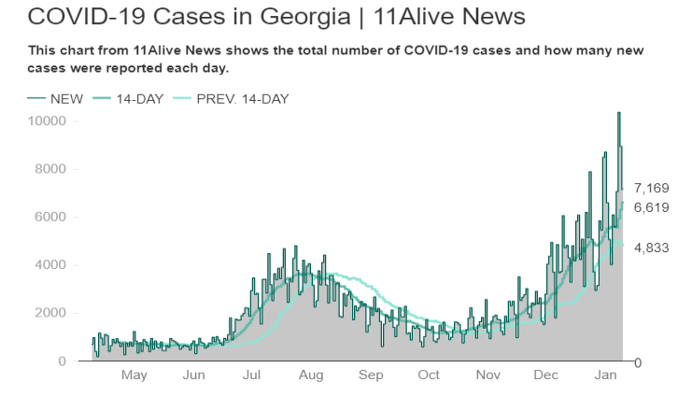
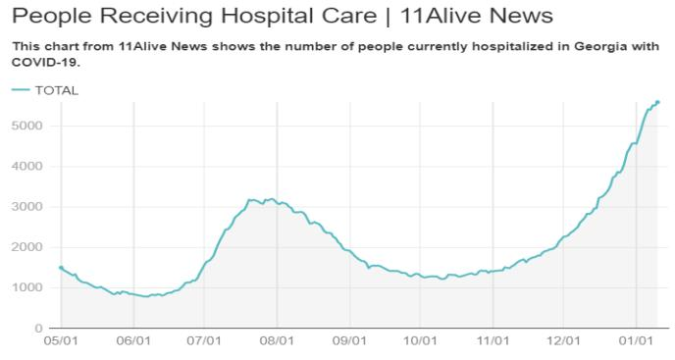
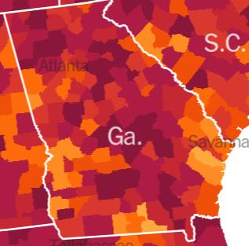
NYT
Considering, that a recent CDC study revealed that, (per The New York Times) “The spread of the coronavirus accelerated sharply in U.S. counties where large universities held classes in person last fall...” and that, conversely, “infection rates declined in counties...where large universities held classes remotely last fall,”
Noting that the administration of Kennesaw State University has pledged to be driven by the data in terms of its response to this historic health crisis,
The Faculty Senate urges the USG Board of Regents to allow KSU to move immediately and entirely to remote learning, and asks President Whitten to advocate for this move on the university’s behalf. Furthermore, we ask President Whitten to instruct all employees to work remotely (with the very few exceptions of those employees whose job functions are impossible to complete remotely).
In short, the situation has rapidly and deeply deteriorated since we last gathered, and therefore the university’s approach to the crisis must respond in kind.
We strongly suggest that this arrangement should remain in place until virus levels in our state and in metro-Atlanta fall below the levels recorded in the mid-Fall 2020 semester. We note that mid-Fall 2020, when plans for the Spring 2021 semester were made, was a time when case counts were just one-fifth of the current level. Additionally, area hospitals were not, as they are currently, overflowing, leaving, per the AJC, “Georgia’s health care system on the brink.”
Motion for the floor of the Senate:
We move for the Faculty Senate to officially request that each of its senators share the KSU Report on Plus-Minus Grading with the faculty of their department and encourage participation in the Faculty Senate Grading Modality survey by all full-and part-time faculty. Senators are requested to have the KSU Report on Plus-Minus Grading and Faculty Senate Grading Modality Survey appear as an agenda item at the February department faculty meeting as well as to send both the report and survey link to all full- and part- time faculty via their department mailing list.
KSU Report on Plus/Minus Grading
Grading Example GPA Recommended Pros Cons System Range Course Grading Scale
Traditional  (currently used by all KSU faculty) | - A 4.00  - B 3.00  - C 2.00  - D 1.00  F 0.00 | A = 90% - 100%  B = 80% - 89.99% C = 70% - 79.99% D = 60% - 69.99% F = 0% - 59.99% | -Requires no change and thus is no additional work for faculty -Consistency maintained by use of the same system across the University | -Students who are at the low end of a letter grade may lack motivation to work as hard as required to move to the next letter grade  -Does not provide a way to accurately reflect differing student performances -Potential for faculty to inflate grades, i.e. an “almost A” is given an A letter grade
Plus/Minus with A+ (to be used by all KSU faculty) | A+ 4.30 A 4.00 A- 3.70 B+ 3.30 B 3.00 B- 2.70 C+ 2.30 C 2.00 C- 1.70 D 1.00 F 0.00 | A+ = 98% - 100% A = 93% - 97% A- = 90% - 92% B+ = 88% - 89% B = 83% - 87%  B- = 80% - 82% C+ = 78% - 79% C = 73% - 77% C- = 70% - 72% D = 60% - 69% F = 0% - 59% | -Provides more grade options for a potentially more accurate way to assess different student performance -Potential for students to be more motivated to continue learning to reach shorter goal of next highest grade  -Greater competitive advantage for high achieving students trying to enter graduate school with the availability of A+ grades  -Fairly grades students if used across a University by all faculty | -Minor decrease, even less than without A+ system, in GPA with change from traditional system  -More complex grading system for students and faculty -May cause marginal students to drop into academic probation without a change in their performance (C- is below 2.0) unless cutoff GPA changes  -Unfairly grades students if not used across a University by all faculty (a 90% is an A in the traditional system course and an A- in the plus/minus course)
KSU Report on Plus/Minus Grading
-No empirical evidence of any of the above
-Less likely for faculty to inflate grades in an objectively graded course, i.e. an “almost A” is now named = B+; 1 private college found 0.062 decrease in GPAs from reduction in inflation due to use of plus/minus grading and found that higher GPA majors had higher decrease, lower GPA majors had less of a decrease
-Potential for student grade complaints to increase
-No empirical evidence of any of the above
-1 small scale empirical study found no increase in student motivation when using plus/minus over traditional grading -Students may feel unhealthy competition for A+ grades
without A+
(to be used by all KSU faculty)
Plus/Minus
A- 3.70 B+ 3.30 B 3.00 B- 2.70 C+ 2.30 C 2.00 C- 1.70 D 1.00 F 0.00
A 4.00
A- = 90% - 93% B+ = 87% - 89% B = 84% - 86% B- = 80% - 83% C+ = 77% - 79% C = 74% - 76% C- = 70% - 73% D = 65% - 69% F = 0% - 64%
A = 94% - 100%
grade options for a potentially more accurate way to assess student performance -Potential for students to be more motivated to continue learning to reach shorter goal of next highest grade
-No empirical evidence of any of the above
-Less likely for faculty to inflate grades in an objectively graded course, i.e. an “almost A” is now named = B+; 1 private college found 0.062 decrease in GPAs
-Provides more
(between 0.04 and 0.08 reported) in GPA with change from traditional system
-More complex grading system for students and faculty -May cause marginal students to drop into academic probation without a change in their performance (C- is below 2.0) unless cutoff GPA changes
-Unfairly grades students if not used across a University by all faculty (a 90% is an A in the traditional system course and an A- in the plus/minus course)
-Minor decrease
KSU Report on Plus/Minus Grading
 |  |  | from reduction in inflation due to use of plus/minus grading and found that higher GPA majors had higher decrease, lower GPA majors had less of a decrease -Students may feel unhealthy competition for A+ grades, avoided without use of A+ -51.17% of KSU faculty support this system (half of all faculty responding) -42% of part-time faculty support this system (1/3 of all part-time faculty responding) | -Potential for student grade complaints to increase  -Potential for students to complain that there is no A+ grade  -No empirical evidence of any of the above  -48.83% of KSU faculty do not support this system (half of all faculty responding)  -47% of part-time faculty do not support this system (1/3 of all part-time faculty responding) -1 small scale empirical study found no increase in student motivation when using plus/minus over traditional grading
Plus Only (to be used by all KSU faculty) | A 4.00 B+ 3.50 B 3.00 C+ 2.50 C 2.00 D+ 1.50 D 1.00 F 0.00 | A = 89.5% - 100% B+ = 84.5% - 89.4% B = 79.5% - 84.4% C+ = 74.5% - 79.4% C = 69.5% - 74.4% D+ = 64.5% - 69.4% D = 59.5% - 64.4% F = 0% - 59.4% | -Increases GPAs -May motivate students without negative grades (minuses), no empirical evidence of this  -25% of 1/3 of part- time faculty support this system | -Rarely used among KSU peer and regional universities -No balance to the benefit of + grades which may inflate GPAs, no empirical evidence of this  -1 small scale empirical study found no increase in student motivation when using plus/minus over traditional grading
*A Note on the HOPE Scholarship*
HOPE Scholarship regulations require GPAs to be calculated on a traditional 4.0 scale. Pluses and/or minuses are ignored in the calculation of HOPE Scholarship GPA in determining undergraduate eligibility
KSU Report on Plus/Minus Grading
for continued HOPE scholarship qualification. For example, an A+, A and A- all equal 4.0 on the HOPE
GPA scale. www.gafutures.org.
Resources
November 2020 KSU General Faculty Survey on Plus/Minus Grading
November 2020 KSU Part-Time Faculty Survey on Plus/Minus Grading
Usage of Plus/Minus Grading in KSU and SACSOOC Peer Institutions: 59% (10 of 17) use Traditional, 41% (7 of 17) use Plus/Minus: 3 with A+ and 4 without A+, 0% use Plus Only
Auburn Report on Plus/Minus Grading 2016, including referenced resources
file:///C:/Users/cdutcher/Desktop/FINALrptAU_PlusMinusGrading.pdf
University of Guam Report on Plus/Minus Grading 2007, including referenced resources
file:///C:/Users/cdutcher/Downloads/Evaluating_The_PlusMinus_Grading_System_For_Underg.pdf
Truman State University Plus/Minus Grading Report 2000, including referenced resources
https://www.wku.edu/senate/documents/truman_state_report.pdf
University of Texas at Arlington Report on Plus/Minus Grading 2005, including referenced resources (Word doc on file with Committee, available upon request)
Bressette, A., Arguments for Plus/Minus Grading: A Case Study, Educational Research Quarterly, vol. 25:3, p 29, 2002 (finding 0.062 reduction in GPA using raw numerical grades after using plus/minus grading in all disciplines at private liberal arts institution (Berry College, GA) for one academic year that higher GPA majors had higher decrease, lower GPA majors had less of a decrease; student survey revealed preference against use of A+ which students felt would lead to unhealthy competition among them).
Dixon, C. Plus/Minus Grading if Given a Choice, College Student Journal, vol. 38:2, p 280, 2004 (small number of students in a single course prefer traditional grading to plus/minus grading at a 2:1 ratio when given the choice of which system to be graded by).
Fries, R. et al., Student and Faculty Perceptions on Plus/Minus Grading: A Case Study, Educational Research Quarterly, vol. 36:4, p 49, 2013 (review of Southern Illinois University Edwardsville’s investigation into the use of plus/minus grading and their ultimate conclusion to stay with traditional grading based on faculty survey, student survey, and literature review).
Kleinman, S. et al., The Changing Landscape of Grading Systems in US Higher Education, Perspectives: Policy and Practice in Higher Education, vol. 22:1, p 26, 2018 (no clear evidence that plus/minus grading in any form is better than other forms of grading, much of the move toward plus/minus seems more for reasons of keeping up with peers/trends).
McClure, J. and Spector, L, Plus/Minus Grading and Motivation: An Empirical Study of Student Choice and Performance, Assessment & Evaluation in Higher Education, vol. 30:6, p 571, 2005 (small scale empirical study finding that students who chose plus/minus grading in a single semester were not
KSU Report on Plus/Minus Grading
significantly more motivated, based on total points earned in the single semester, than students who chose traditional grading in the same semester).
University of Georgia Plus/Minus Sample Grading Scales
file:///C:/Users/cdutcher/Desktop/UGAPlusMinusSampleGradingScales.pdf

