Authorized Users Guide

Authorized Users Login Page
Authorized users can access a student's account by logging into epay.kennesaw.edu. When a student authorizes you, you receive two emails: one confirming authorization and one containing a temporary password. Log in as soon as possible, as the temporary password expires quickly. After the first login, you will be prompted to create a new password.

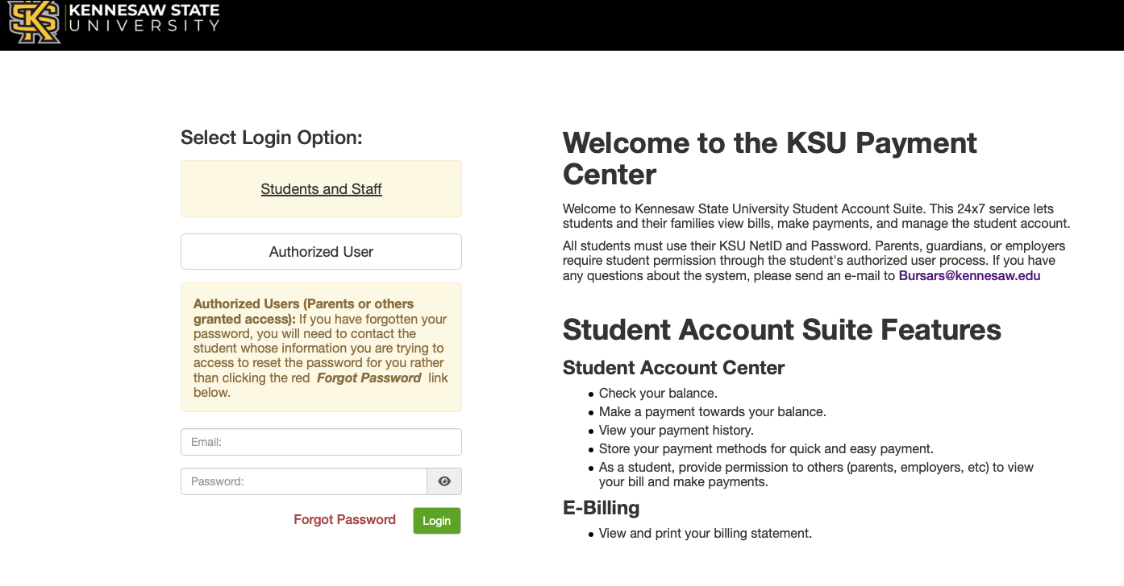

Setting Up an Authorized User
Students can allow parents or guardians to access their account information and make payments. To add an authorized user, the student must log in to Owl Express, navigate to the Student Services tab, and then select View Account. Inside ePay, the student can then select Authorized Users under My Profile Setup.

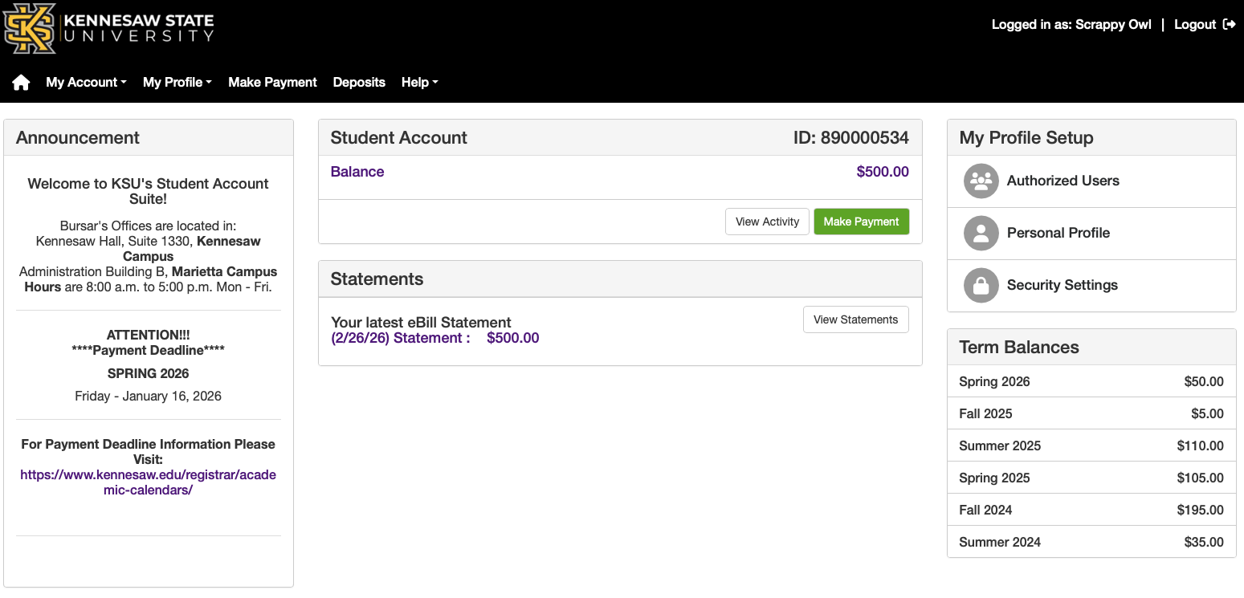

Adding an Authorized User
1. Click the Authorized Users link.
2. Select Add Authorized User.
3. Enter the user's email address.
4. Choose which access permissions to grant.
5. Click Continue.
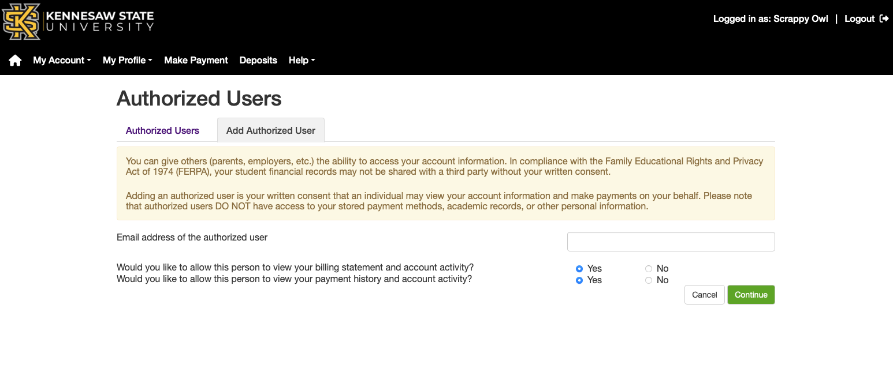
6. After clicking Continue, the student must agree to the terms by checking the 'I Agree' box.

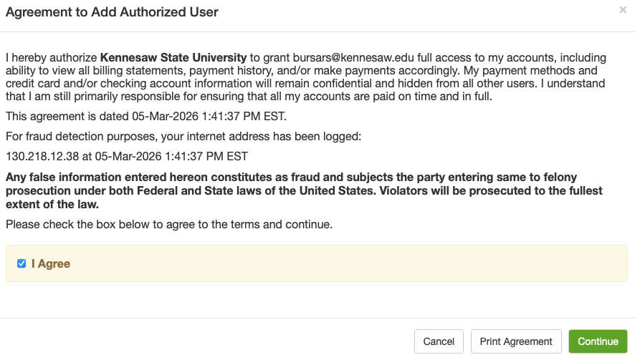

Once added, authorized users appear under the Authorized Users tab in ePay.

