Creating a Workload Summary Report

- Log into Watermark via the link provided on the Faculty Activity Data website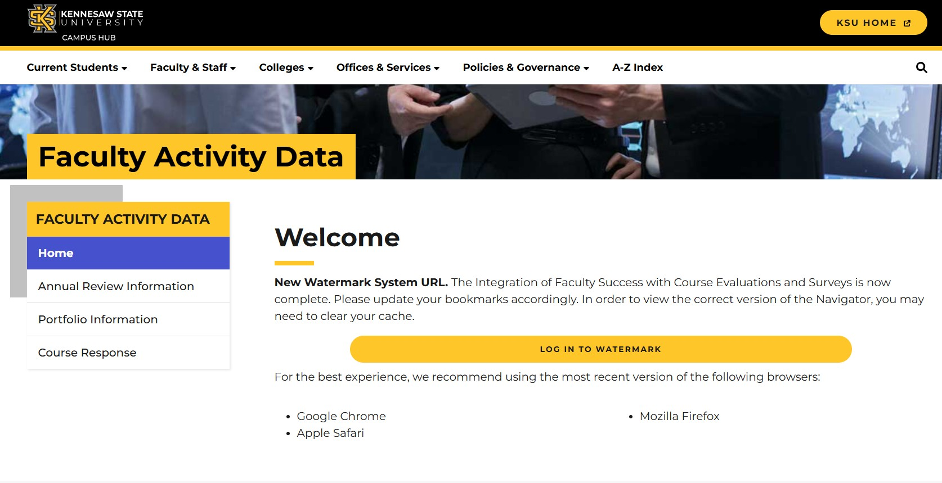

- Click on the ‘Faculty Success’ box.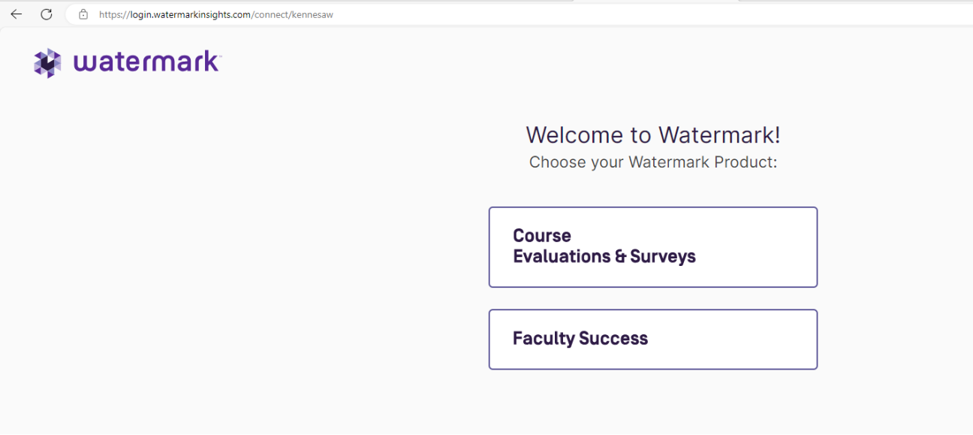

- Click the ‘Reports’ icon on the Watermark homepage.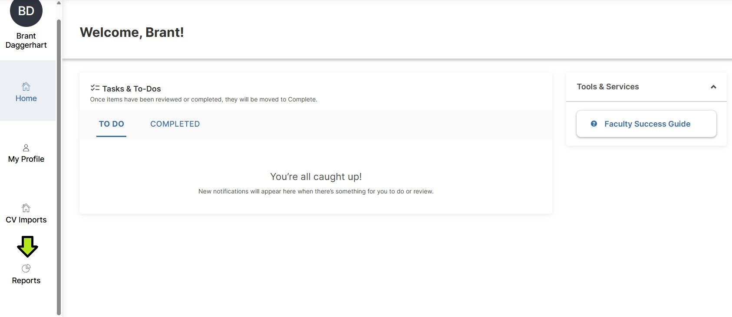

- Click the ‘Workload Summary’ link to generate a report showing faculty members who have entered their Yearly Workload Summary.
-or-
Click the ‘Z_Faculty Workload Monitoring’ link to generate a report showing faculty members who have NOT entered their Yearly Workload Summary.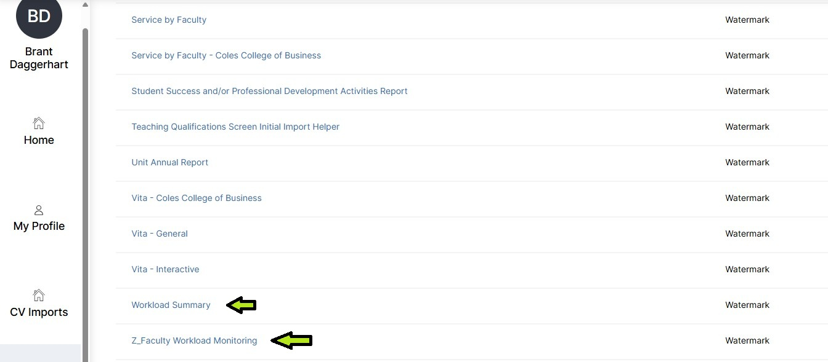

- Click the ‘Change Selection’ link in ‘Groups to Include’ to select the appropriate college or department.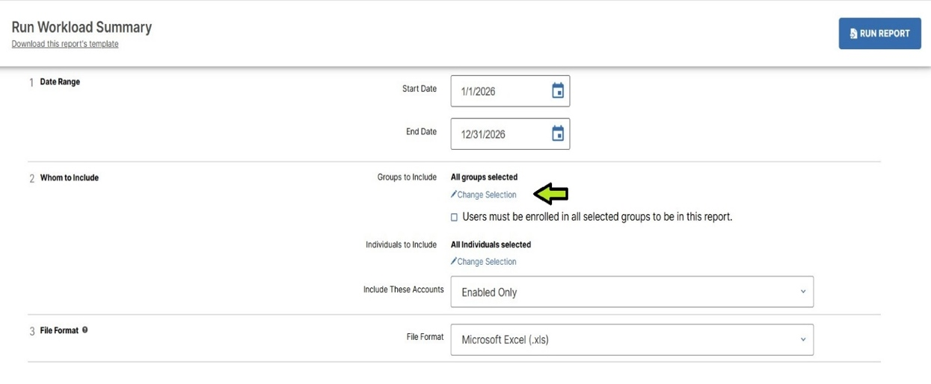

- Select the appropriate college or department using the ‘Academic Home College Description’ segment or the ‘Academic Home Department Description’ segment. Then click ‘Save’.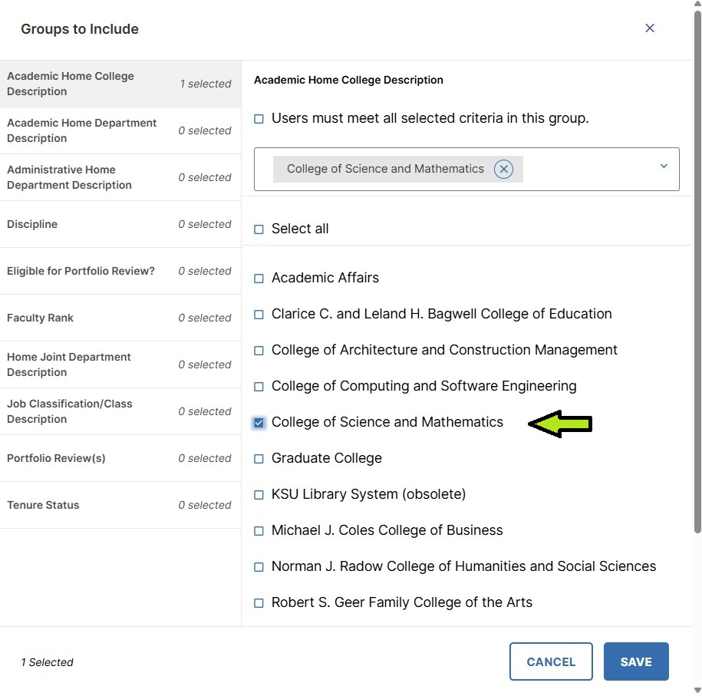

- Click ‘Run Report’. Watermark will automatically download an Excel file that will be saved according to your browser’s settings.
The file name generated will follow this format: Z_Faculty+Workload+Monitoring-20240620-074850-CDT