Adding Data to Yearly Workload Summary

1) Click the ‘My Profile’ icon on the Watermark homepage

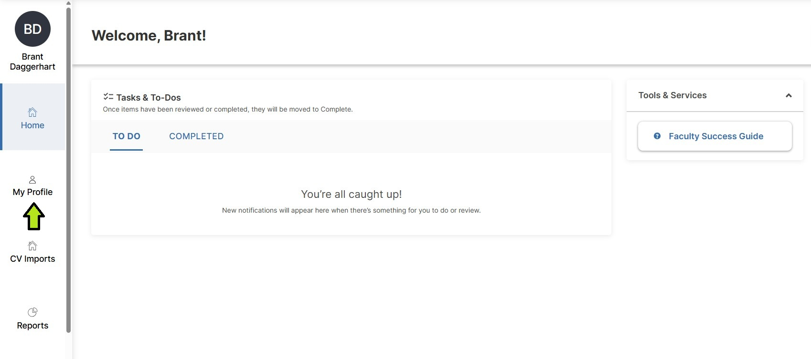

2) Click the ‘Yearly Workload Summary’ link
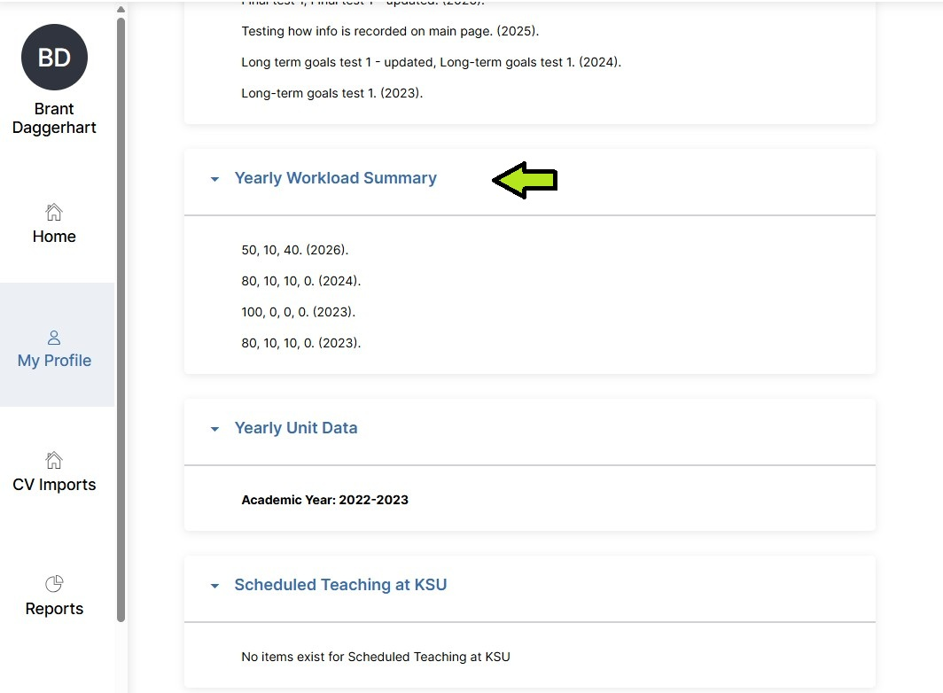

3) Click ‘Add New’

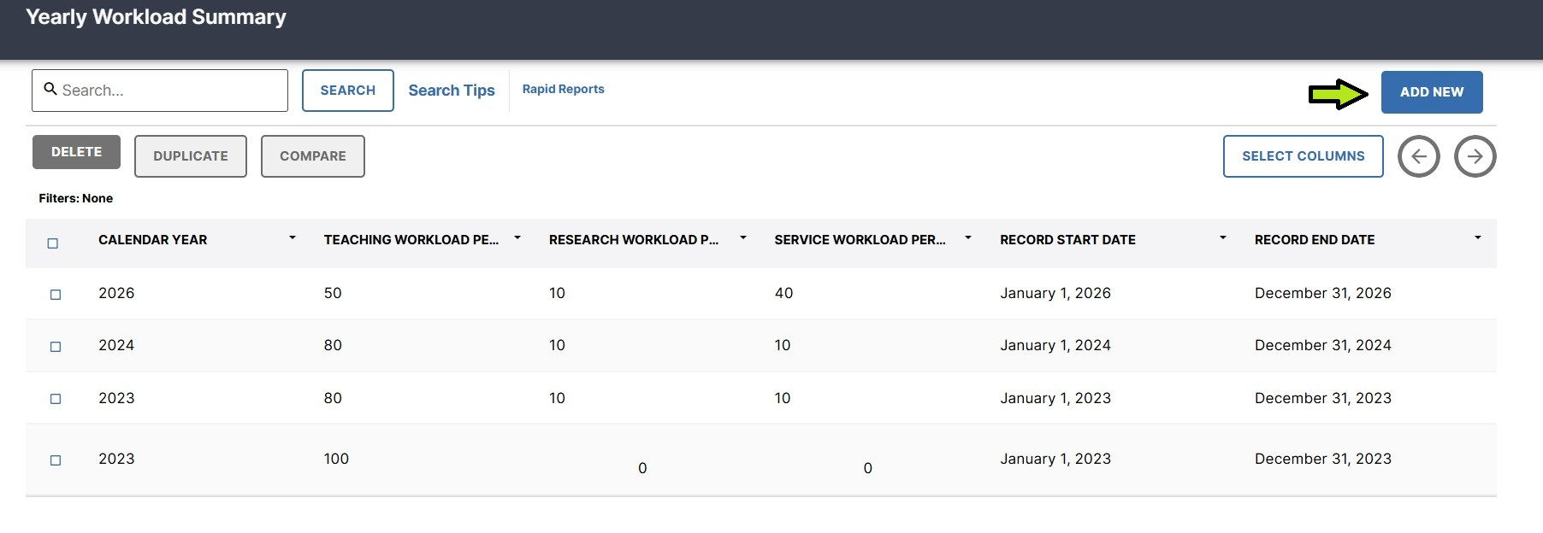

4) Enter the appropriate Calendar year.

5) Enter the workload percentages in the appropriate boxes.

6) Click ‘Save’

