Search Committee Member Access and Applicant Review

In Careers, only persons identified for the roles of Hiring Manager or Committee Member for a specific posting may access the applicant pool for that posting. Note: Only Hiring Managers can change the status of an application.

Application Review

- Log in to OneUSG Connect when you are ready to begin.
- On the Employee Self Service screen, select the Recruiting Self Service tile.
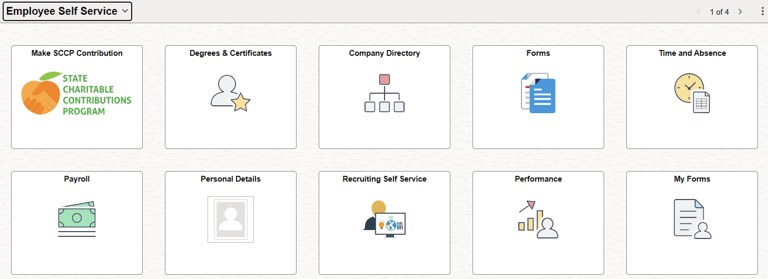

- Access your available job postings in OneUSG Connect through Recruiting Self-Service. On the Recruiting Self Service screen, select the Search Job Openings tile.
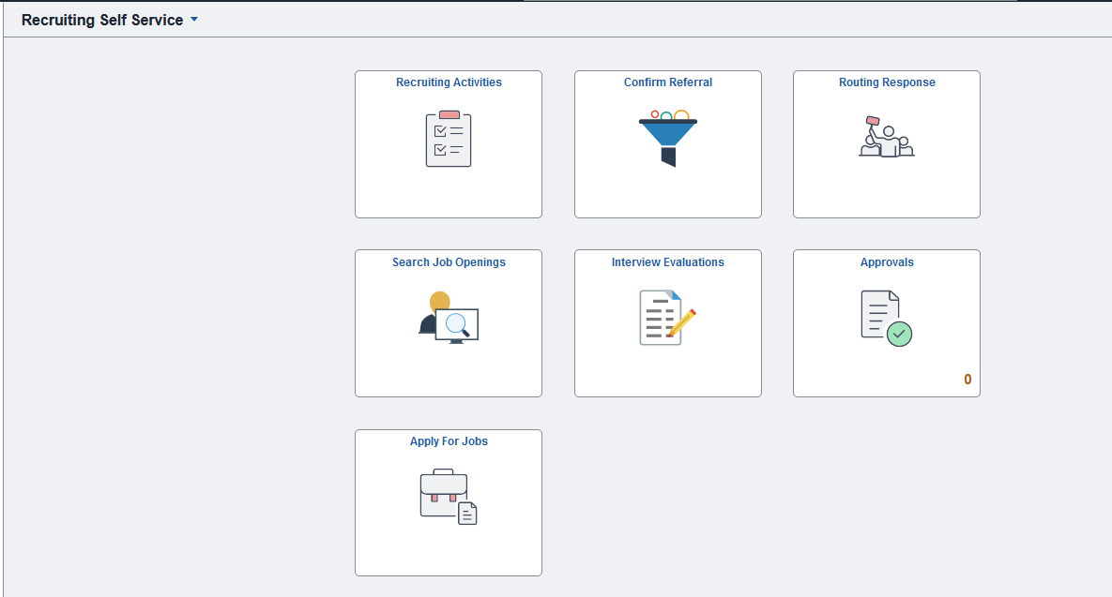

- On the Search Job Openings screen, the Status defaults to “Open” and all other fields remain blank. Simply click the green “Search” button to obtain a list of all openings to which you are associated and have access.
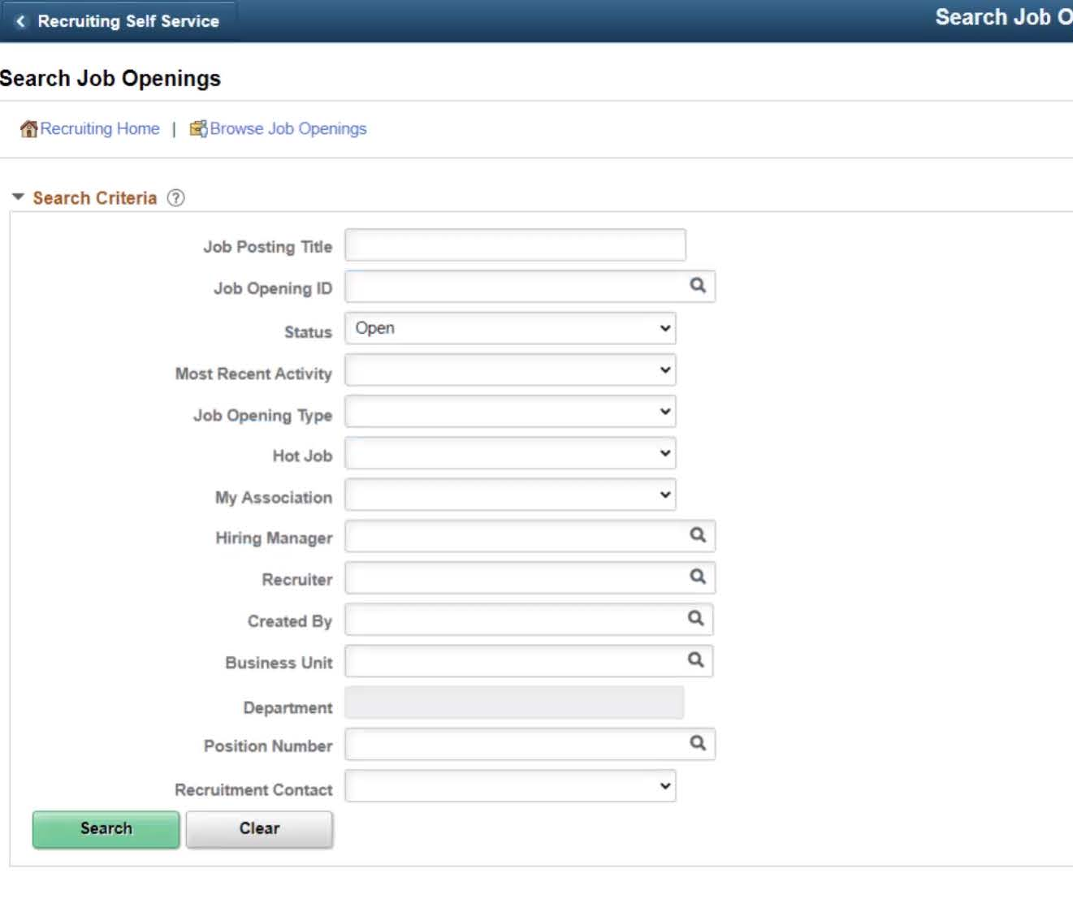

- Click on the Job Opening title for the posting you wish to see applications.
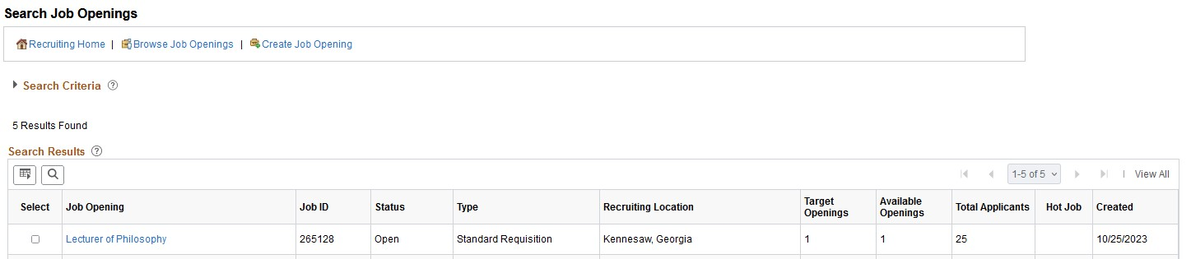

- Here you will find a list of all applicants who have applied for the position. NOTE: Only 25 applications will be visible unless you choose the “View All” option above “Other Actions”.
  - Click on the Application icon to bring you to the Manage Application screen. Here you have access to the application and any required or optional attachments, such as cover letters, curriculum vitae, transcripts, references, etc.
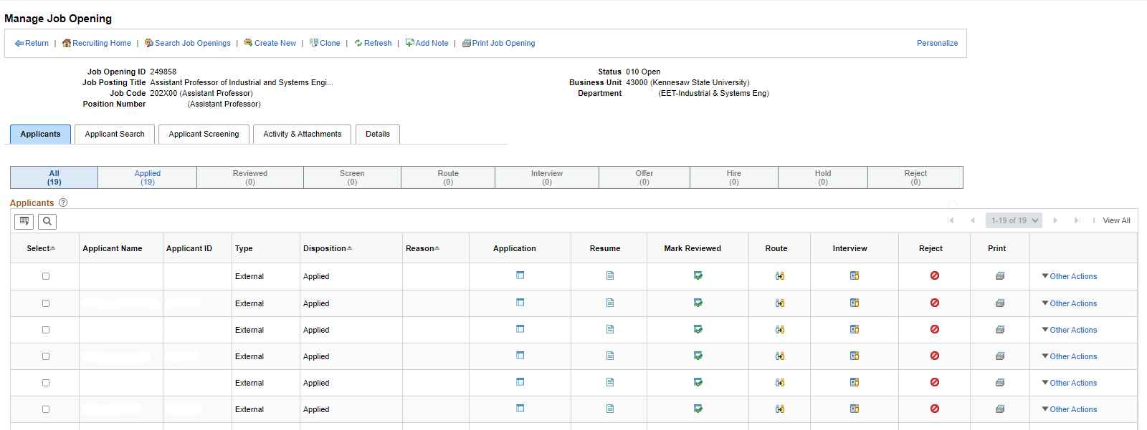

NOTE: There may be multiple pages of attached documents so you may need to scroll all the way to the right of the screen and choose View All.
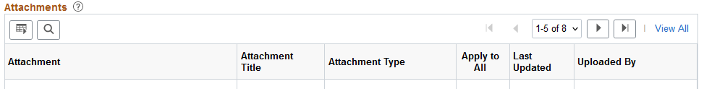

- As applications are reviewed, their status should be changed to Reviewed by the Hiring Manager. The Hiring Manager and the search chair should work out a process so that the Hiring Manager can change the statuses in a timely manner.

