Part-Time And Limited Term Faculty Hiring Process
  - Hiring Manager: Preparing the Job Offer

Once an applicant has been selected for hire, Hiring Managers must navigate to that applicant via the Job Posting.

CENTRAL REPOSITORY
      - Upload applicable documents listed below in the Activities and Attachments tab in OneUSG Careers per the Faculty Search Guidelines. User guides for the central repository can be found on the Faculty Affairs Hiring Policies and Guidelines website.
        - application materials from all candidates, including letters of application or application forms, curriculum vitae or resumes, academic transcripts, samples of writing or publications, and reference letters (No Action Needed - already in the system)
        - job descriptions (No Action Needed - already in the system)
        - position announcements, (college/department advertising)
        - approval documentation to initiate the position search (PAF for LT Only)
        - candidate lists (telephone/virtual and campus interview lists)
        - faculty search committee memoranda (summary only, if applicable)
        - evaluation rubrics and scoring sheets for applicants (justification for hiring this person) For multiple hires use KSU_Job ID #_Recommendations_APPLICANT’S LAST NAME
        - interview questions (including those for telephone and face-to-face interviews) and notes
        - telephone reference check questions and notes (summary only)
        - itineraries of finalists invited to campus
        - Search process trainings

NOTE: Welcome letter cannot be sent out without Central Repository information uploaded.

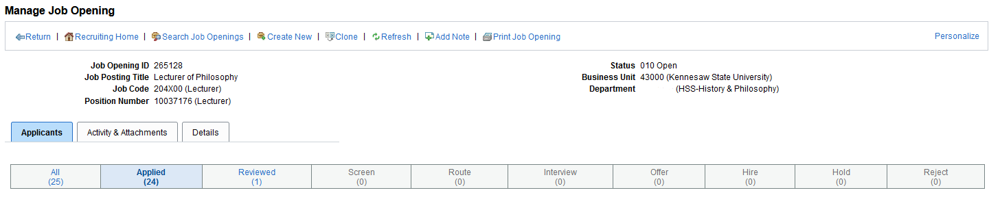

Faculty Part-Time And Limited Term Job Offer Process

- Before extending the verbal offer, hiring managers must seek approval by the Dean. Once verbal offer approval is granted, the verbal offer is extended by the hiring manager to the applicant outside the electronic system.
- If verbal offer is accepted, hiring manager will prepare the job offer in the system. (Application must be at the Interview Disposition)
Moving applicant to Interview
- Select Other Actions
- Select Recruiting Actions
- Select Edit Disposition
    - Select Reviewed
- Start over from “a” above
    - Select Interview
Prepare Job Offer
- Select Other Actions
- Select Recruiting Actions
- Select Prepare Job Offer

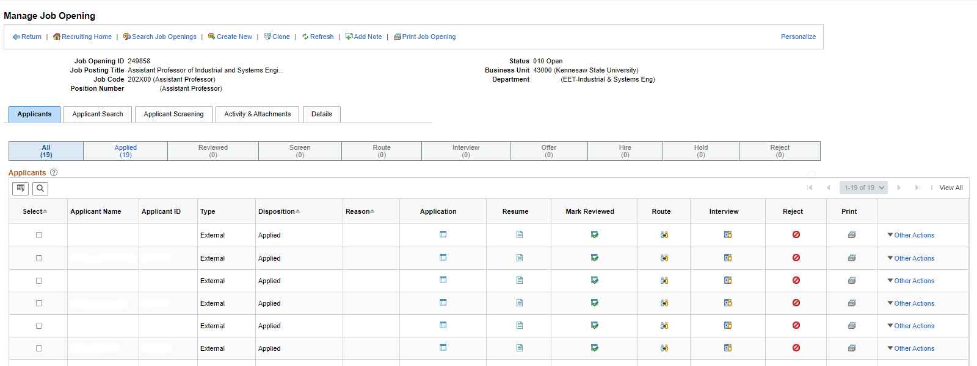

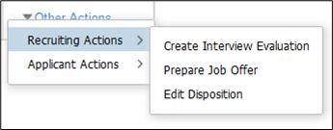

- Complete the full Job Offer including the following:
  - Official start date (Fall = 8/1; Spring = 1/1)
  - Offer expiration date (make the same as start date)
  - Comments Box – For limited term, fill in final rank and correct position number. Also, enter any special information you need to share.
  - Complete the Job Offer Components section as listed below

Job Offer Components | For Part-Time | For Limited Term
Components | Base Pay | Base Pay
Offer Amount | Department’s per credit hour rate for highest degree earned | Actual offer dollar amount
Payment Mode | Cash | Cash
Currency | USD | USD
Frequency | Hourly | Annual

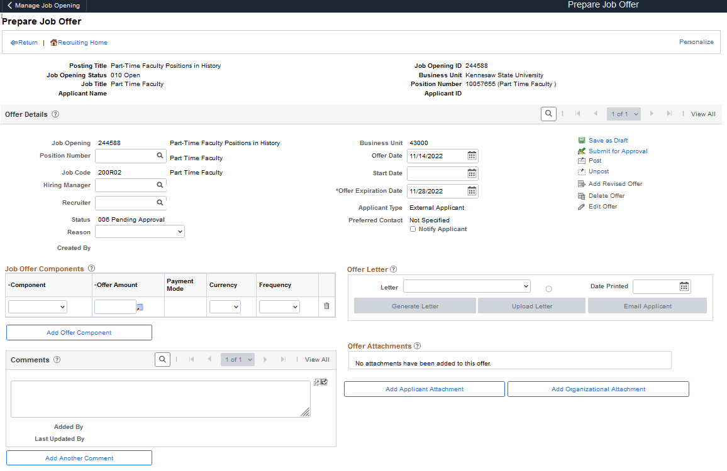

- Once you have completed your job offer preparation:
  - Save as a draft and review the information
  - Select Edit Offer
  - Select Submit for Approval

Please Do Not edit the job offer after it has been submitted. Work with your Faculty Coordinator if changes are needed. The offer will not return to the hiring manager.

