Applicant Review And Management For Faculty Searches
  - Hiring Manager: Transitioning Applications during Review Process

In Careers, only persons identified for the roles of Hiring Manager or Committee Member for a specific posting may access the applicant pool for that posting.
Notes:
- Only Hiring Managers can change the status of an application.
- Only committee members who are employees of KSU will have access to the Careers portal.

Application Review

- Access your available job postings in OneUSG Connect through Recruiting Self-Service. On the Recruiting Self Service screen, select the Search Job Openings tile.

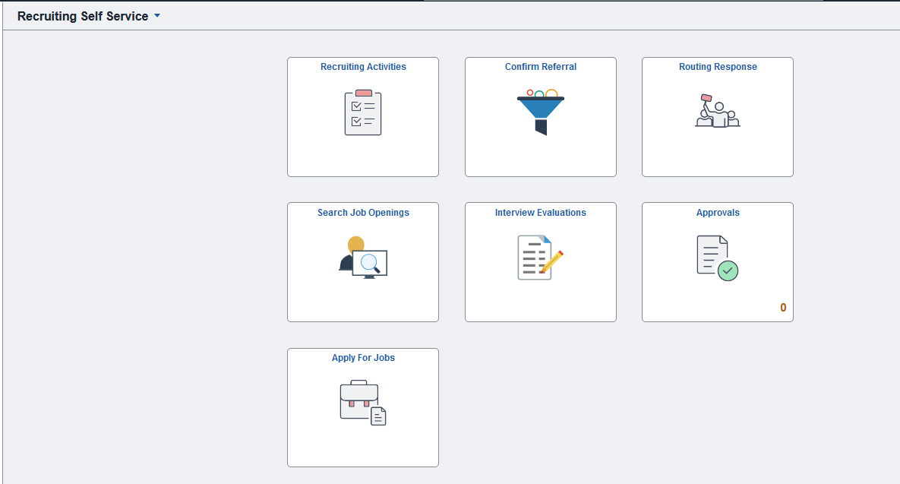

- On the Search Job Openings screen, the Status defaults to “Open” and all other fields remain blank. Simply click the green “Search” button to obtain a list of all openings to which you are associated and have access.

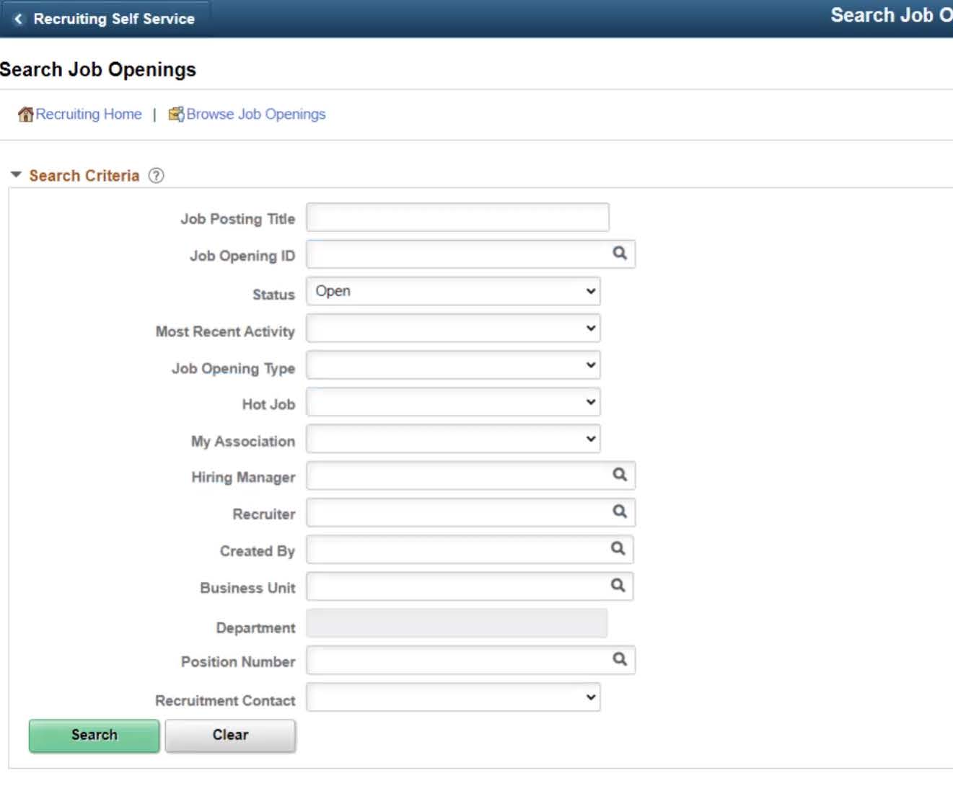

- Click on the Job Opening title for the posting you wish to see applications.

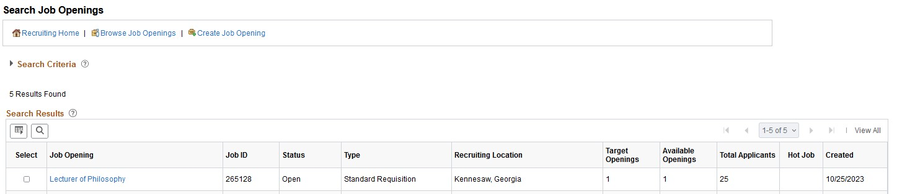

- Here you will find a list of all applicants who have applied for the position. NOTE: Only 25 applications will be visible unless you choose the “View All” option above “Other Actions”.
  - Click on the Application icon to bring you to the Manage Application screen.
    - Here you have access to the application and any required or optional attachments, such as cover letters, curriculum vitae, transcripts, references, etc.
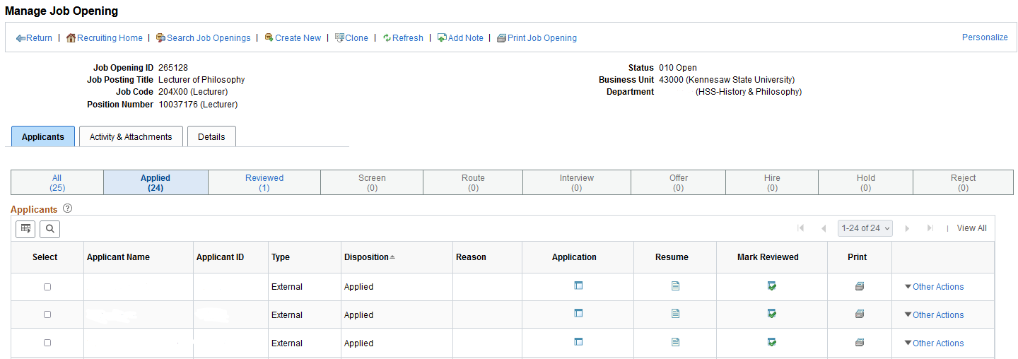

NOTE: There may be multiple pages of attached documents so you may need to scroll all the way to the right of the screen and choose View All.
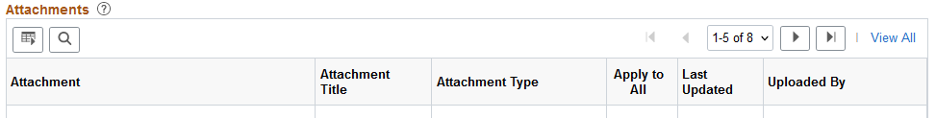

- As applications are reviewed, their status should be changed to Reviewed by the Hiring Manager. The Hiring Manager and the search chair should work out a process so that the Hiring Manager can change the statuses in a timely manner.

After they are moved to Reviewed they can then move to Interview, or be Rejected if they do not meet minimum qualifications. Instructions for rejecting applications are in a separate section below.

There are two ways to mark application as Reviewed:
- On the application row
  - Click the Mark Reviewed icon on the application row.

- Using the Other Actions drop down
- Click the box next to the applicant’s name to highlight the row
- Select Other Actions
- Select Recruiting Actions
- Select Edit Disposition
    - Select Reviewed. This must be done before any application can be moved to Interview or be rejected.

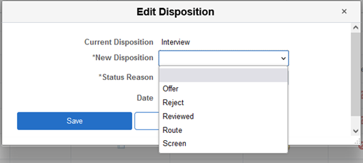

- Move applications to Interview after the applicant has agreed to be interviewed.
- Click the box next to the applicant’s name to highlight the row
- Select Other Actions
- Select Recruiting Actions
- Select Edit Disposition
  - Select Interview

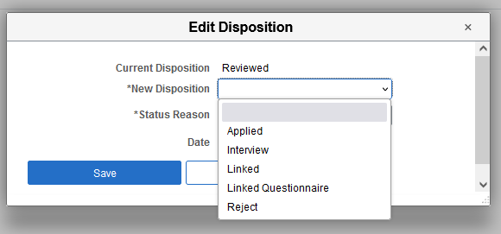

Job Offer Management And Closeout

Once an applicant is selected for the position, it is time to prepare the job offer in the system. Please refer to the applicable job aid on the Faculty Affairs Hiring Policies and Guidelines webpage for preparing job offers.

Rejecting Applications

Move applications to Reject as you review them if they do not meet the minimum qualifications and reject those remaining when a job offer is accepted. You may keep your top three candidates in the pool in case your first choice does not work out. Any remaining applications will automatically be rejected with the reason, Hired more qualified candidate, when the job offer and application status is moved to Hired.

NOTE: It is very important to choose the appropriate Status Reason for the rejection because this is part of our EEO state mandated reporting.

There are two ways to move the applications to Reject:
- On the application row
  - Choose the Reject icon on the application row
  - Choose the appropriate dispensation reason per the table in the Appendix

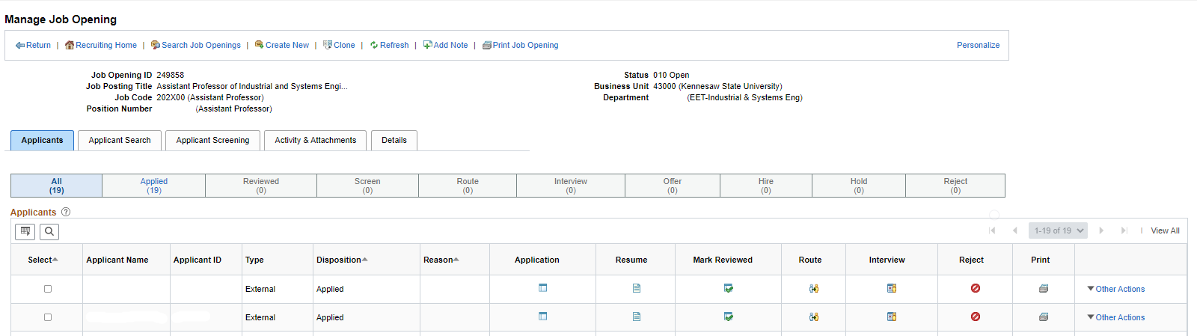

- Using the Other Actions drop down
- Click the box next to the applicant’s name to highlight the row
- Select Other Actions
- Select Recruiting Actions
- Select Edit Disposition
  - Select Reject
  - Choose appropriate dispensation reason per the table in the Appendix

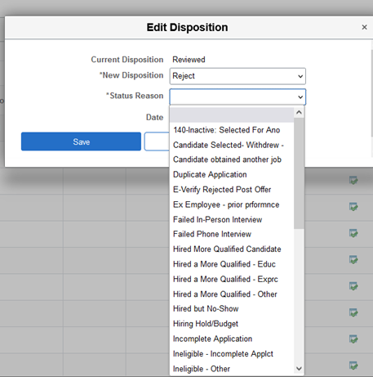

See Appendix for appropriate dispensation Reason choices.

Moving Applications In Bulk

This should only be done when the reason for rejection is truly the same for each candidate.

- Select multiple applicants by clicking the box next to the applicants’ names on their row
- Click on the Group Actions dropdown
- Click on Recruiting Actions
- Choose Action
- Choose the appropriate Reason for the Rejection

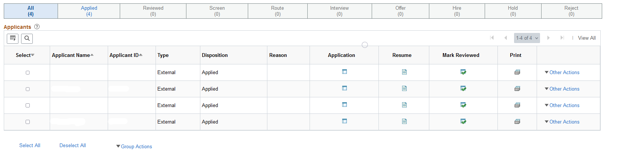

Appendix

Dispensing Applications

Initial Application Review Process
Who Takes Action | Application Status | Dispensation Reason  to Use | Notes
N/A | N/A | Applied | Initial Disposition when applicant applies.
HM - Moves to | Reviewed | Reviewed | Hiring Manager - as applications are reviewed
HM - Moves to | Reject | Screening - Failed Min Quals | Hiring Manager - does not meet minimum qualifications or application is not complete
HM - Moves to | Reject | Unable to Contact/Make Offer | Hiring Manager - If applicant cannot be reached for an interview.
N/A | N/A | Withdrawn | Automatically moves applicant to this when they withdraw from consideration.

Interview Process
Who Takes Action | Application Status | Dispensation Reason  to Use | Notes
HM - Moves to | Interview | Interview | Hiring Manager - After applicant agrees to telephone and/or campus interviews
HM - Moves to | Reject | Interviewed - Not Selected
HM - Moves to | Reject | Hired More Qualified Candidate  After candidate is hired. | This is used for all applicants that qualified but were not chosen or interviewed. Move applications after offer is accepted. The Faculty Affairs Coordinator will notify the Hiring Manager.
HM or FA Recruiter - Moves all applications who met minimum qualifications to | Reject | Job Requisition Cancelled  (Used by Faculty Affairs only) | This is used when a search fails or when the posting is at the end of its term and no candidates were hired (PT). Email must be sent to facultysearches@kennesaw.edu to request posting cancellation for full-time postings.

Job Offer Process – Full-Time Faculty (Faculty Affairs and HR)
Who Takes  Action | Application  Status | Dispensation Reason | Notes
HM - Creates  Job Offer | Remains at  Interview | N/A | Comes to Faculty Affairs Coordinators (FAC) in  this disposition to start the job offer approval  process. Hiring Manager begins the job offer.

