WAVE Web Accessibility Checker

Brief Description
Anyone who has attempted to do legitimate research online quickly learns that not all sites are created equal. We tell our students that they need to do a little digging before using a website as a reference in order to ensure that it is an appropriate resource.
Generally, we use the same thought process to determine whether a website is an appropriate supplementary resource. However, while many sites have great content, if that content is not formatted properly, it may be completely inaccessible to students who are using a screen reader.
If your course uses external websites, there are tools you can use to verify that they were created with accessibility in mind. One of these tools is an accessibility checker created by WebAIM called the WAVE Web Accessibility Evaluation Tool. With this tool, you can quickly generate an accessibility report on any website to help you decide whether to use it in your course.
It’s helpful to remember that, unless the website you’re checking is your own website, WAVE will not enable you to correct these issues. It is an evaluation tool designed to inform you.

The WAVE Report
After you’ve run the report, WAVE will show you the number (and location) of:
- Errors (Red): Indicate potential issues that make parts of the site difficult or impossible to use
- Warnings (Yellow): Indicate potential issues that could make the site difficult to use
- Features (Green): Indicate a point in the site that has been correctly labeled or tagged for accessibility
- Structure (Blue): Indicate how the site as a whole has been structured using headings and styles to be more easily navigable

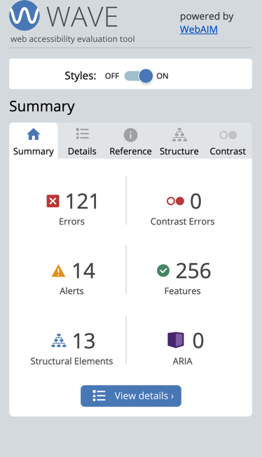
WAVE also provides a reference resource for understanding its symbols. To learn more about how to read the WAVE report, visit their WAVE Help Page.
This tool can be very useful for faculty linking to several external sites in their courses. It is important to remember that all sites may have some errors, and it is up to you to determine whether the errors found will limit or prevent students from accessing it.
Keep in mind, this checker is only applicable to websites. It cannot be used on third party tools.

Steps to Running a WAVE Check
There are two ways to run a WAVE accessibility check. After you run the check, review the errors to determine if the website is suitable to use in your course.

Method 1: Web-based check
- Navigate to WAVE Web Accessibility Evaluation Tool (webaim.org)
- Enter the URL for the site you would like to check in the available address bar under “Web page address:.”
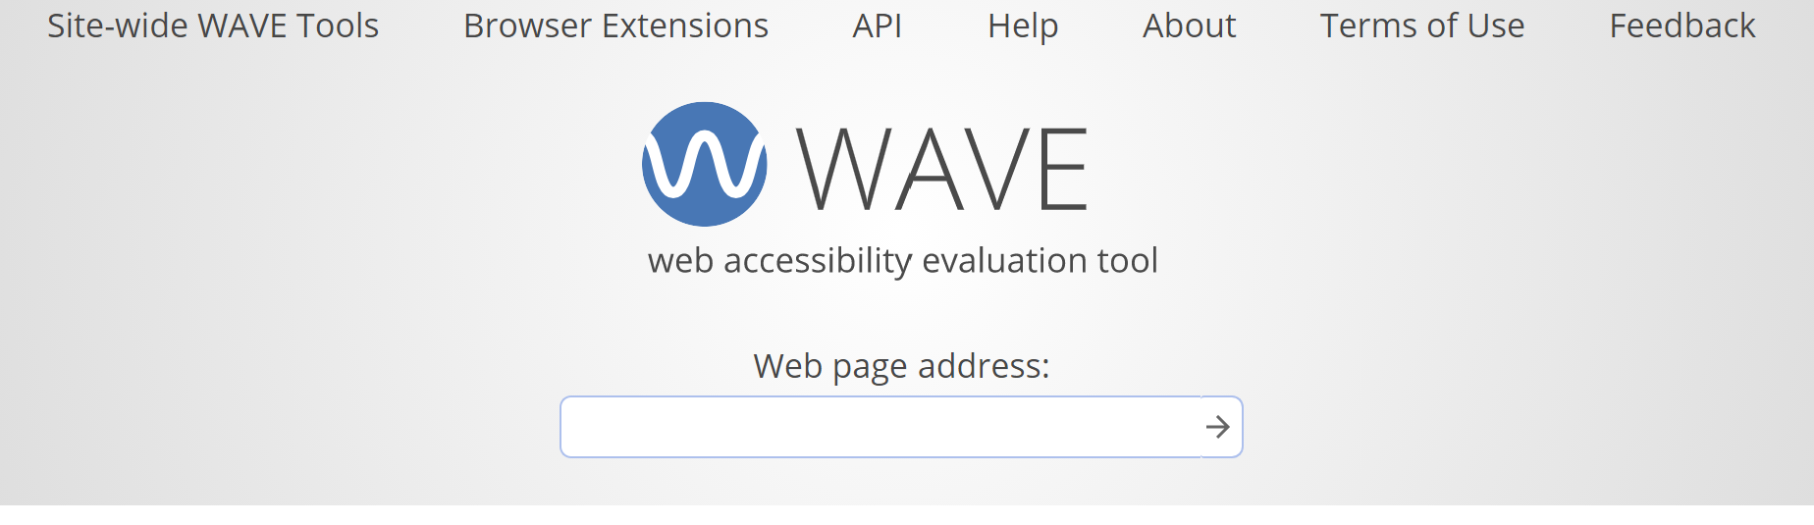
- Review the results for errors and determine whether the errors or alerts are significant enough to pose a problem and whether the features and structure are suitable.
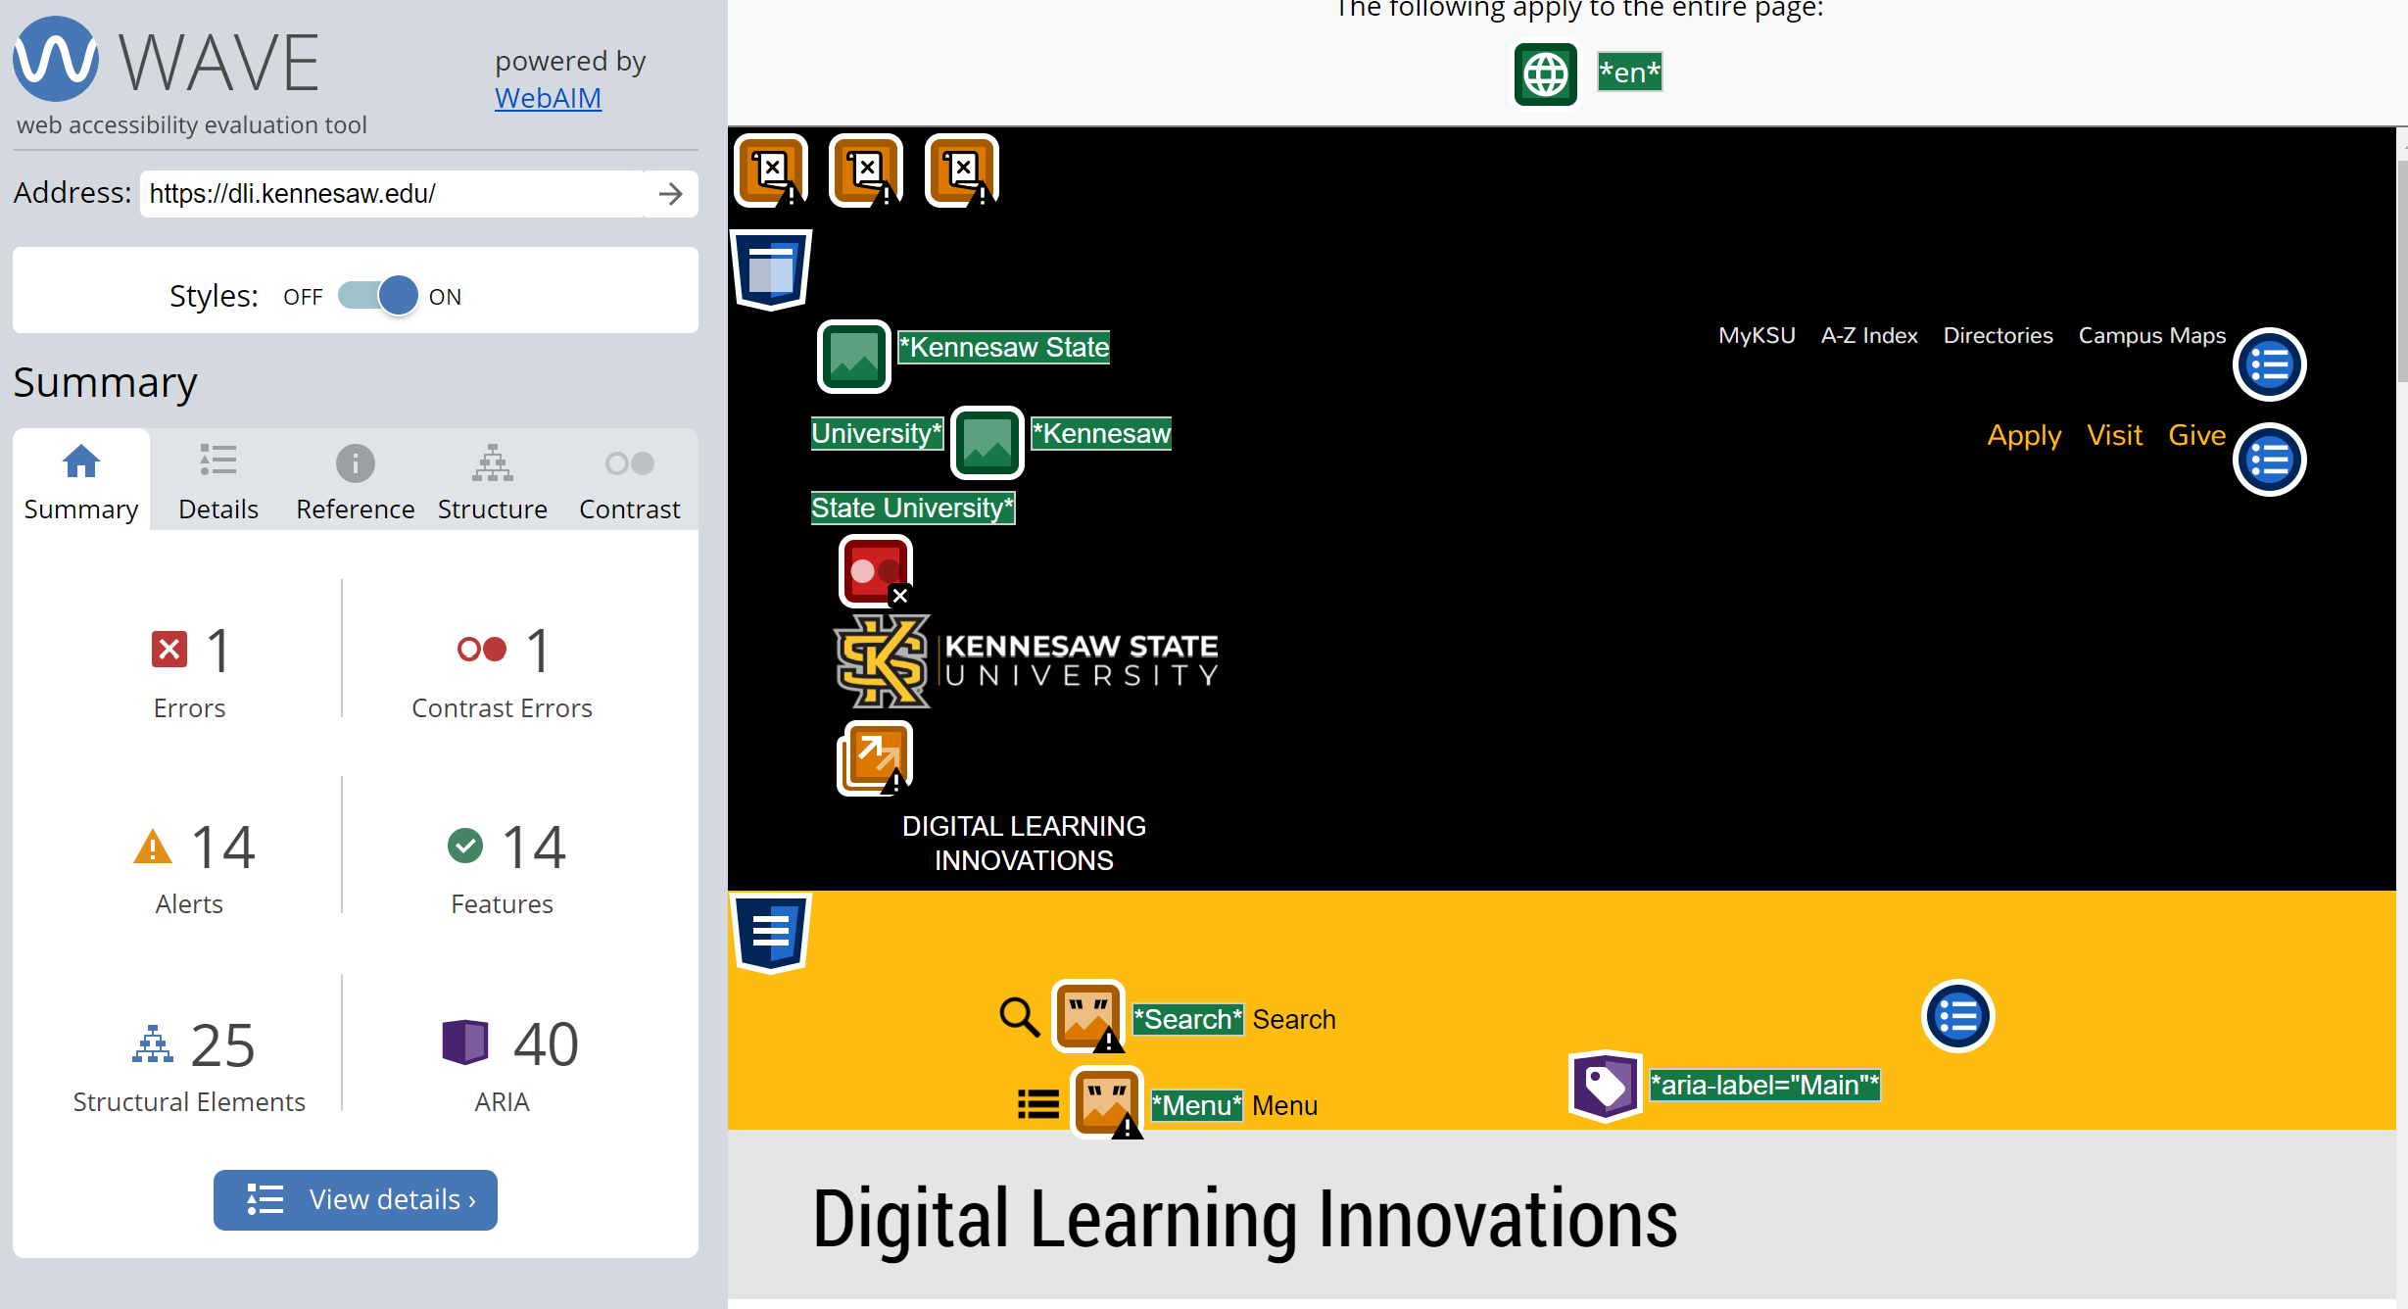

Method 2: Extension check

- Open the Google Chrome or Firefox browsers and add the WAVE extension for Chrome or Firefox from WAVE Chrome & Firefox Extensions (webaim.org)
- To check a site, click the WAVE extension icon to the right of your browser’s address bar.
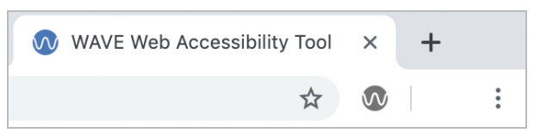
You may need to pin the WAVE extension to the address bar in Chrome for it to appear there. You can access the WAVE extension from the extension menu to pin it in Chrome. The menu looks like a puzzle piece.
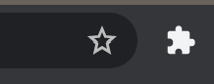

- Again, review the results for errors, adjustments, etc.
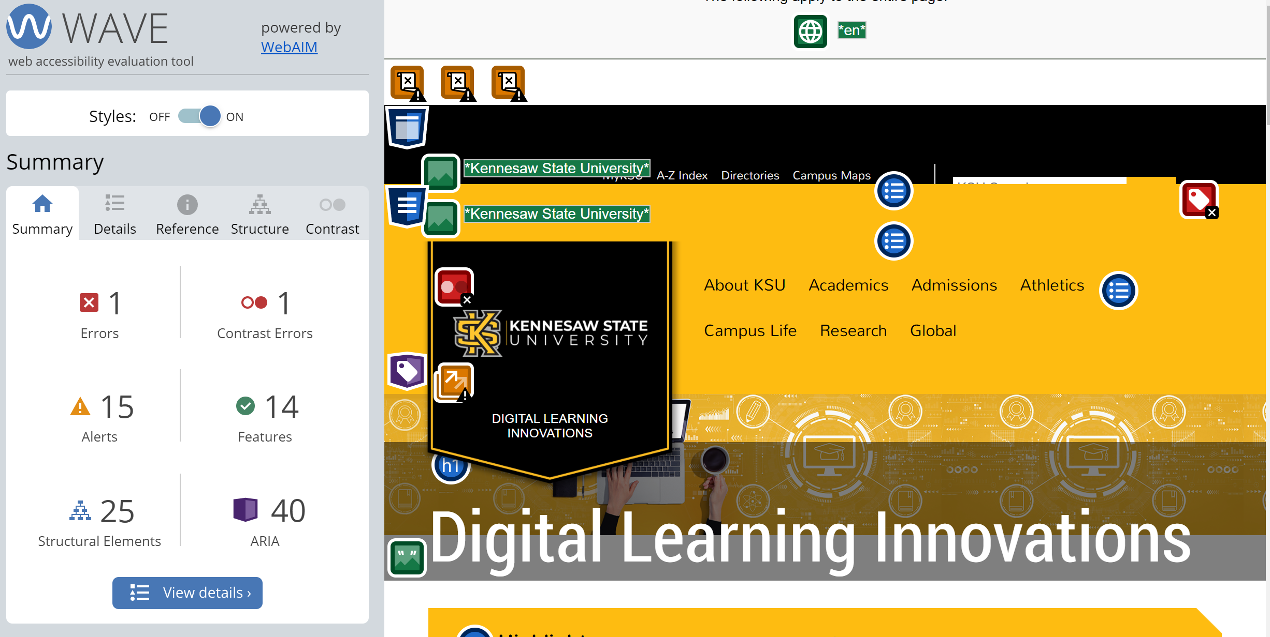

Get Help
Again, it’s vital to remember that WAVE is only an evaluation tool. It can help you determine how accessible a site is, but you will have to decide whether to use it after reviewing the report. If you’ve visited WebAIM's WAVE Help page but would still like more help using this tool, contact us through our one-on-one service request form.

