How to Turn Off Respondus Lockdown Browser for One Student
If you’re not sure how to turn off Respondus Lockdown Browser, instructions are provided by Digital Learning Innovations (DLI) below. Please feel free to contact DLI through the DLI Service Portal if you would like to explore other options for test security or need help with any settings described here.

To exempt specific students from the Respondus Lockdown Browser in order to use assistive technology to take exams in D2L, follow the following steps:

- Go to the Quiz tool in D2L Brightspace and click the arrow to the right of specific quiz. From the resulting drop-down menu, select Edit.
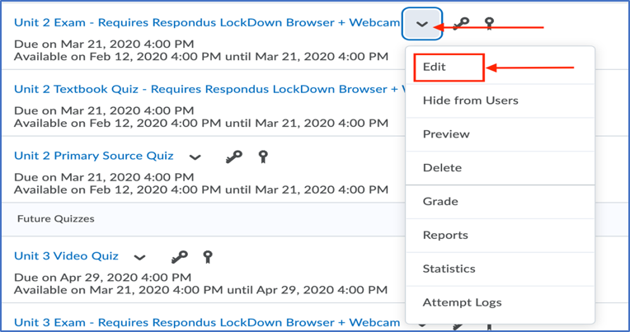
- Once you are inside the edit feature for your respective quiz or exam, click the Restrictions tab.
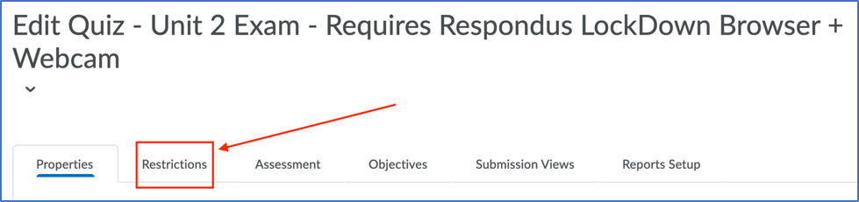
- Within the Restrictions tab, scroll down to the Special Access section. Then, click inside the option to Allow selected users special access to this quiz and click on the “Add Users to Special Access” button.
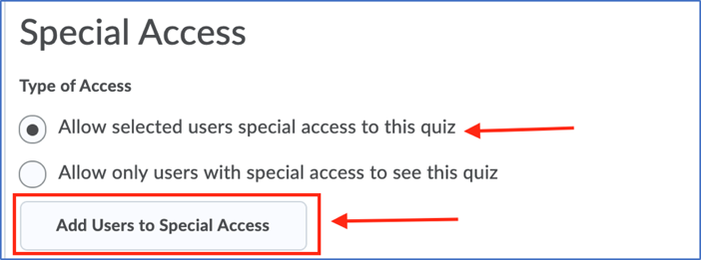
- On the Special Access page, check the box for Lockdown Browser (Not required to take this quiz), select the student(s) you are granting special access to, and click inside the Add Special Access option.
