Fixing SmartArt in PowerPoint for Accessibility
  - Image-heavy version

SmartArt is a great way to add some visual fun to your PowerPoint presentation, especially if you struggle with designing your own. Unfortunately, we have discovered it may cause an issue with screen readers and the information may be lost to disabled users. But there is a fix that allows you to keep the design and make it more accessible!
There’s also an easy fix where you right-click on the SmartArt and choose Convert to Text. That will change everything to a list. But you do lose the visual aspect.

If you wish to maintain the visual design, here are some basic instructions on how to do that. You can either do this as you build your slides out or you can do this on a previously created presentation.

Step 1: Open PowerPoint.

Step 2: Create your SmartArt object or locate a previously made SmartArt object.
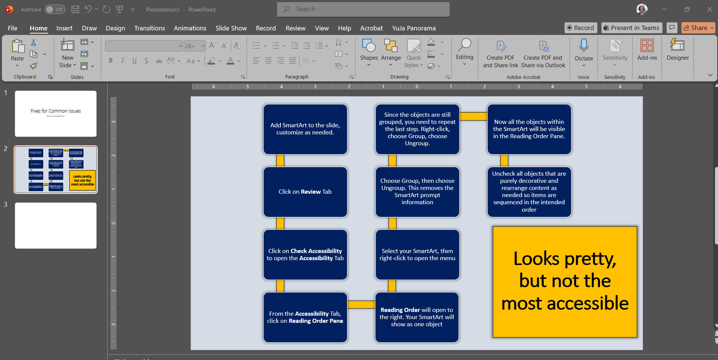

Step 3: Click on the Review Tab.

Step 4: Click on Check Accessibility.
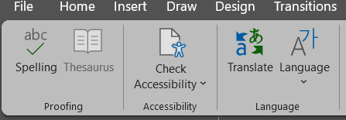

Step 5: Choose Reading Order Pane.
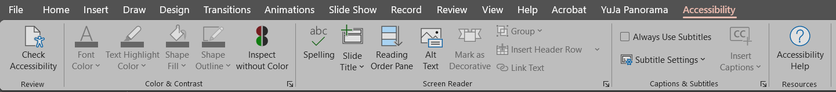

Step 6: The Reading Order Pane will open to the right. Your SmartArt will show as one object.
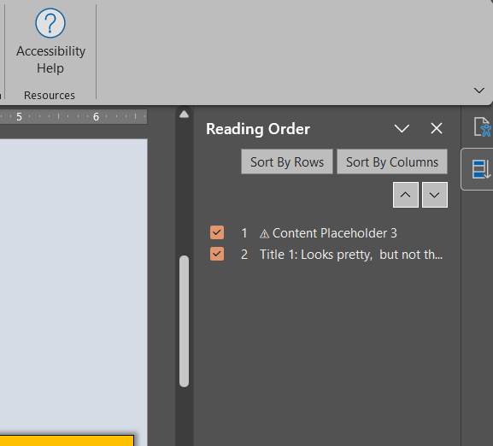

Step 7: Select your SmartArt, then right-click to open the menu.
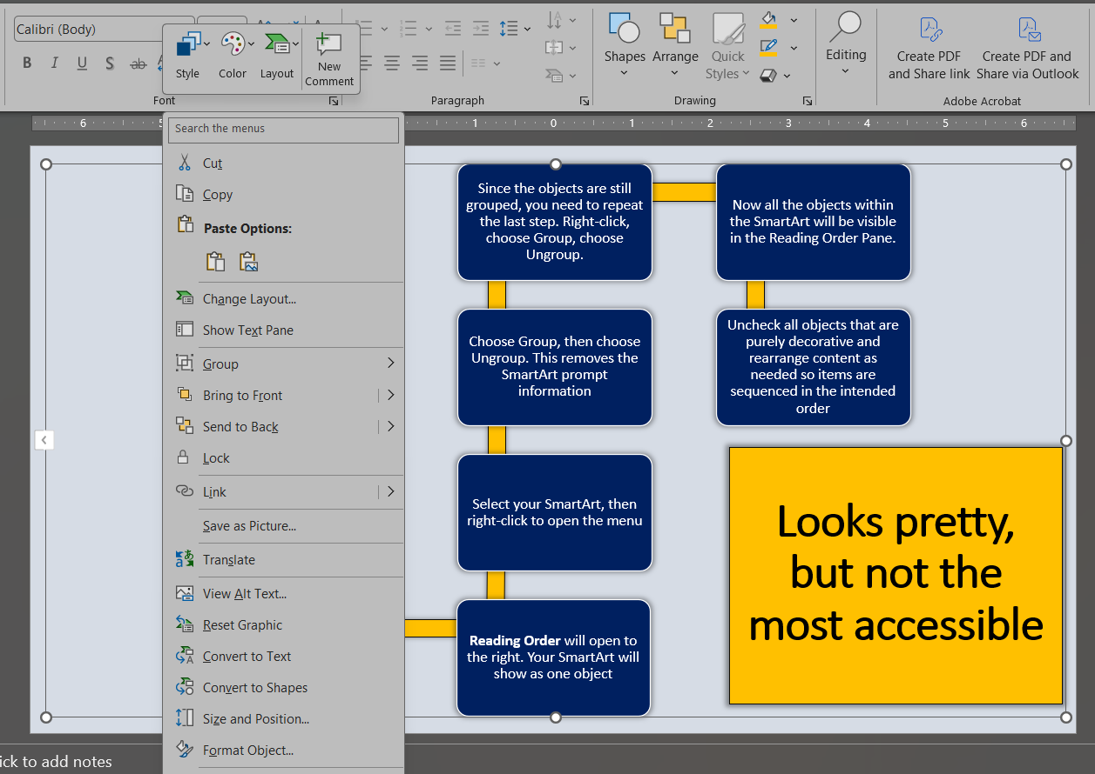

Step 8: Choose Group, then choose Ungroup. This removes the SmartArt prompt information.
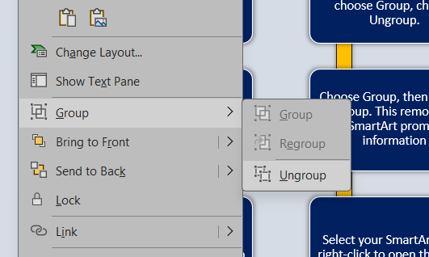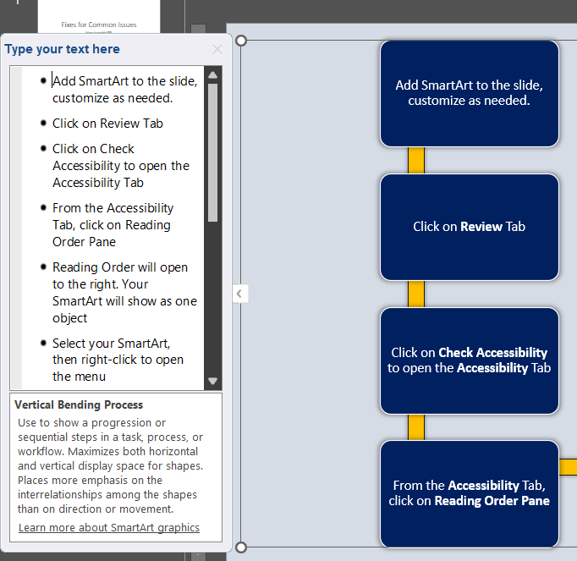

Step 9: Since the objects are still grouped, you need to repeat the last step. Right-click, choose Group, choose Ungroup.

Step 10: Now all the objects within the SmartArt will be visible in the Reading Order Pane.
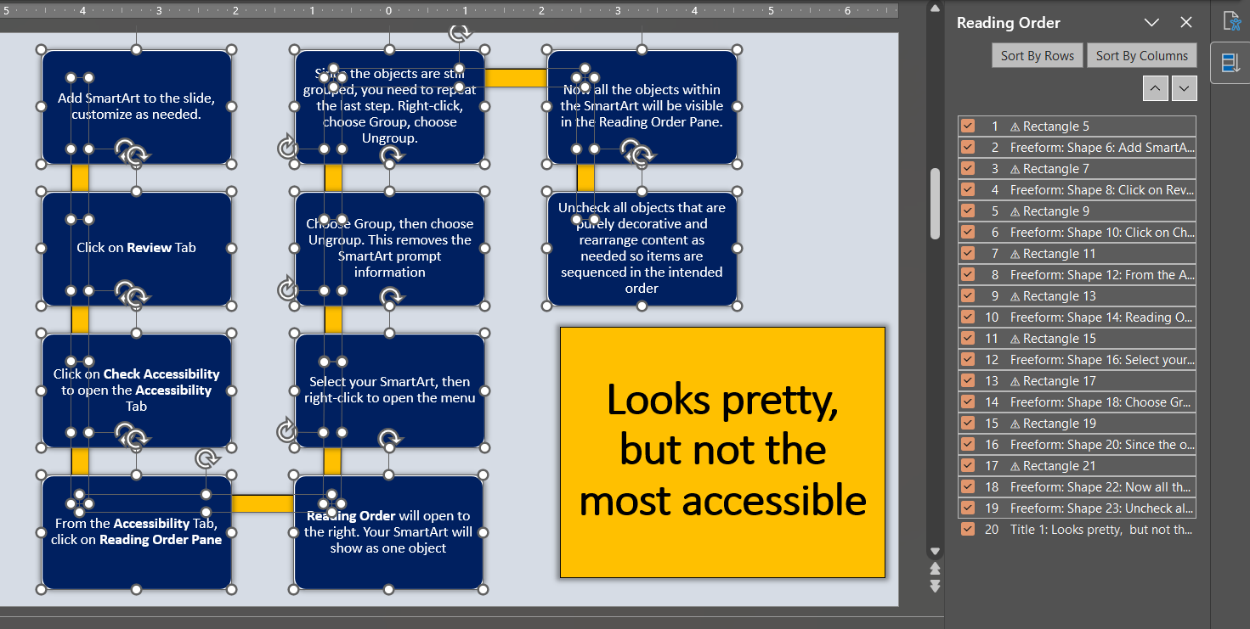

Step 11: Uncheck all objects that are purely decorative and rearrange content as needed so items are sequenced in the intended order.
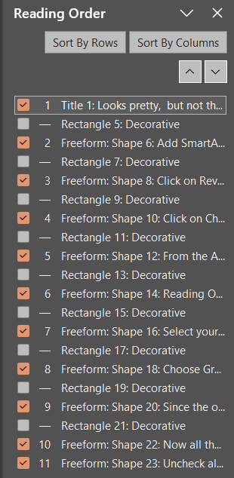
All the Rectangles that did not contain text were set as decorative (they were easy to spot because there was a warning triangle next to each indicating they were missing a description).
The title was also moved from the bottom position to the top. That way the title is read first but still gets to be situated in the bottom corner for aesthetics.

