How to Find and Complete Forms:

- Starting from the IMLeagues homepage
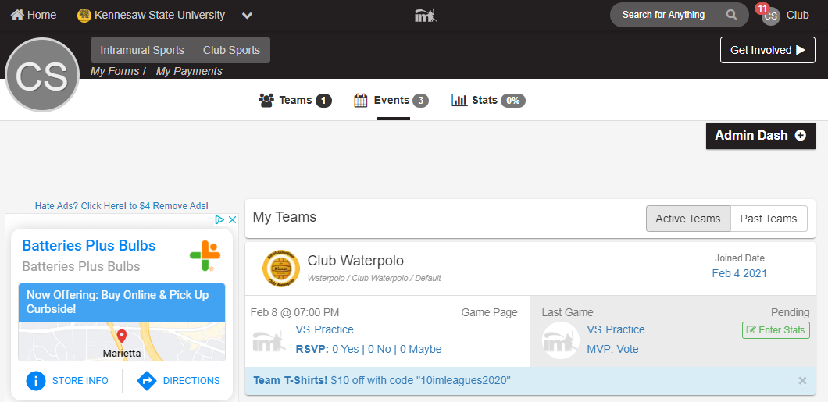
- At the top left of the screen click on “My Forms,” located in the black ribbon, under the Intramural Sports & Club Sports tabs
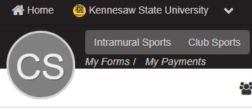

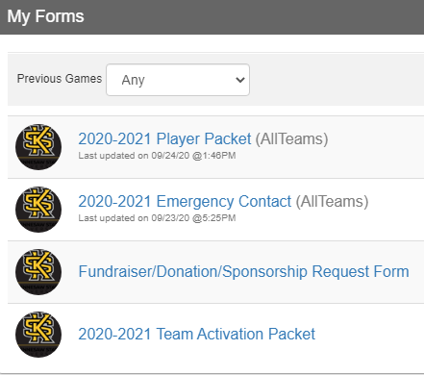
- There are several forms, choose desired from based on need:
- Player Packet – Mandatory for every participant
  - Must be completed annually
- Emergency Contact – Mandatory for every participant
  - Must be completed annually
- Fundraiser/Donation/Sponsorship Request Form – Officers only
  - Completed frequently throughout school year
- Team Activation Packet – Officers only
  - Must be completed annually

Additional Information:
- When filling out Player Packet use KSU email as noted in the form
- A Concussion baseline test is required to achieve an approved player packet for many activities, please reference the list provided in the Club Sports Manual. Concussions test can be taken at The Owl’s Nest: 3220 Busbee Dr NW, Kennesaw GA, 30144

If experiencing any difficulties, please direct questions to clubsports@kennesaw.edu

