How to Schedule Practices and Competitions in IMLeagues:

Note: Only club officers have the permission to add practices and competitions to the calendar
- Sign in and begin at the IMLeagues home page
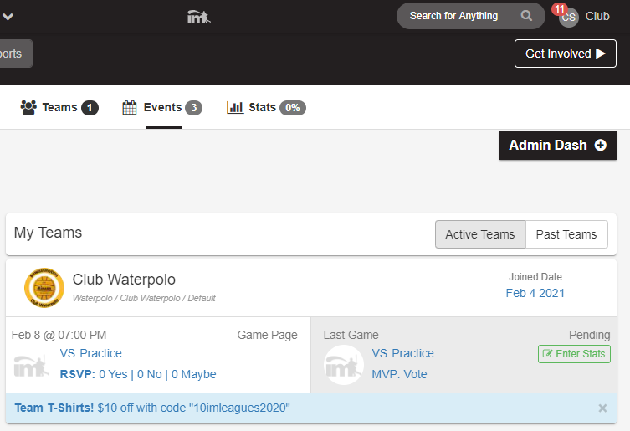

- Under the “My Teams” tab click on the desired team
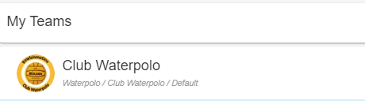

- Scroll down until you find the table labelled “Add New Game”. Click on the slider button as shown below.
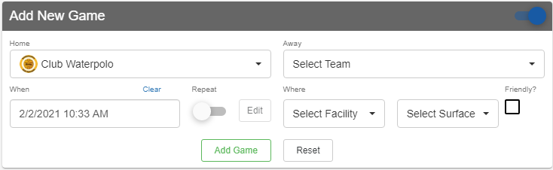
- Under the Away section:
  - Select the appropriate event type (e.g. practice, scrimmage, or event)
  - Or use “Type in Team Name” for competitions and name the opponent
- Select date & time of the event being scheduled
  - Click on the Repeat slider for weekly scheduled practices
- Select which facility and surface/room
  - Only on-campus options will show. For off-campus events, use the “Type in Facility” option
- Select “Add Game” once all information is entered
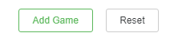

How to check in participants who attended (PC Version):

- Begin on Team page

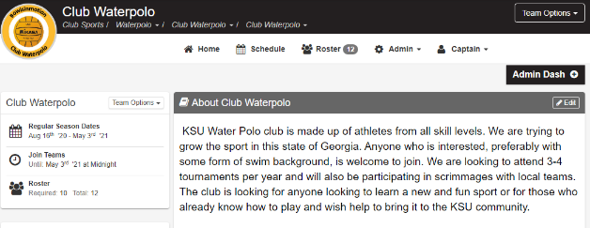

- Scroll down until you find the table labelled “Regular Season Schedule”
  - Locate the desired event and click the upside-down arrow
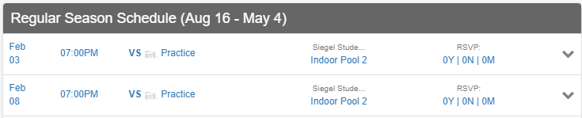

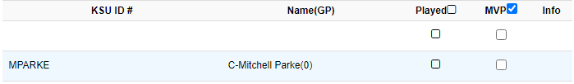
- Under ‘’Played’’ column, check who attended the event
KSU ID 1 Club Sport
KSU ID 2 Club Sport

- Scroll to the bottom of the roster list and click “Save”.

How to check in participants who attended (Mobile App):
1
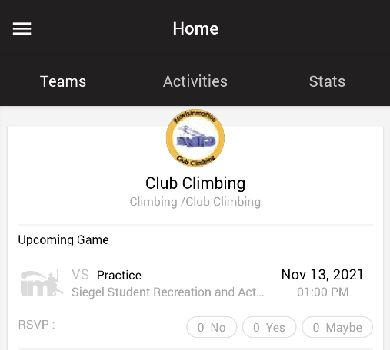
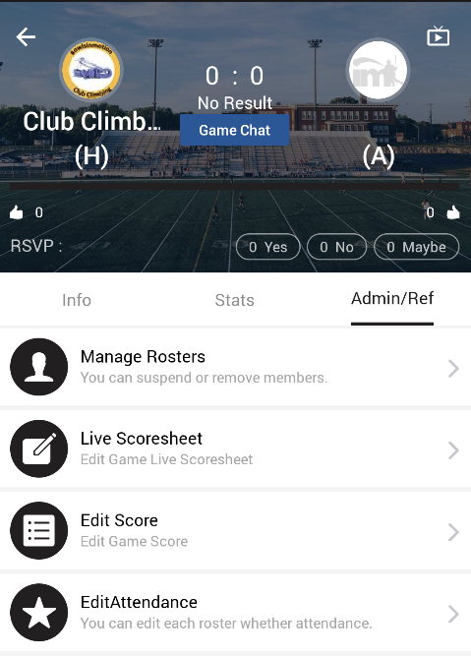
4

2
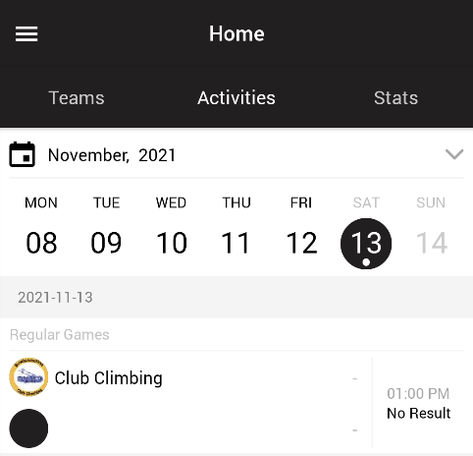

5
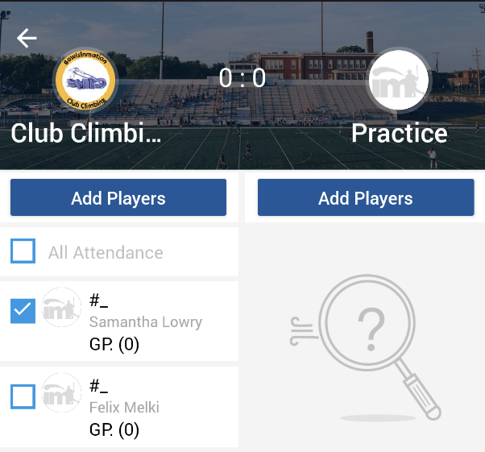
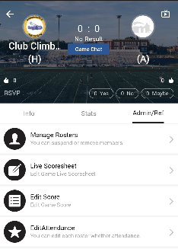
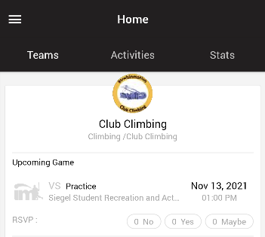
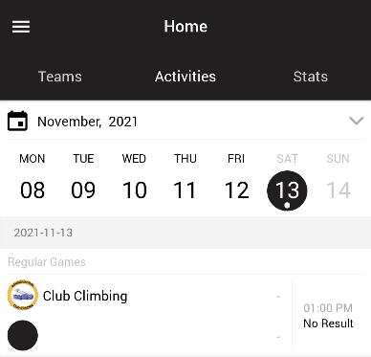

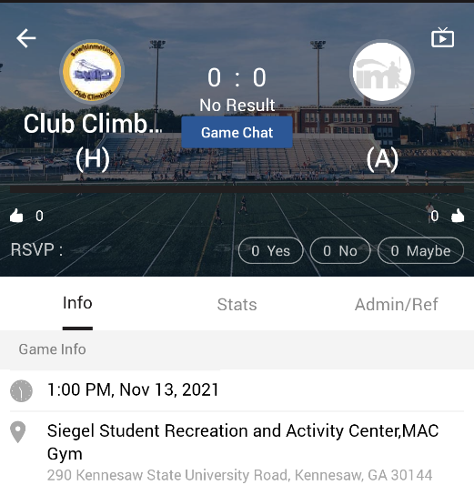
3
If experiencing any difficulties, please direct questions to clubsports@kennesaw.edu

