How to Manage Roster:

Inviting Members (PC Version):
- Begin at the IMLeagues home page
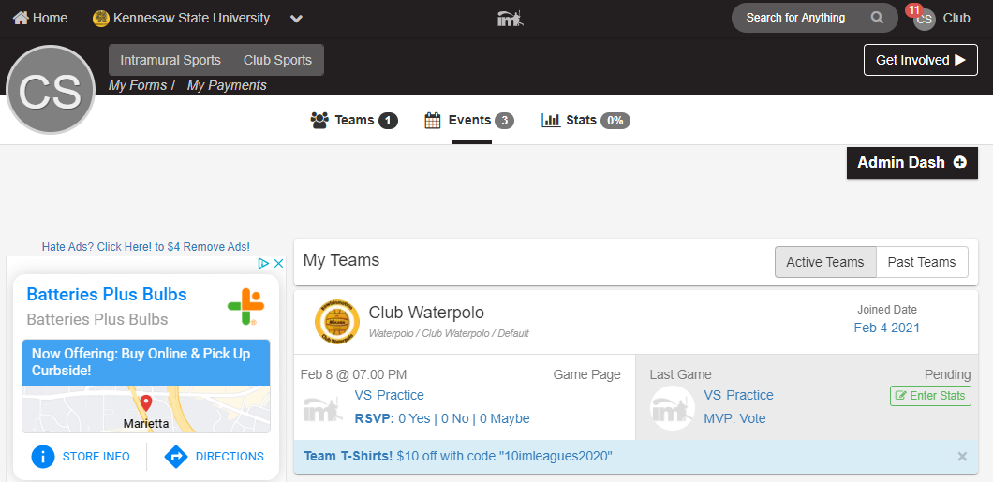
- Under the “My Teams” tab click on the desired team
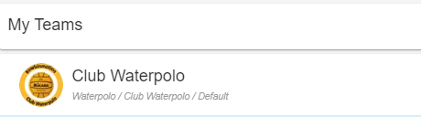
- Team Page will load
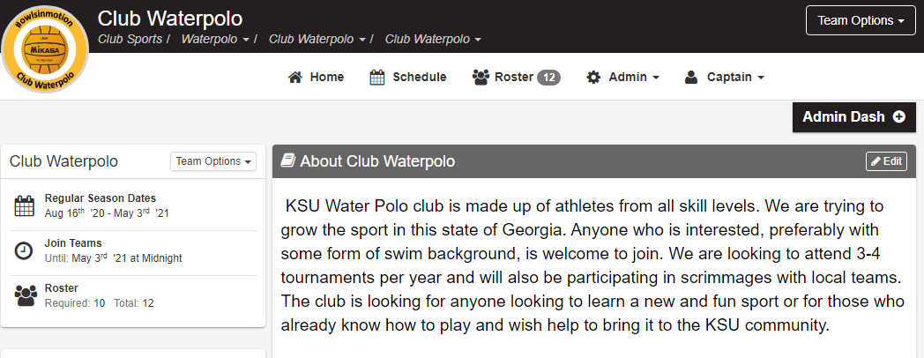
- Scroll down until the “Roster” heading is visible, click on the “Invite” button to the right of the Roster heading
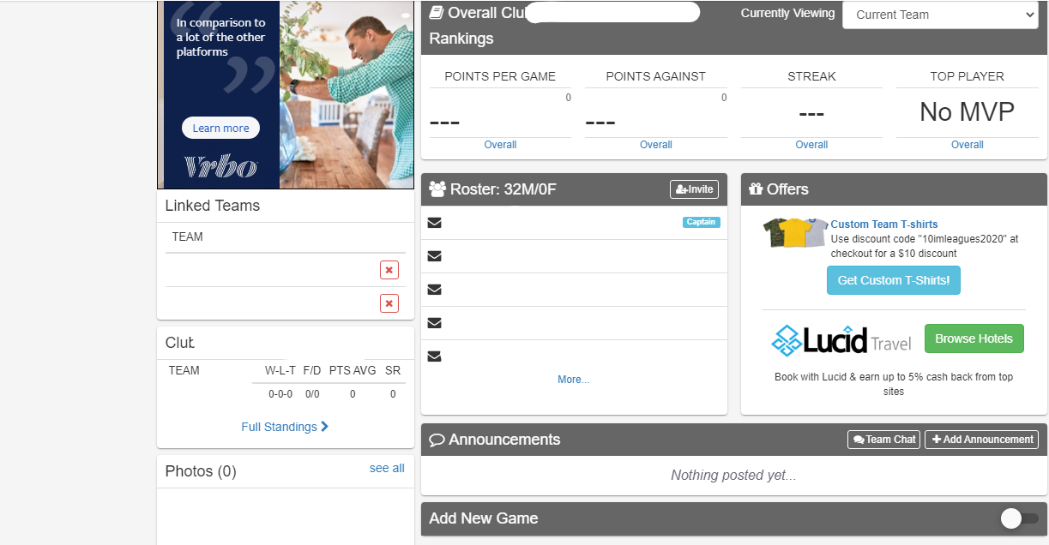
- Type in the search bar the individuals name or KSU email to search. Click on “desired name” and add to the queue
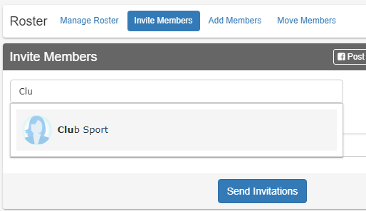
- Once all members have been added to the queue select “Send Invitations”
  - A notes box is available if any comments are desired
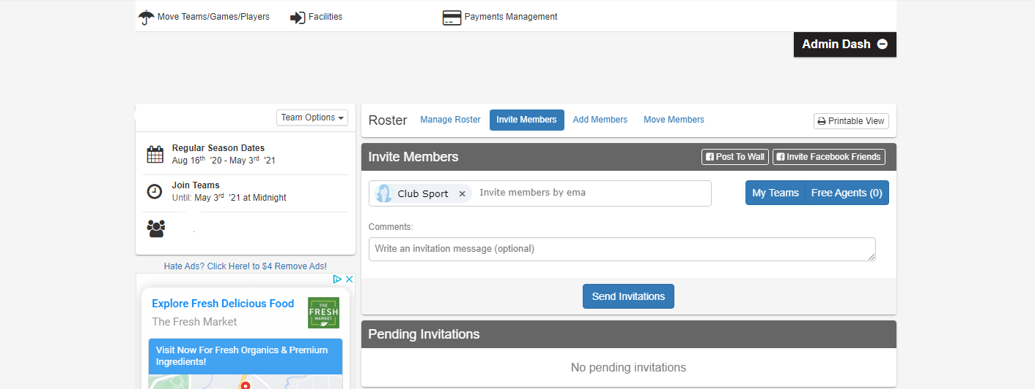

Inviting Members (Mobile App):

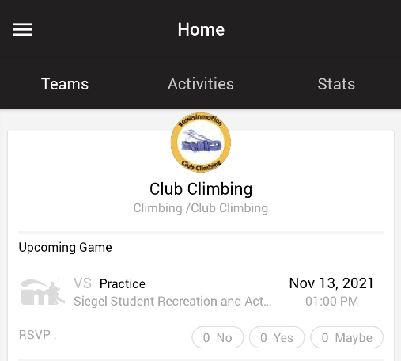
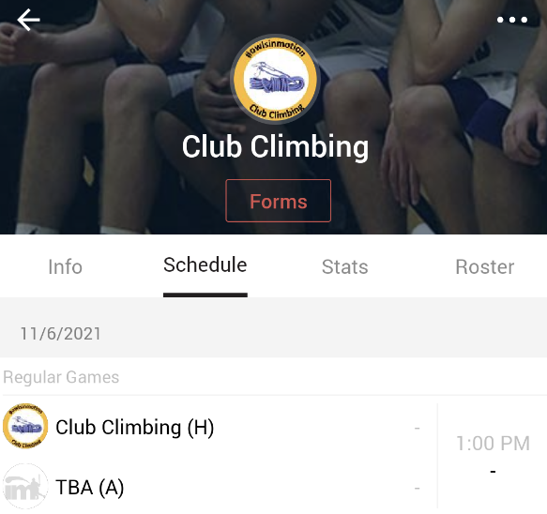
1
2

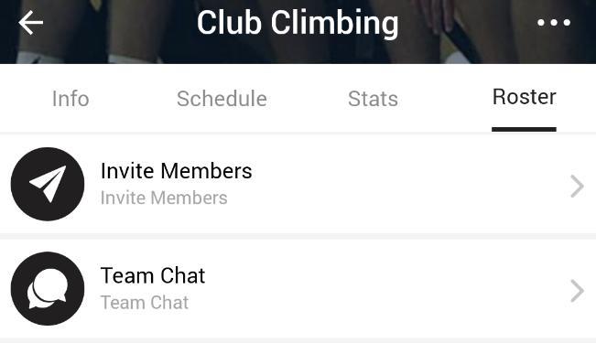
3

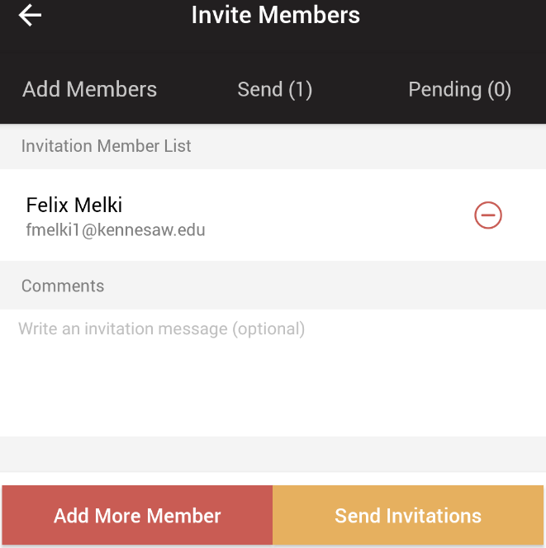
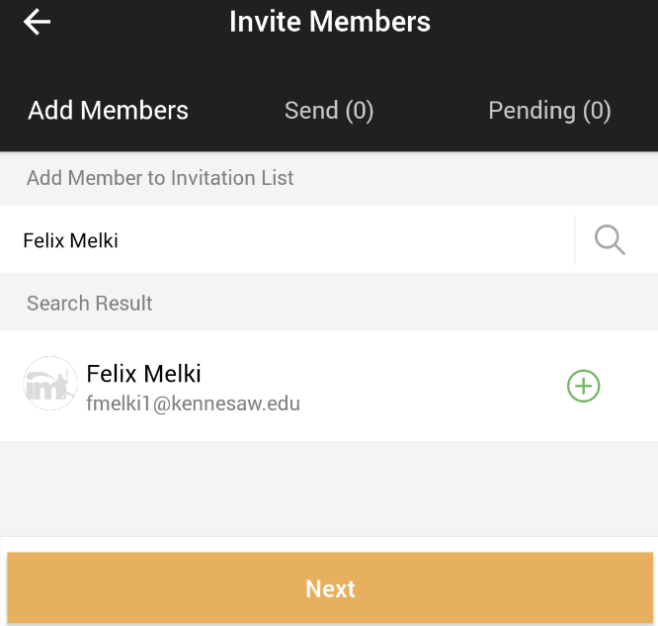
5
4

View a member’s emergency contact (only available on PC):
- Begin on Team Homepage; listed in step 2 above
- Scroll down until the “Roster” heading is visible, at the bottom of this section click on “More”
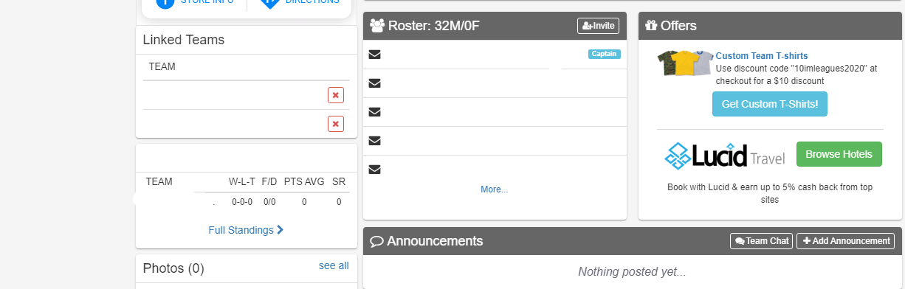
- Click on “Detailed” view option, located just under Roster tabs and Linked Teams button
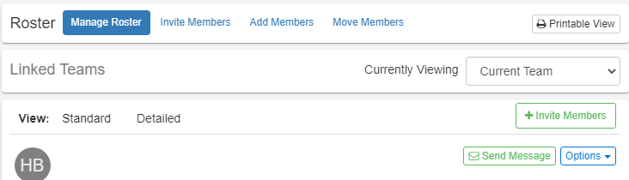
- Find the member of interest, in the list of documents section locate “2020-2021 Emergency Contact”
  - To the right of 2020-2021 Emergency Contact click on the “Options” button
  - A flyout menu will load, click on “View Form”
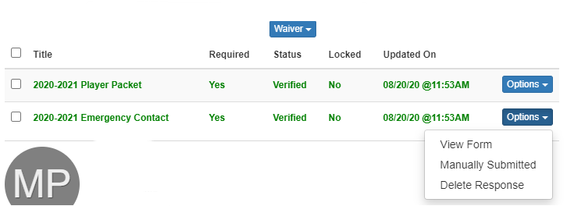
If experiencing any difficulties, please direct questions to clubsports@kennesaw.edu

