- Navigate to the KSU Sports and Recreation Membership Portal
- https://mysportsrec.kennesaw.edu/
- Click on “Club Sports”
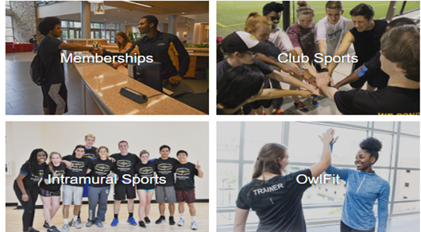
- Click on “KSU NetID and Password” and login in with KSU credentials
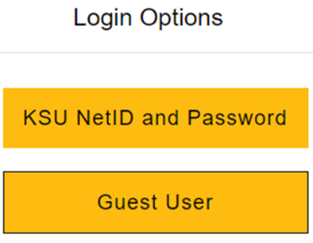
- If a student has not already signed a facility waiver you will need to scroll to the bottom and select accept on the waiver.
- Signing the waiver is common for first year students, the waiver must be signed before entrance is admitted to any Sports and Recreation facilities
- Click on the “IMLeagues” icon at the bottom of the screen
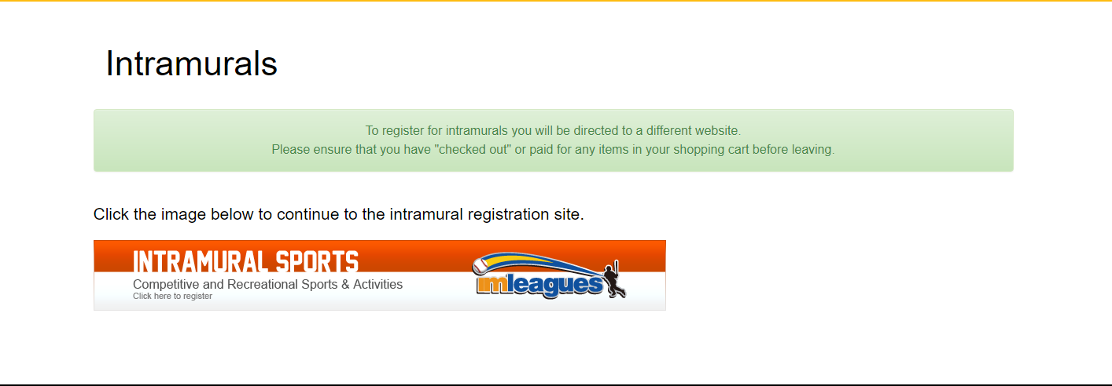
- Check contact information is correct on IMLeagues Software Registration Page
- First Name, Last Name, and Email address are automatically loaded into software via student account
- Fill out all remaining information: gender, year in school/grad year, primary campus, and birthdate
- Please utilize public gender identity
- Primary campus is utilized for demographic reporting
- Be sure to read and acknowledge the Terms and Conditions and select the Agree Terms and Conditions. Finally select “Complete”
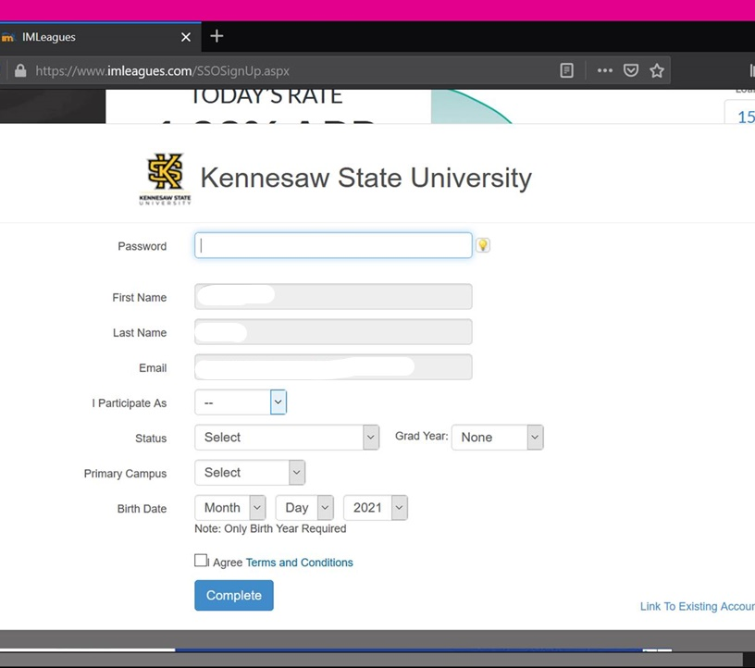
- Once account creation is complete, the IMLeagues homepage will load. This page will be the starting point for many of the remaining tutorials.
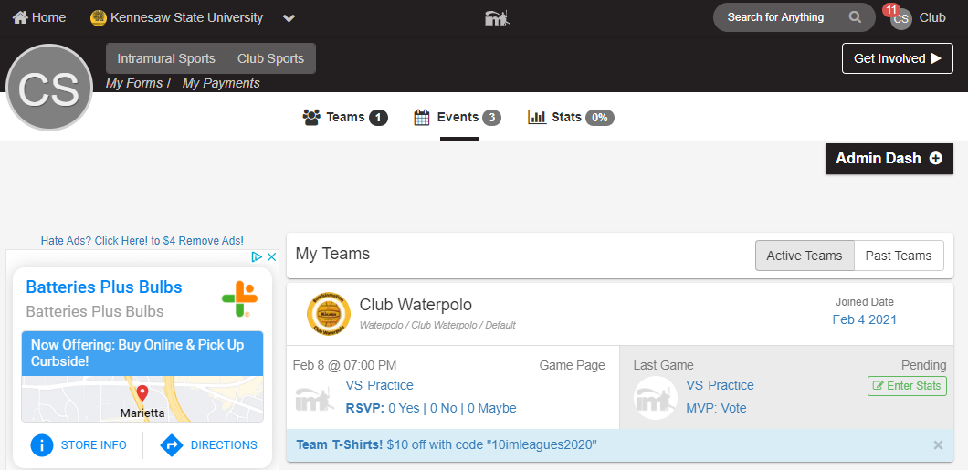

If experiencing any difficulties, please direct questions to clubsports@kennesaw.edu

