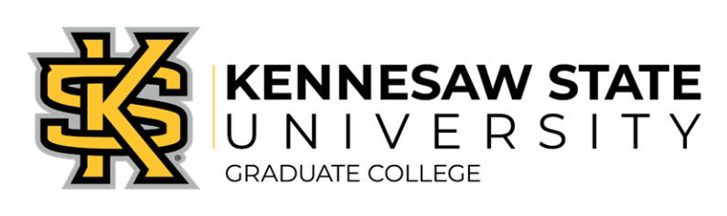

Graduate Council Meeting
Agenda
04/15/2026

- Closing out Spring
  - Graduate Assistant Evaluations Dates.
  - Funded Programs Annual Reviews are due by 05/04/2026.
  - Collecting publications and presentations from all graduate students. We are closing the survey end of day on 05/04/2026.
- Summer
  - GA Hiring Closes 05/01/2026.
- Preparing for Fall
  - Share new Graduate Assistant hiring process and training document.
  - GRAD 9001 will be offered online with monthly synchronous meetings.
  - CETL is planning to offer the Graduate Student Teaching Orientation on 08/21/2026.
  - CETL is also offering Introduction to Scholarly Teaching micro-credential for GTAs.
- 3MT update
- Discussion/Questions.

