CSE 1321L: Programming and Problem Solving I Lab

Lab 1

Getting Started with Python Programming

What students will learn
- Become familiar with the PyCharm Integrated Development Environment (IDE).
- Understand how to run applications from within an IDE
- Explore how Python applications work.
- Have a basic understanding of I/O – or Input/Ouput. This means printing things to the screen and reading input from the user.
- Understand how to submit labs in Gradescope
- Understand the basics of the “autograder” in Gradescope, which auto-assigns a grade based on the output of your programs.

For each lab program you develop, make sure to include the following “header” - replace the dots with your section #, semester, your full name, your instructor’s name, and lab #:
# Class: CSE 1321L
# Section: ...
# Term: ...
# Instructor: ...
# Name: ...
# Lab: ...
Note: putting *anything* after the # symbol makes it a “comment” – which is ignored by the computer. For all your future labs and assignments, you are required to put the header so we know who submitted the file.
Thank you ahead of time!

What is an IDE?
An Integrated Development Environment, or IDE, is basically an application that programmers use to make their lives easier when writing and testing code. You can think of it as Word (or Pages if you use a Mac), but instead of using English or some other human language, it allows programmers to efficiently enter/edit code and run it. More formally, it’s an application that provides almost everything needed by computer programmers for software development. At the core of it is a “interpreter” which is responsible for taking (human-readable) source code and converting it into binary code (1s and 0s) as it runs. An IDE normally consists of at least a source code editor, build automation tools, and a debugger. You can see a larger overview on Wikipedia: https://en.wikipedia.org/wiki/Integrated_development_environment Realize that, technically, an IDE is not needed. You could work directly with the interpreter from the command line if you wanted to. This is something you should explore later on, because some companies, like Apple, ask these things in job interviews.

Why do we use an IDE?
IDEs simplify the whole process, allowing programmers to write and test code quicker and with less errors than using the interpreter directly. On top of that, many modern IDEs enable multiple developers coordinate their work and also provide fast and intelligent error catching systems. So, all of this together makes any IDE a one-stop place to write, run, and fix code.

What is Gradescope and the Autograder?
Gradescope is where you’re going to submit your labs and assignments. For some of your labs (including this one), you’ll submit your source code (which will end in .py for Python code). When you do that, the autograder in Gradescope will take your source code, interpret it, and run some test cases through it to see if you did what you were supposed to do. It then automatically assigns a grade.

However (and pay attention) – it’s picky. For example, if the lab requires you to print “Hello, World!” and you print “Hello”, you won’t receive points for that part of the lab. The same thing would happen if you forgot the “!” at the end – so it’s important to have a critical eye! The autograder will point out these errors when you submit. Second, if the lab or assignment says “The filename must be called X”, you must do that and the case must match. For example, if you must call your file “Lab1A.py” and you called it “lab1a.py”, the autograder may or may not recognize it depending on the mood it is in that day.

No worries – if it’s not working for you, the autograder tries to give you feedback about what it’s seeing based on input and output. Also, don’t forget you have a lab instructor and lab assistants who are here to help.

Directions:

Installing PyCharm on your home laptop/workstation (if you haven’t done so)
- Please visit this link: https://www.jetbrains.com/pycharm/download/
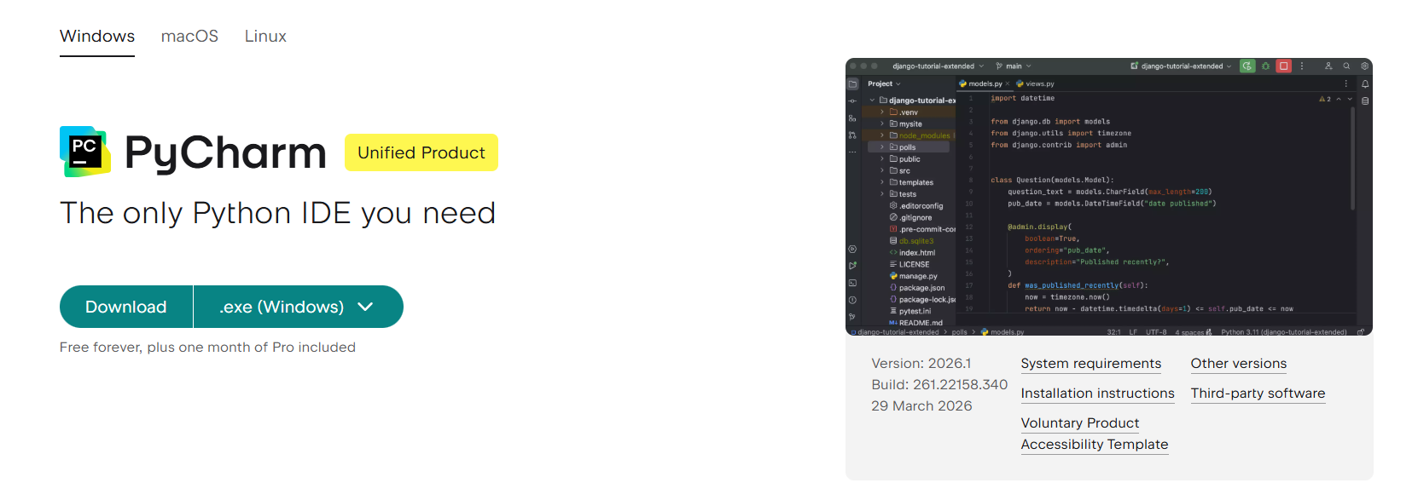
  - Please make sure you select the correct platform of your computer

- After the download is complete
- If you have a MAC you will need to open the .dmg file which was downloaded and drag the application to the applications folder
- If you have a WINDOWS PC you will need to run the downloaded setup executable and install IntelliJ on your computer

Creating new projects and configuring PyCharm the first time

- After installing, run PyCharm for the first time.
- The first time you run Pycharm, it will show you with a welcome project already setup.
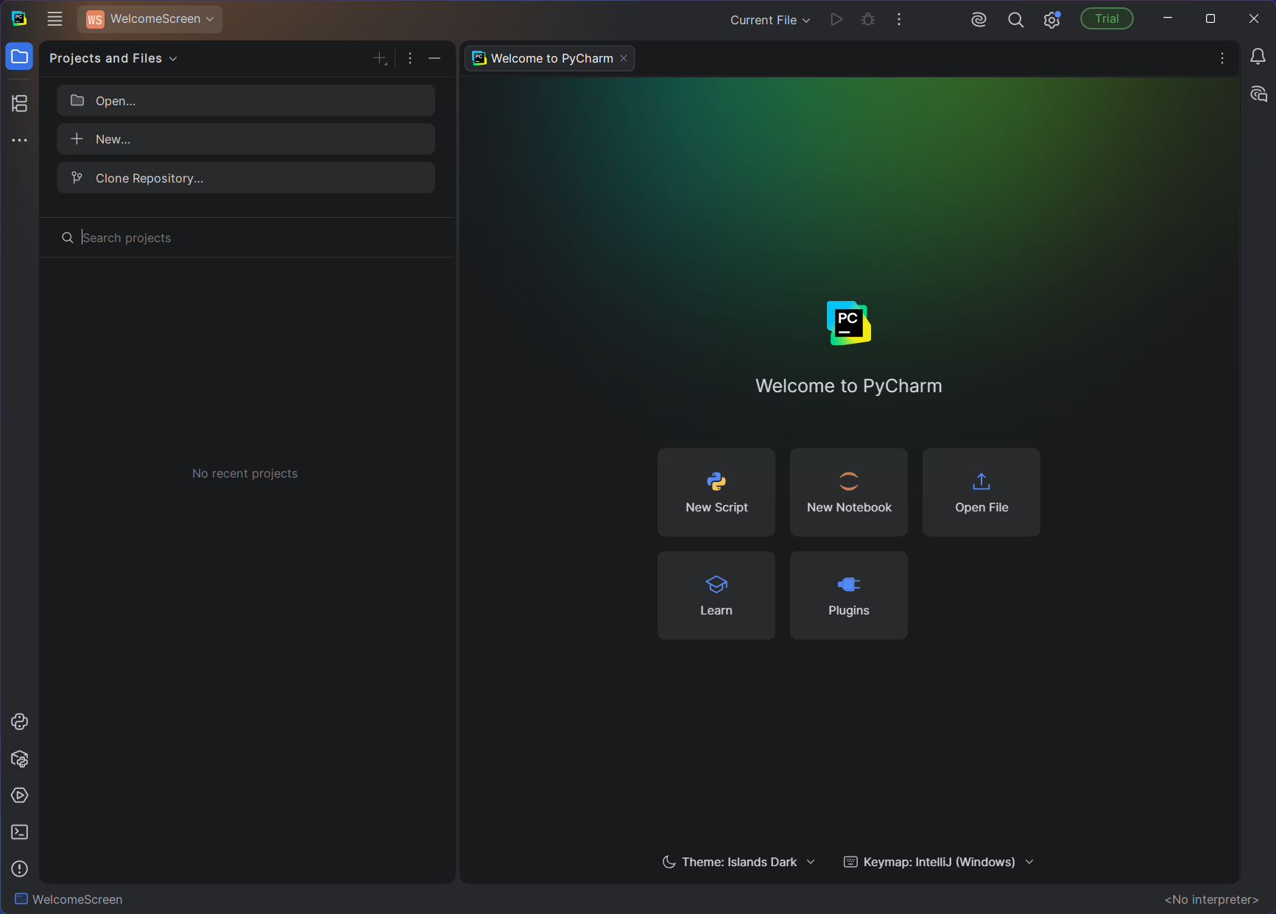
- We are not going to use this project, instead we will create a new PyCharm project by pressing the “hamburger” icon on the top left corner of the window.
- Hover your cursor on “File” then click on “New Project”
- A new window will pop up to set up the new project.
- First, we will set where in your computer your project will “live”. We suggest you create one folder that will contain all your project this semester on your computer. This will help you have your files organized and easy to find.
  - In this example, the location of this folder will be in the “C:\CSE1321L” folder.
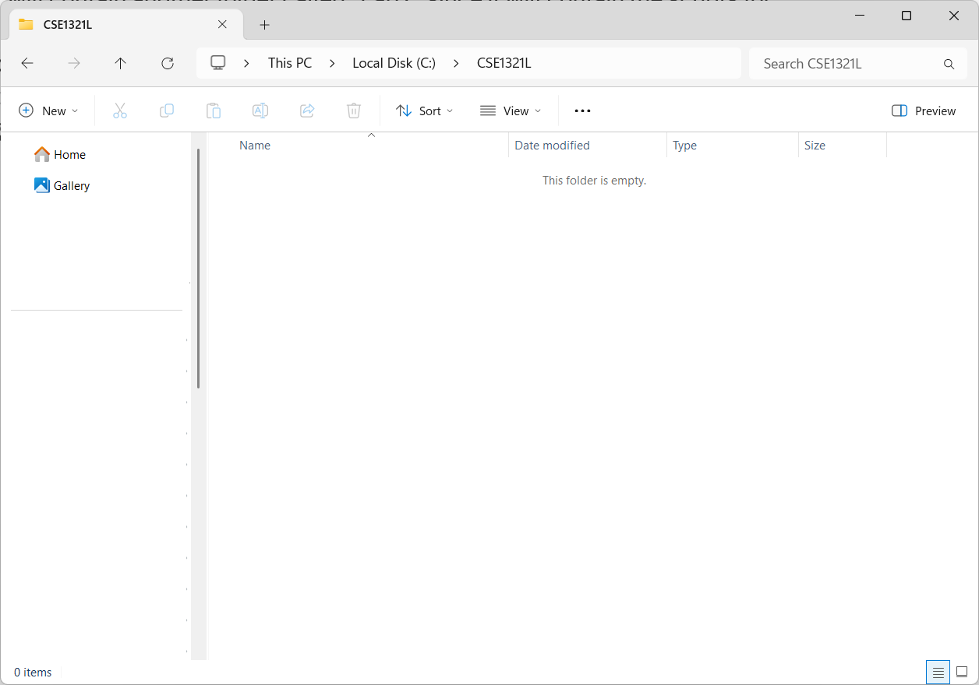
  - This folder will contain another folder called “Lab1” since it will contain the scripts for this lab.
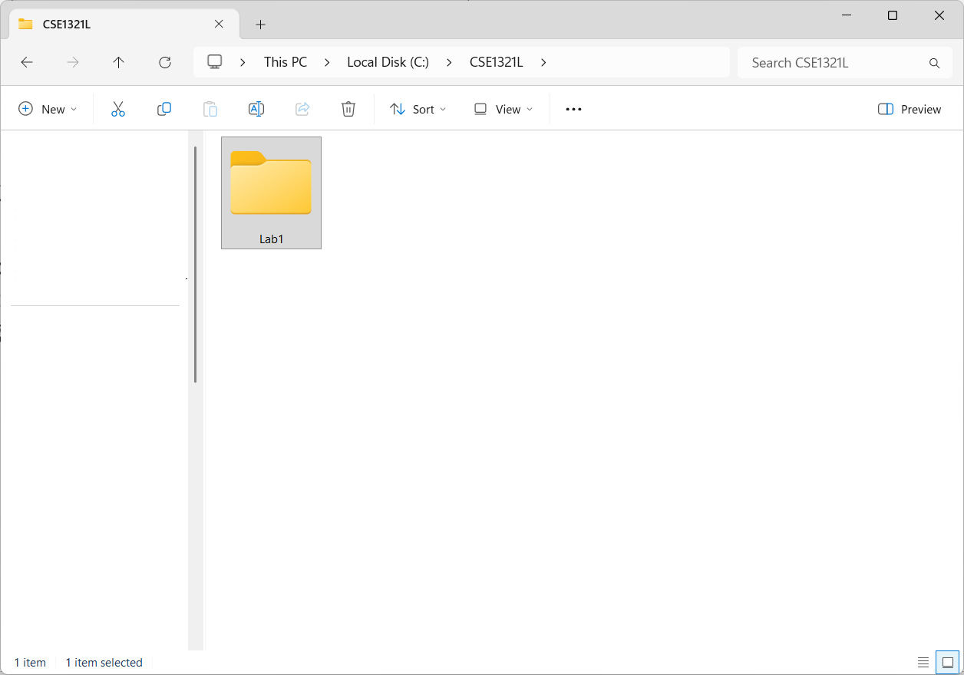
  - As you go on in the semester, you may add more folders such as “Lab2”, “Lab3”, and so on.
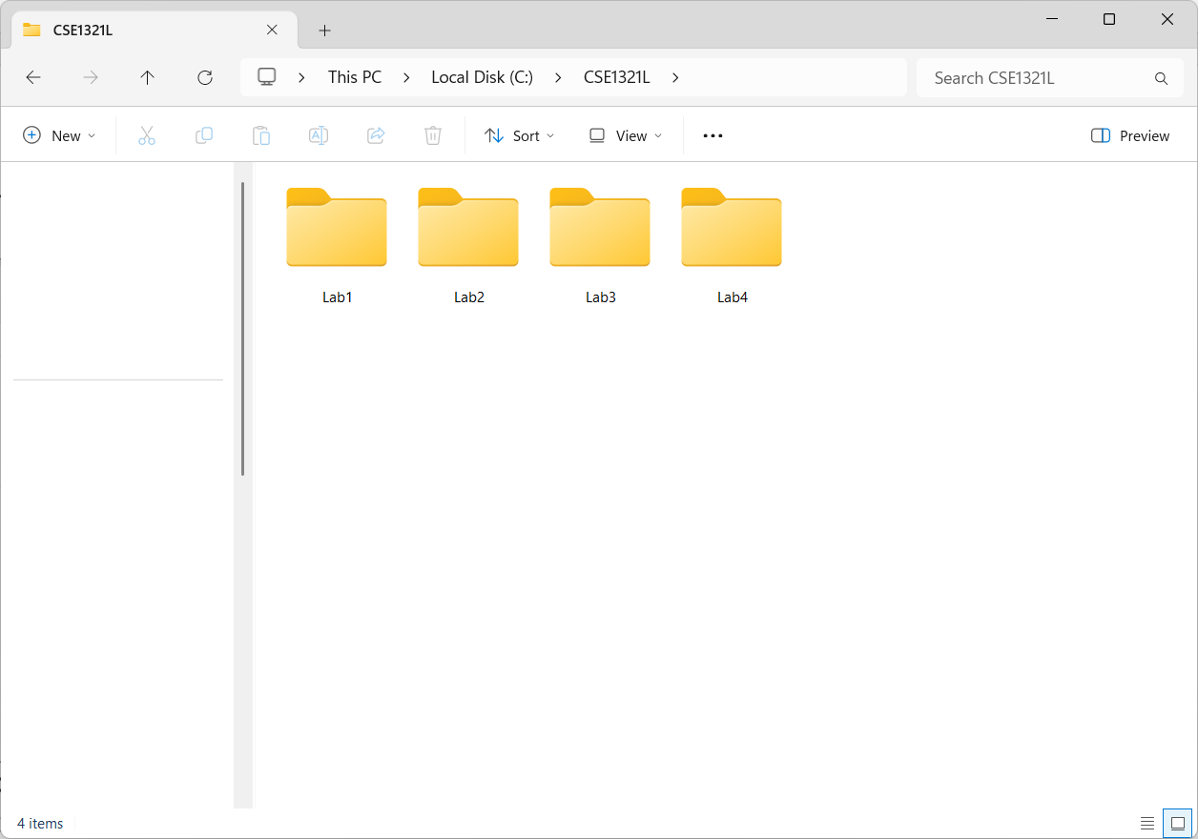
- In the new project window, make sure the location is set to the folder you created and in the Lab1 folder. If you followed the example from step 6, your location should be set to “C:\CSE1321L\Lab1”
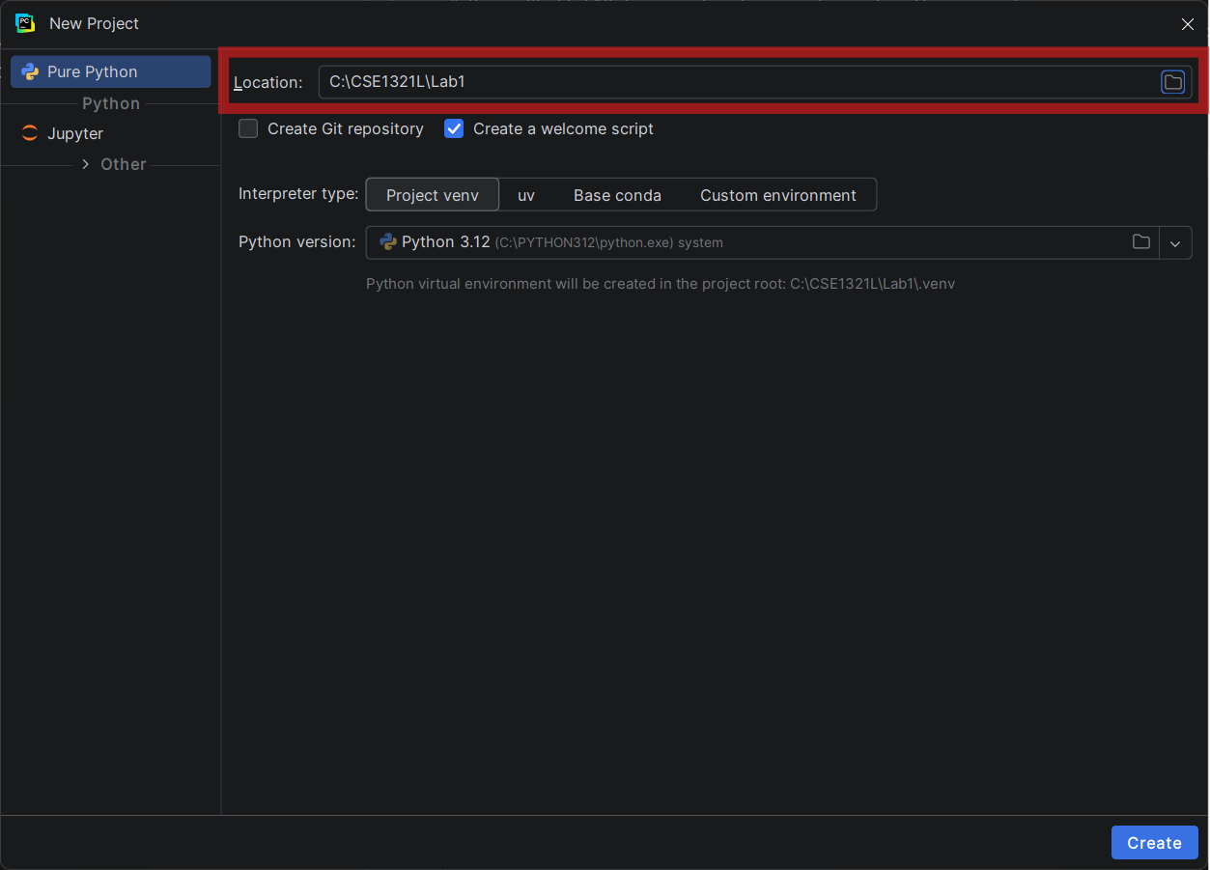

- We will keep the “Create a welcome script” option selected.
- Then, under Python version you will most likely not have anything selected. If that is the case, do download the latest version PyCharm recommends.
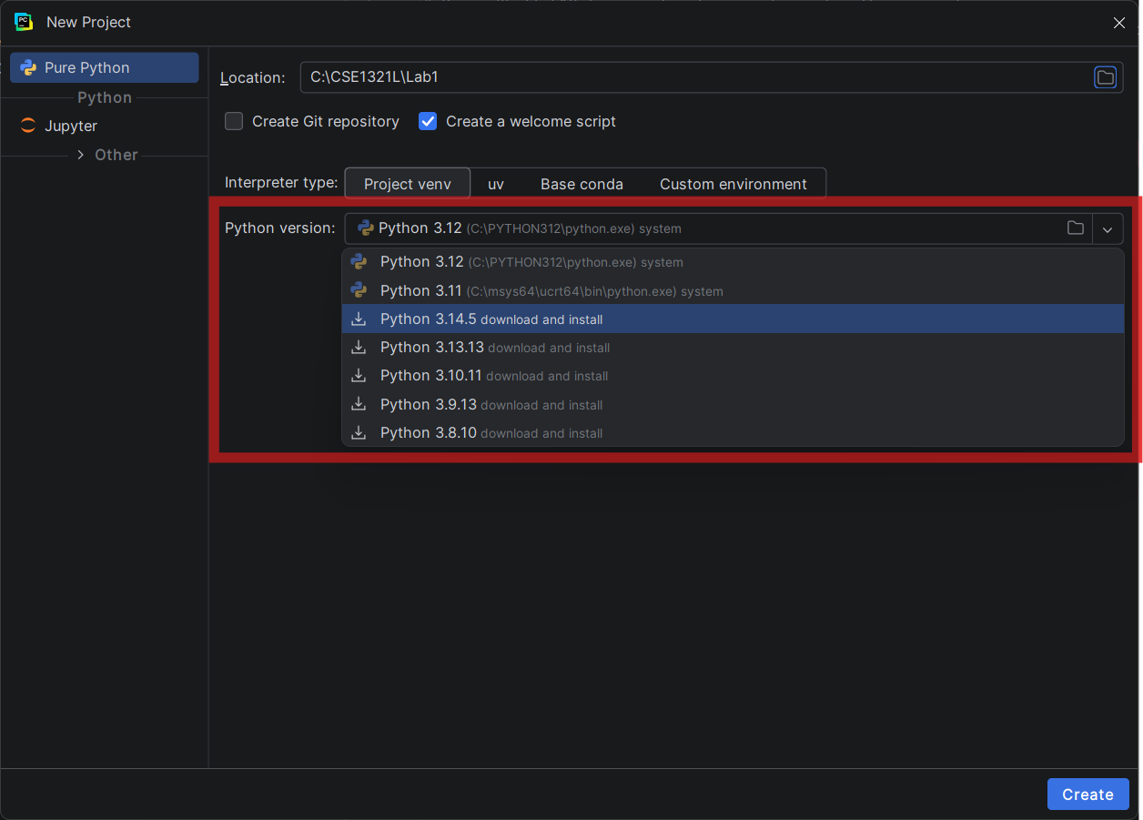
  - Do not worry about matching the version you see in the screenshot, any recent version of Python will work.
- After this, you should be good to click on the “Create” button located in the bottom-right corner of the new project window.

Testing your PyCharm Project
Once you have a project, you can start working on your lab but before you do that, let’s verify everything is working.
As specified before, when we created the project, you should have selected the option to create a welcome script, we will run this script first to see if everything is working.
- Go to the navigation panel which is located on the right side of the window.
- Click on the arrow/greater than symbol next to the project name. Doing this it should expand the project folder.
  - If you followed the suggested folder structure from before, the project name should be “Lab1”
- Once expanded, you should see a file called “main.py”, double click it to open it. The script should open on the right side of the window.
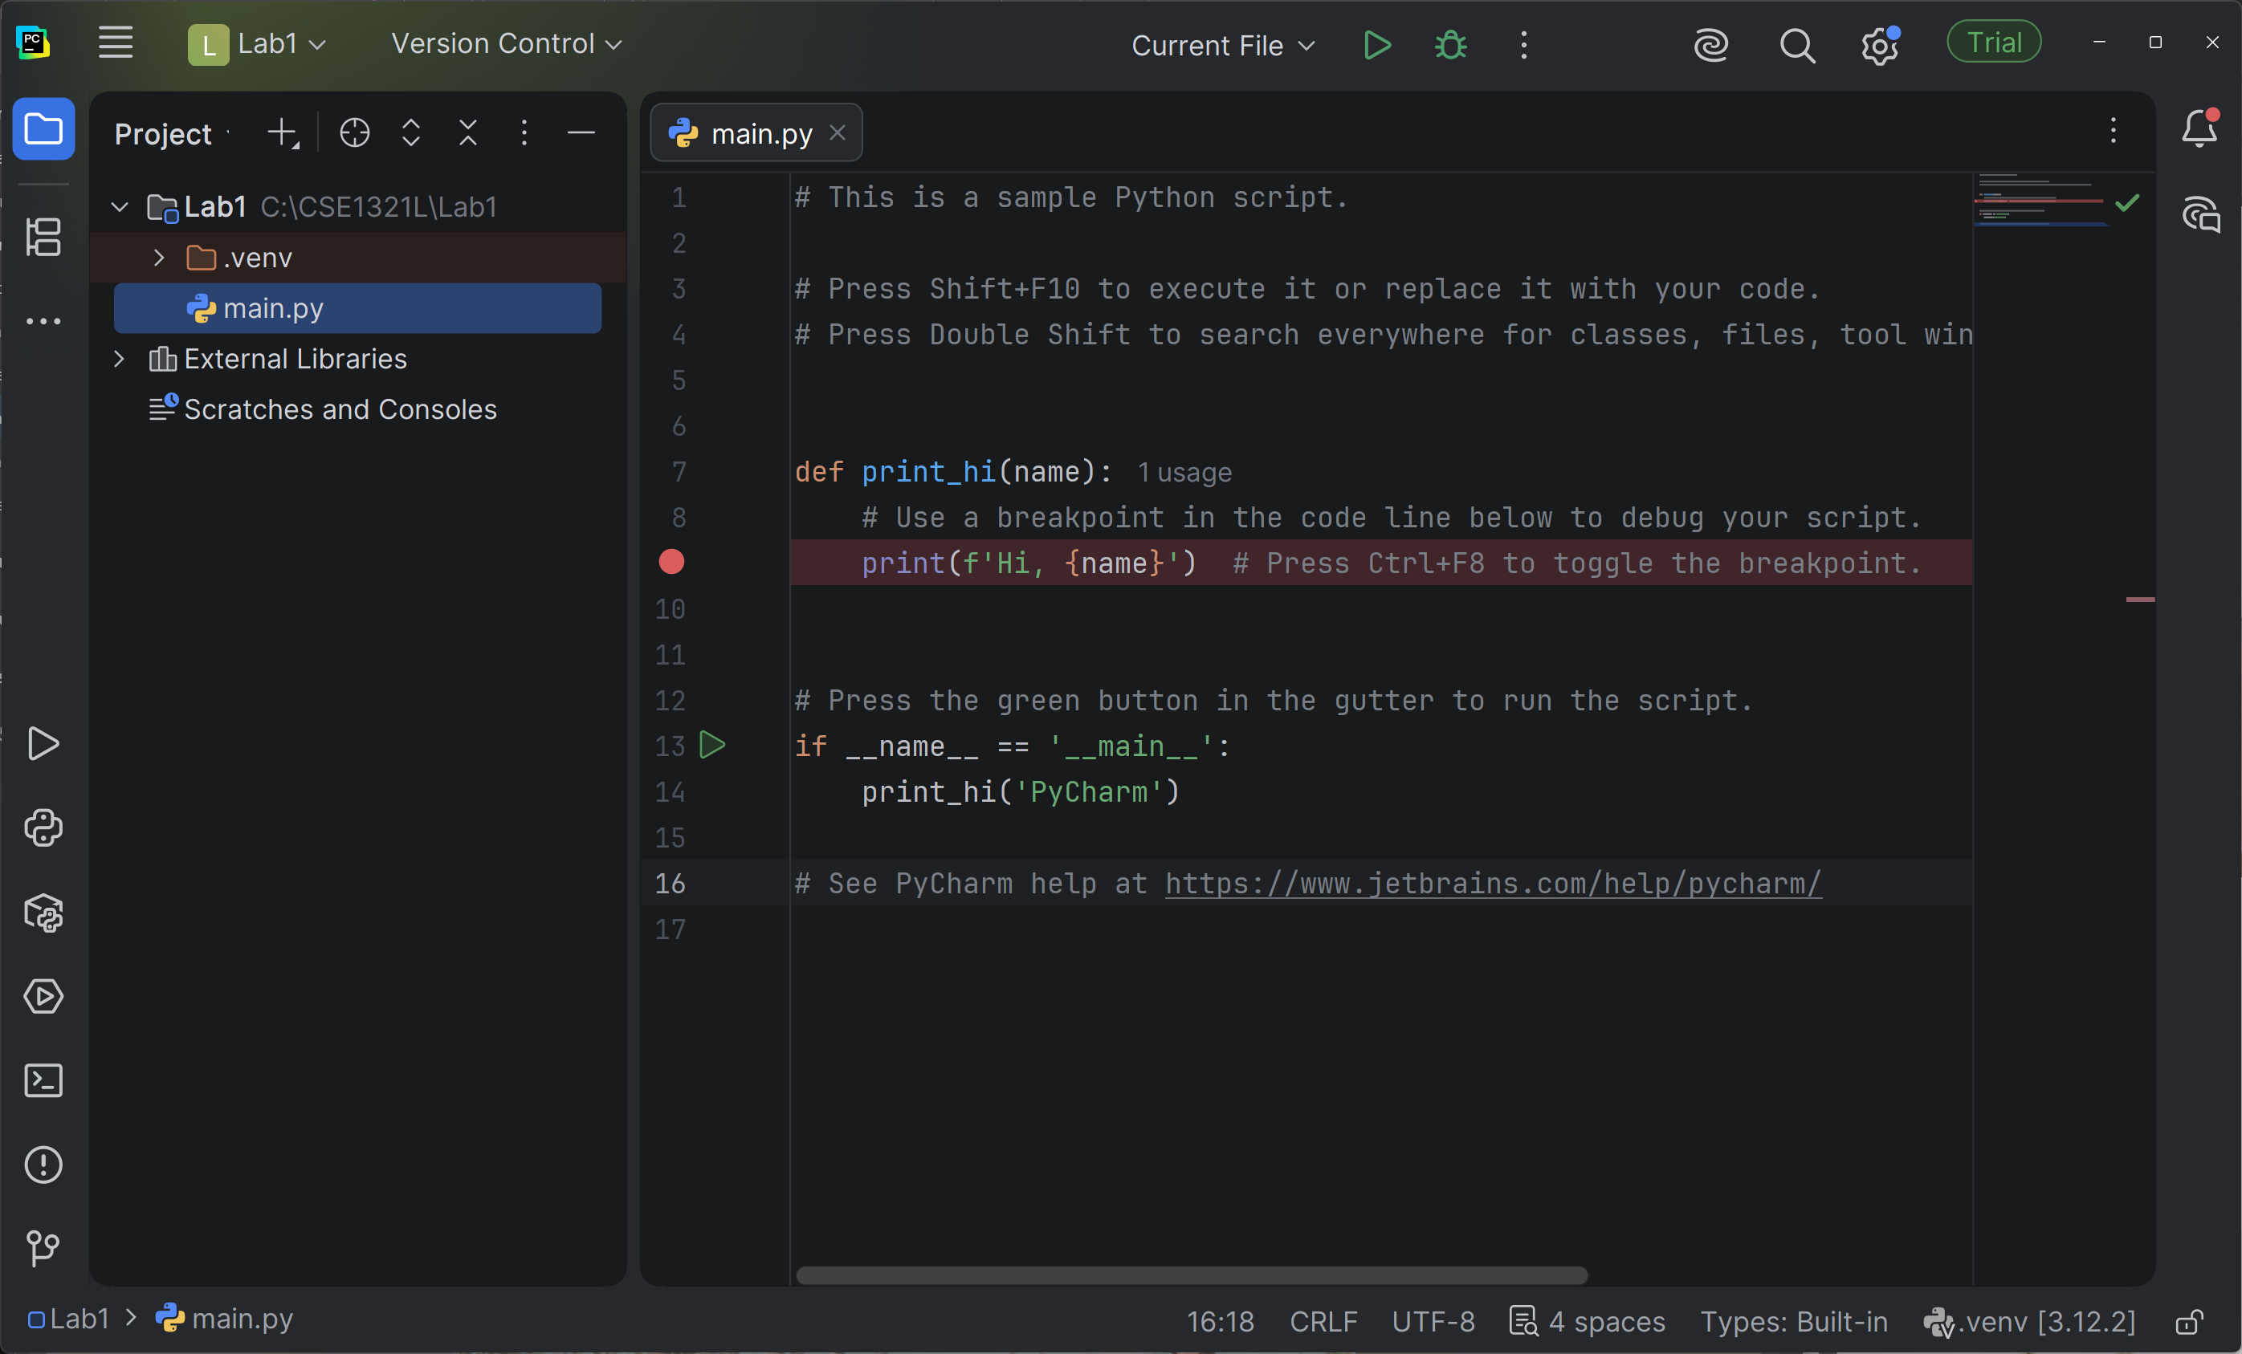
- Click on the green arrow/triangle on the top of the window. This is the “Run” button, you will press this button anytime you want to run your script.
- After you run the “main.py” script, a new panel will appear at the bottom of the window. This is the terminal which we will use to display our programs. If everything worked, the terminal should output “Hi, Pycharm”
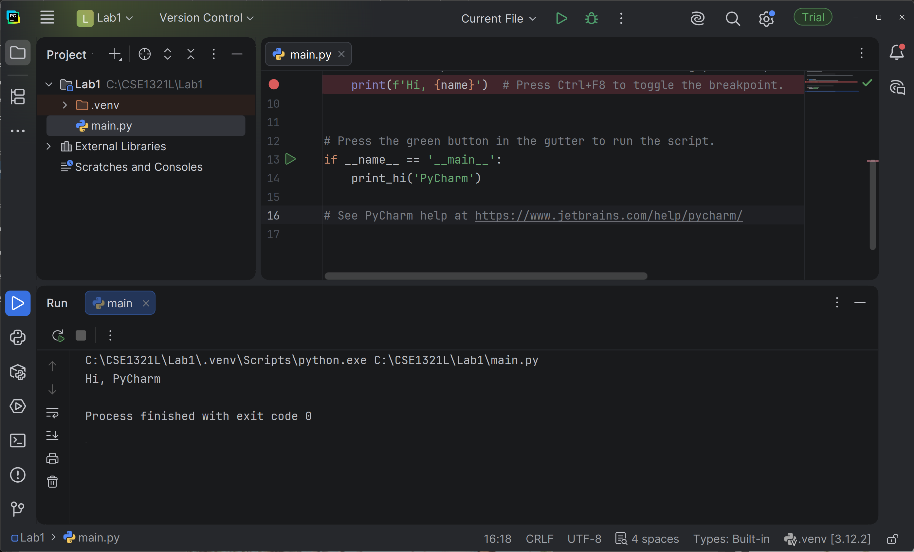
- If at any point you encounter any issues or the program does not execute the “main.py” script correctly, reach out to your Graduate Teaching Assistant for help.

Creating your own scripts
Once we have verified our project work and we can successfully run and execute python scripts within PyCharm, we can start creating our own scripts for labs and assignments.
- Go to the navigation panel again, this time right click on the project folder. A list of options should appear.
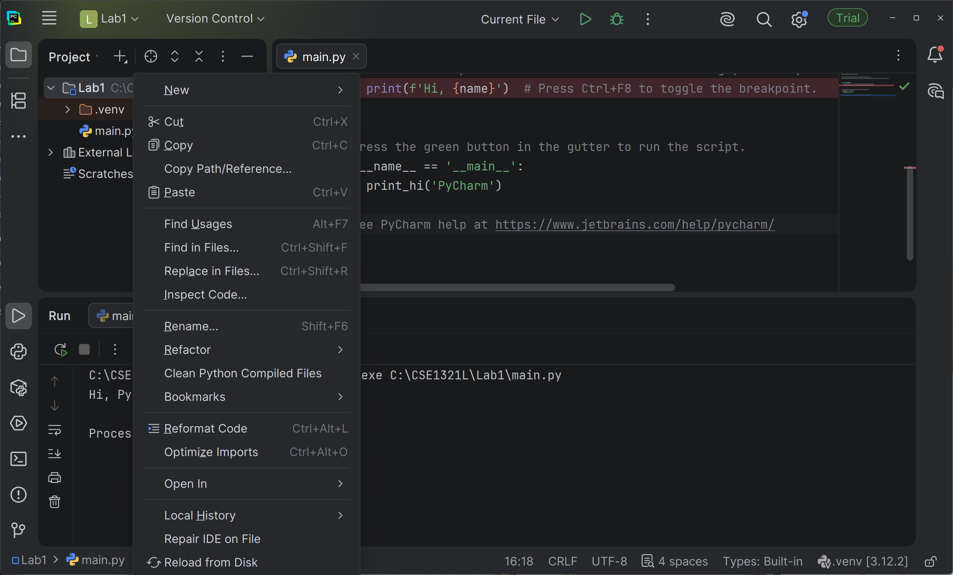
- Hover your cursor over “New”, then click on “Python File”
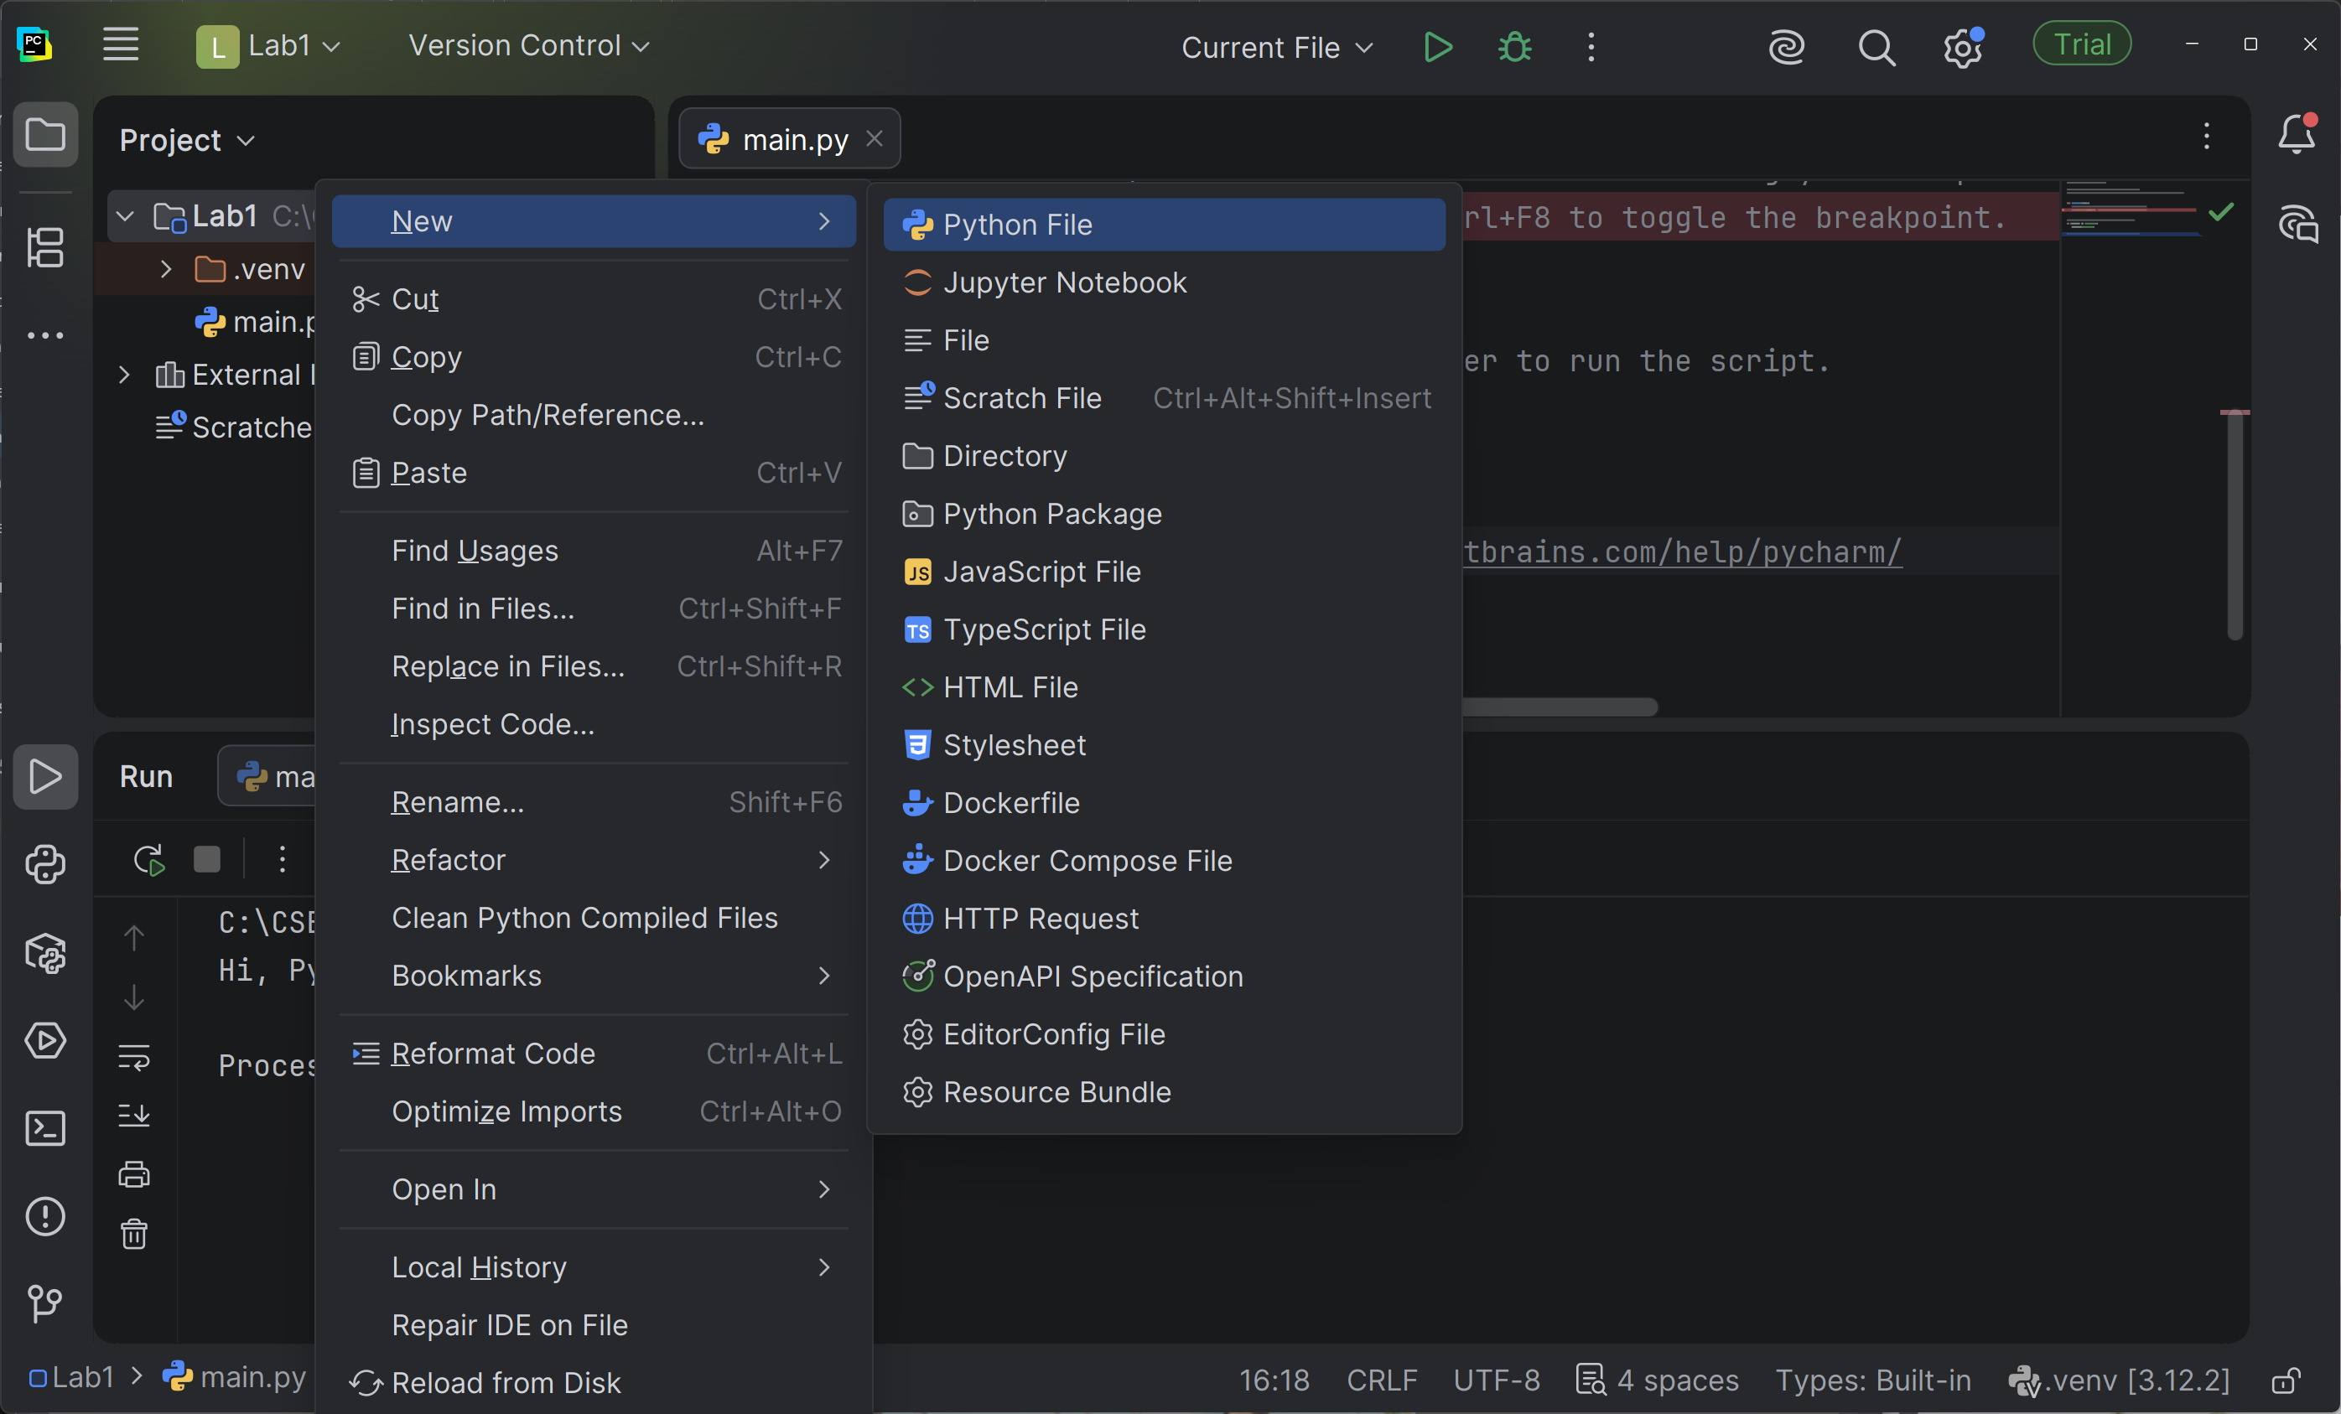
- As soon as you click “Python File” a “New Python File” window will pop-up asking you the name of the script you want to create.
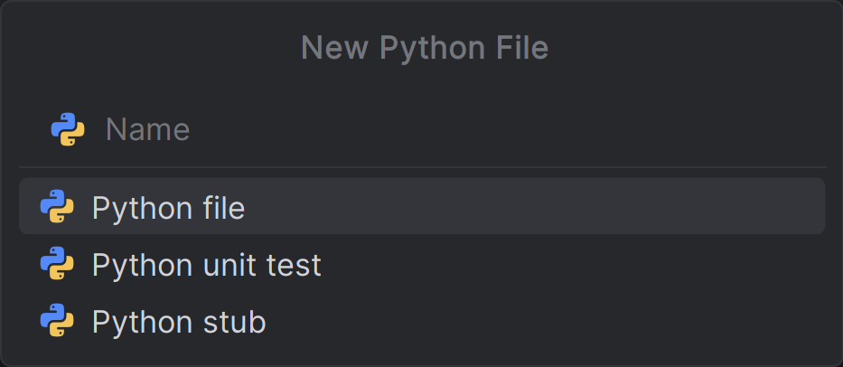
- Name the script “Lab1A” and press enter.
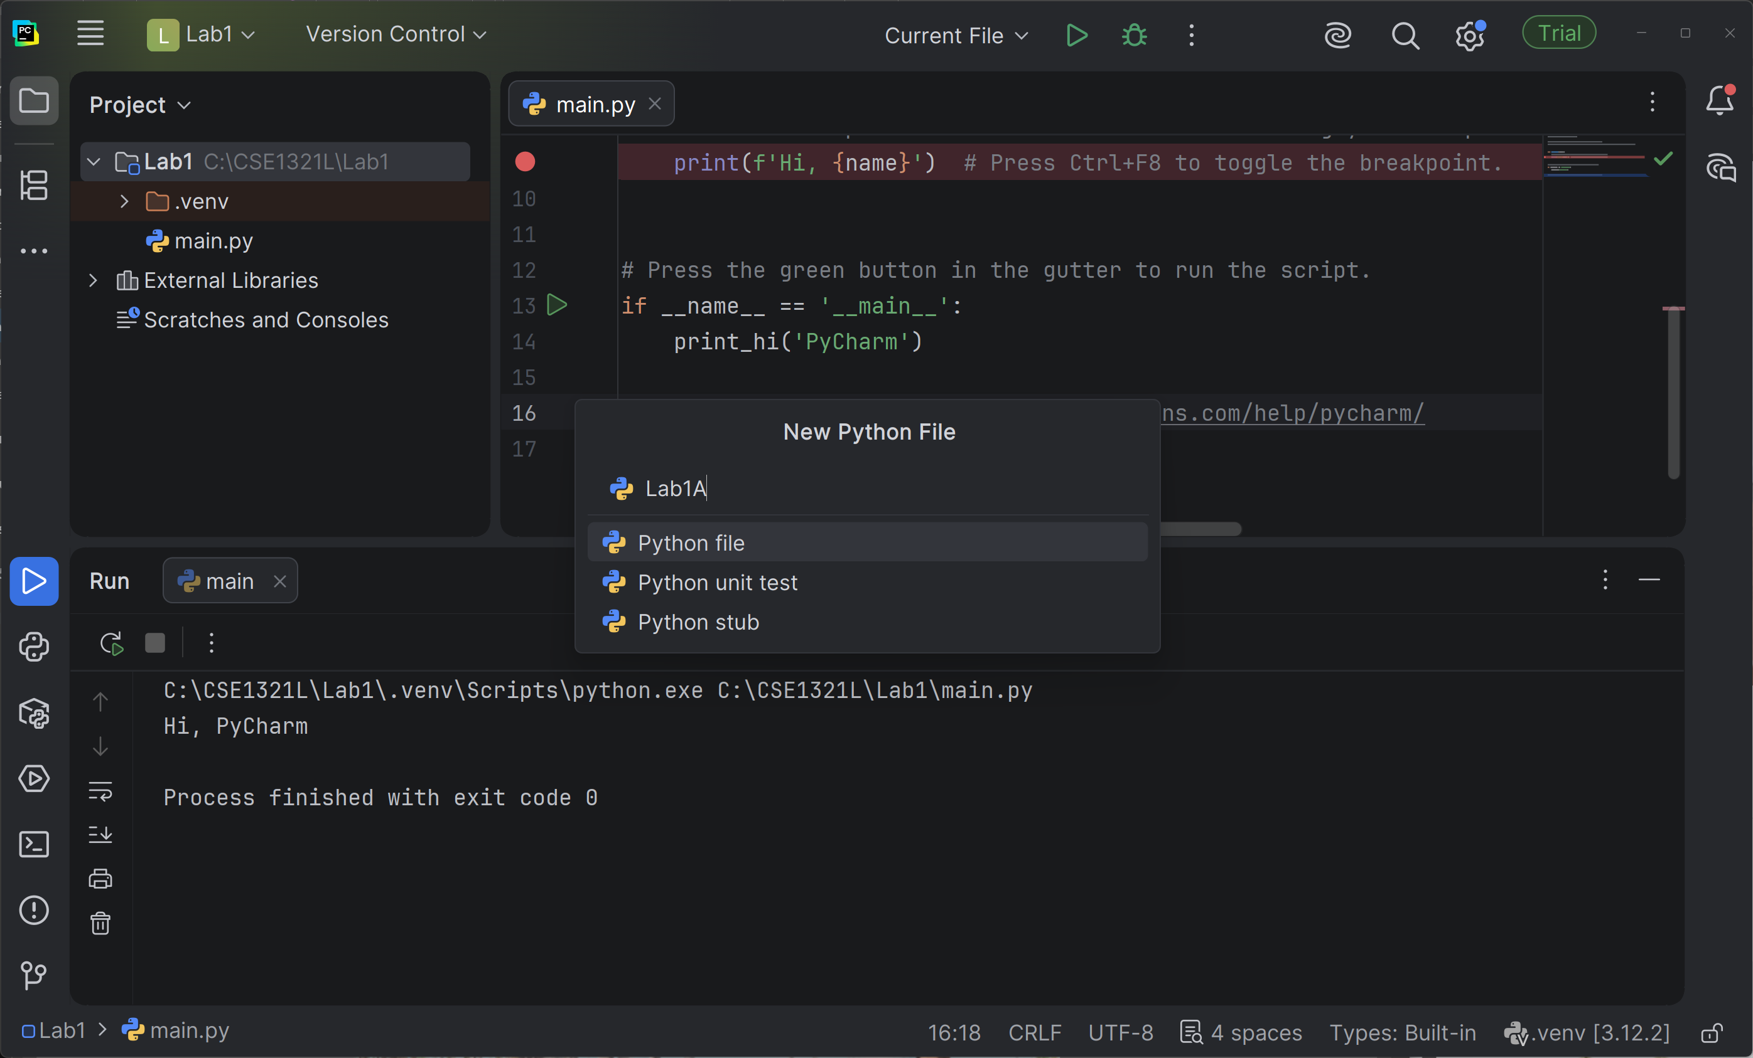
- You will see that a new script is now open called “Lab1A.py”, moreover, you will also see that the navigation panel now shows another script with the same name. You have successfully created your first script.
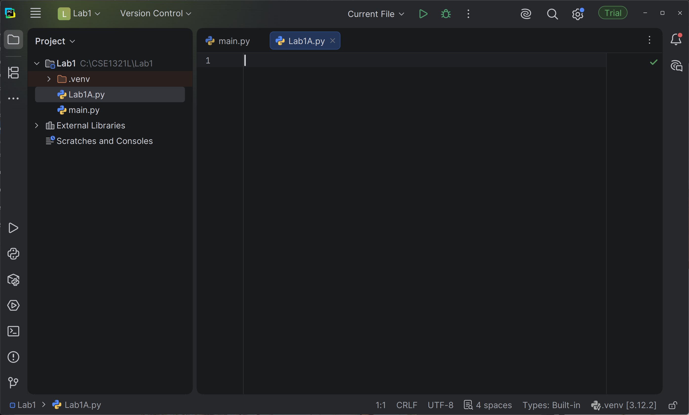
- From this point, you should be good to start writing your own script and running them.

Lab 1
For this lab, you’re going to work with your IDE to code and run some programs we have provided you. By the end of this lab, you will have three files that you need to submit to the autograder at the same time – Lab1A, Lab1B and Lab1C. You should be able to create one project with three Python files (one for each Lab part below).
Before you begin the next part of this lab, you might start feeling overwhelmed when you first look at the source code below. There are some strange symbols there! You’ll get comfortable with these as you go.

Three programs have three problems with them:
- One of the programs below has a logic error in it – meaning that, while it runs, it doesn’t produce the correct output. You must find the error and fix it.
- One of the programs below is written incorrectly, so you can’t even run it! Based on what we just told you, you must figure out why, fix the error, save the file, and re-run the code.
- One of the programs runs fine – but has a typo in the output. If you were to submit this file, the autograder won’t like it (because the output does not match). You may try submitting the lab before fixing the error so you can see what the autograder does.

When creating the files for the programs below, they must be called Lab1A, Lab1B, and Lab1C (and have the appropriate .py file extension).

Fix and run the programs below, then submit them in Gradescope.

============================== Program Lab1A.py ============================
# Program Lab1A.py
# Demonstrate the difference between print with and without a newline.
# Prints two lines of output representing a rocket countdown.
print ("Three... ", end =" ")
print ("Two... ", end =" ")
print ("One... , end =" ")
print ("Zero..." , end =" ")
print ("Liftoff!")
# appears on first line
print ("Houston, we have a problem.")

============================== Program Lab1B.py ============================
# Program Lab1B.py
# Demonstrate reading a string from the user.
# Reads a character string from the user and prints it.
message = input ("Enter a line of text: ");
print ("You rote '" + message + "'");

============================ Program Lab1C.py ============================
# Program Lab1C.py
# Demonstrate the use of the input function to read numeric data.
# Calculates fuel efficiency based on values entered by the user.
miles = input ("Enter the number of miles: ")
gallons = input ("Enter the gallons of fuel used: ")
mpg = int (miles) * float (gallons)
print ("Miles Per Gallon: " + str (mpg))

Save all programs in one folder (call it Lab1) for future reference. You may also save this on a USB device or OneDrive.

Submission Instructions:
- Programs must follow the output format provided. This includes each blank line, colons (:), and other symbols.
- Programs must be working correctly.
- Programs must be written in Python.
- Programs must be submitted with the correct .py format.
- Programs must be saved in files with the correct file name:
  - Lab1A.py
  - Lab1B.py
  - Lab1C.py
- Programs (source code files) must be uploaded to Gradescope by the due date.

