CSE 1321L: Programming and Problem Solving I Lab

Lab 1

Getting Started with Python Programming

What students will learn
- Become familiar with the PyCharm Integrated Development Environment (IDE).
- Understand how to run applications from within an IDE
- Explore how Python applications work.
- Have a basic understanding of I/O – or Input/Ouput. This means printing things to the screen and reading input from the user.
- Understand how to submit labs in Gradescope
- Understand the basics of the “autograder” in Gradescope, which auto-assigns a grade based on the output of your programs.

For each lab program you develop, make sure to include the following “header” - replace the dots with your section #, semester, your full name, your instructor’s name, and lab #:
# Class: CSE 1321L
# Section: ...
# Term: ...
# Instructor: ...
# Name: ...
# Lab: ...
Note: putting *anything* after the # symbol makes it a “comment” – which is ignored by the computer. For all your future labs and assignments, you are required to put the header so we know who submitted the file.
Thank you ahead of time!

What is an IDE?
An Integrated Development Environment, or IDE, is basically an application that programmers use to make their lives easier when writing and testing code. You can think of it as Word (or Pages if you use a Mac), but instead of using English or some other human language, it allows programmers to efficiently enter/edit code and run it. More formally, it’s an application that provides almost everything needed by computer programmers for software development. At the core of it is a “interpreter” which is responsible for taking (human-readable) source code and converting it into binary code (1s and 0s) as it runs. An IDE normally consists of at least a source code editor, build automation tools, and a debugger. You can see a larger overview on Wikipedia: https://en.wikipedia.org/wiki/Integrated_development_environment Realize that, technically, an IDE is not needed. You could work directly with the interpreter from the command line if you wanted to. This is something you should explore later on, because some companies, like Apple, ask these things in job interviews.

Why do we use an IDE?
IDEs simplify the whole process, allowing programmers to write and test code quicker and with less errors than using the interpreter directly. On top of that, many modern IDEs enable multiple developers coordinate their work and also provide fast and intelligent error catching systems. So, all of this together makes any IDE a one-stop place to write, run, and fix code.

What is Gradescope and the Autograder?
Gradescope is where you’re going to submit your labs and assignments. For some of your labs (including this one), you’ll submit your source code (which will end in .py for Python code). When you do that, the autograder in Gradescope will take your source code, interpret it, and run some test cases through it to see if you did what you were supposed to do. It then automatically assigns a grade.

However (and pay attention) – it’s picky. For example, if the lab requires you to print “Hello, World!” and you print “Hello”, you won’t receive points for that part of the lab. The same thing would happen if you forgot the “!” at the end – so it’s important to have a critical eye! The autograder will point out these errors when you submit. Second, if the lab or assignment says “The filename must be called X”, you must do that and the case must match. For example, if you must call your file “Lab1A.py” and you called it “lab1a.py”, the autograder may or may not recognize it depending on the mood it is in that day.

No worries – if it’s not working for you, the autograder tries to give you feedback about what it’s seeing based on input and output. Also, don’t forget you have a lab instructor and lab assistants who are here to help.

Directions:

Installing PyCharm on your home laptop/workstation (if you haven’t done so)
- Please visit this link: https://www.jetbrains.com/pycharm/download/
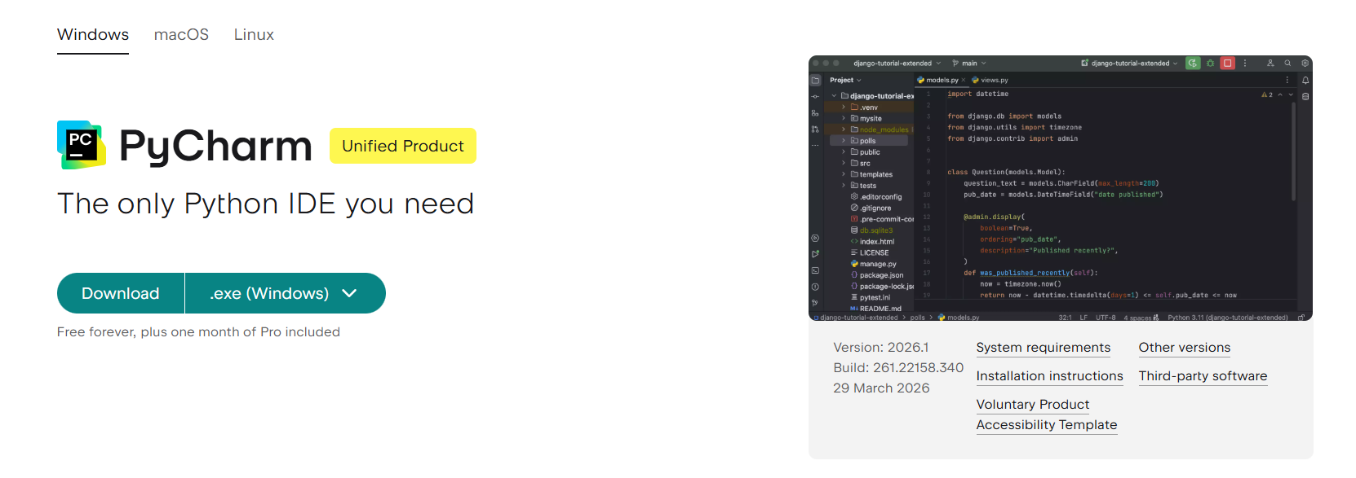
  - Please make sure you select the correct platform of your computer

- After the download is complete
- If you have a MAC you will need to open the .dmg file which was downloaded and drag the application to the applications folder
- If you have a WINDOWS PC you will need to run the downloaded setup executable and install IntelliJ on your computer

Creating new projects and configuring PyCharm the first time

- Run PyCharm for the first time and go through the set-up screen; skip all the tips that it presents to you
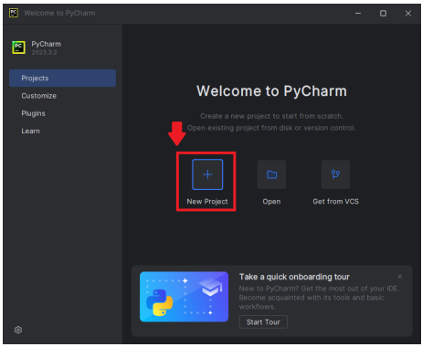
- Once you get to the main screen, please click “New Project”
- Please then select “Python” and select the dropdown menu. Then, click “Download Python” as show in the two figures below
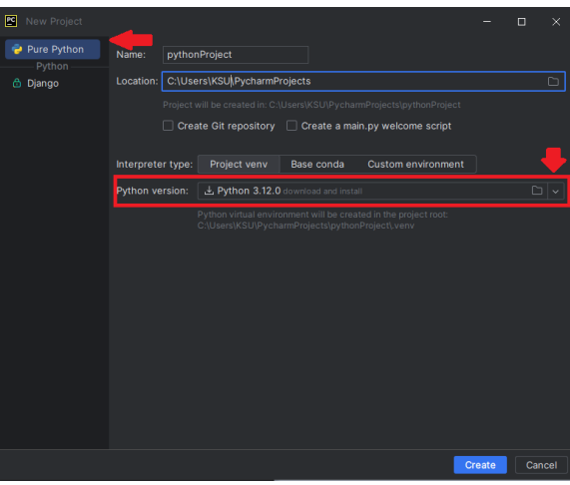

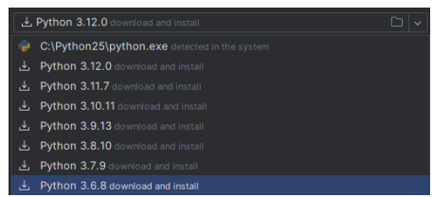

- Please select the choice as shown in the screenshot, the version number may have changed since the making of this document. Please note that you will only have to do this once, afterwards this Python version will automatically be selected whenever you make a new Python project using PyCharm
- After this, you will arrive at the screen where you will be instructed to give your project both a name and a location. The name provided should match the Lab or Assignment that you are solving (you should create a new project every time you start a new Lab or Assignment). Each file you create (explained below) should represent each exercise solution. Then click Finish.
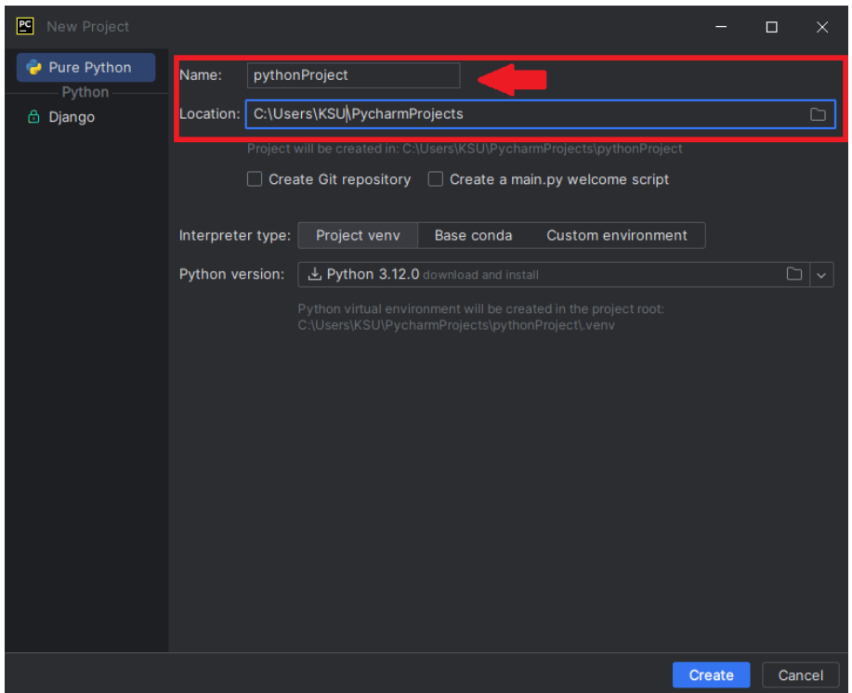

Creating Scripts

As mentioned above, for every exercise solution, it has to have its own script unless otherwise instructed
- To create a class, right-click the “Scripts” folder (as shown in the screenshot) and click New, then Python File.
- Please give the script an appropriate name and press enter on your keyboard. Viola! You have created a new script. Please give the scripts appropriate names as provided to you in either the assignment or the lab exercises (see below). Naming your classes incorrectly may (and likely will) result in the autograder assigning a zero for that part of the lab
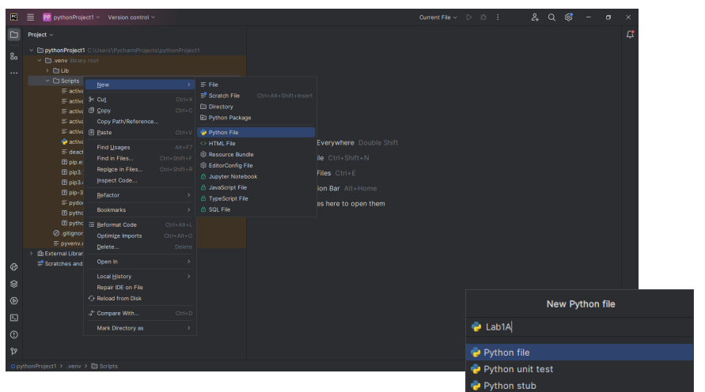

Running a Script
Please click the green “play button” (as show in the screenshot below) and click “run”
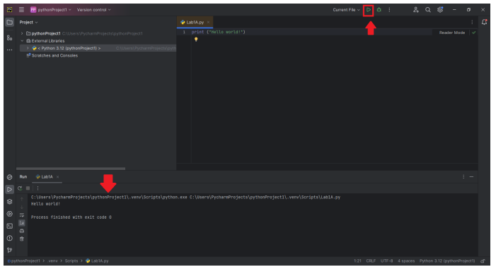
For this lab, you’re going to work with your IDE to code and run some programs we have provided you. By the end of this lab, you will have three files that you need to submit to the autograder at the same time – Lab1A, Lab1B and Lab1C. You should be able to create one project with three Python files (one for each Lab part below).
Before you begin the next part of this lab, you might start feeling overwhelmed when you first look at the source code below. There’s some strange symbols there! You’ll get comfortable with these as you go.

Three programs have three problems with them:
- One of the programs below has a logic error in it – meaning that, while it runs, it doesn’t produce the correct output. You must find the error and fix it.
- One of the programs below is written incorrectl, so you can’t even run it! Based on what we just told you, you must figure out why, fix the error, save the file, and re-run the code.
- One of the programs runs fine – but has a typo in the output. If you were to submit this file, the autograder won’t like it (because the output does not match). You may try submitting the lab before fixing the error so you can see what the autograder does.

When creating the files for the programs below, they must be called Lab1A, Lab1B, and Lab1C (and have the appropriate .py file extension).

Fix and run the programs below, then submit them in Gradescope.

============================== Program Lab1A.py ============================
# Program Lab1A.py
# Demonstrate the difference between print with and without a newline.
# Prints two lines of output representing a rocket countdown.
print ("Three... ", end =" ")
print ("Two... ", end =" ")
print ("One... , end =" ")
print ("Zero..." , end =" ")
print ("Liftoff!")
# appears on first line
print ("Houston, we have a problem.")

============================== Program Lab1B.py ============================
# Program Lab1B.py
# Demonstrate reading a string from the user.
# Reads a character string from the user and prints it.
message = input ("Enter a line of text: ");
print ("You rote '" + message + "'");

============================ Program Lab1C.py ============================
# Program Lab1C.py
# Demonstrate the use of the input function to read numeric data.
# Calculates fuel efficiency based on values entered by the user.
miles = input ("Enter the number of miles: ")
gallons = input ("Enter the gallons of fuel used: ")
mpg = int (miles) * float (gallons)
print ("Miles Per Gallon: " + str (mpg))
Save all programs in one folder (call it Lab1) for future reference. You may also save this on a USB device or OneDrive.

Submission Instructions:
- Programs must follow the output format provided. This includes each blank line, colons (:), and other symbols.
- Programs must be working correctly.
- Programs must be written in Python.
- Programs must be submitted with the correct .py format.
- Programs must be saved in files with the correct file name:
  - Lab1A.py
  - Lab1B.py
  - Lab1C.py
- Programs (source code files) must be uploaded to Gradescope by the due date.

