How to Log in to CCSE Virtual Machines (VMs) Using a Web Browser

Purpose
This document provides step-by-step instructions for accessing CCSE Virtual Machines (VMs) using a web browser through the Unified Desktop System (UDS).
Using the browser-based connection allows students and faculty to complete coursework and labs without installing or configuring specialized software on their personal devices.

Requirements
Before beginning, please verify the following:
- A stable Internet connection
- A supported web browser:
  - Google Chrome 26 or later
  - Microsoft Edge 79 or later
  - Safari 11 or later
  - Firefox 22 or later
  - Opera 18 or later
  - Brave
- Your KSU Email address
- Your KSU NetID and password
- A KSU VPN connection
  - Instructions on how to access the VPN can be found here:
  - Download and install the KSU VPN client
NOTE: A VPN connection is required. Attempting to connect to a VM without the VPN will result in errors and inability to connect.

Step 1: Access the cseview Website
- Open a supported web browser.
- Navigate to:
KSU CCSE Virtual Machine Access URL
You will be presented with a Microsoft login screen.
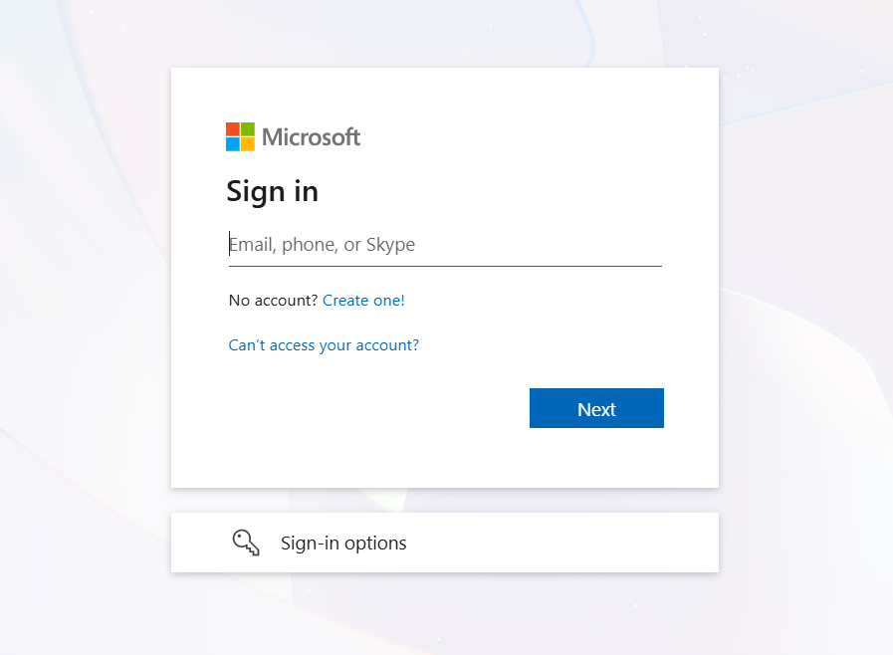
Step 2: Sign in and Authenticate with KSU Credentials
- Sign in using your KSU email address and password.
- Authenticate with Microsoft Authenticator
After logging in successfully, you will be taken to the UDS Home Screen, which displays a list of available VM pools assigned to you.
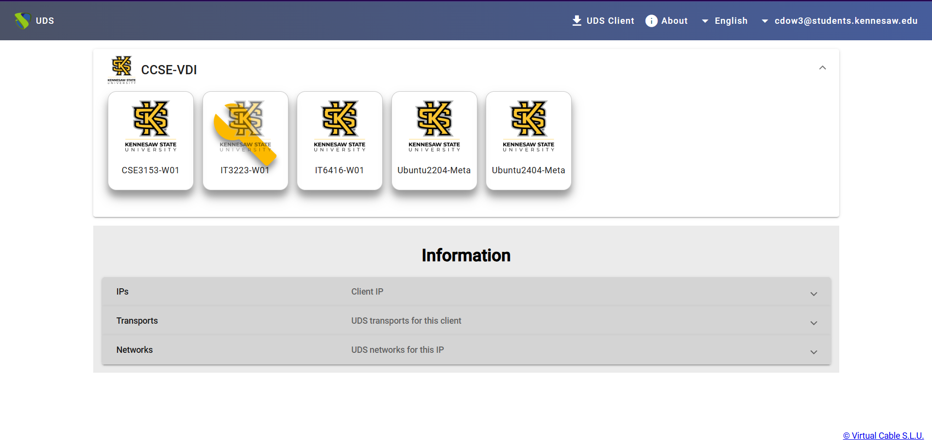
VM Pool Status Indicator
- A wrench icon covering a VM pool indicates that the pool is under maintenance.
- VM pools in maintenance cannot be accessed until maintenance is complete.

Step 3: Launch a Virtual Machine Using the Browser
- Locate the VM pool you wish to access.
- Click on the icon for the desired VM pool.

This launches the UDS HTML5 service in your browser.

The initial launch may take a moment. Please wait while the service loads.
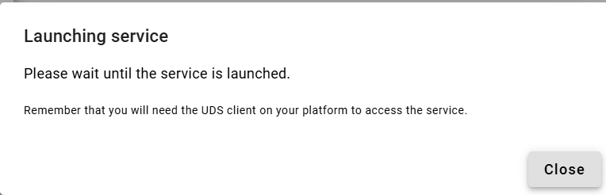Client Installation Reminder (Ignore This)
If you see a message recommending the installation of a UDS client:
- Ignore this message.
- The browser-based method does not require installing any additional software.

Step 4: Log in to the Virtual Machine
Once the HTML5 service loads, you will be prompted to log in to the virtual machine.
- Enter your KSU NetID and password
- DO NOT USE YOUR KSU EMAIL
- Confirm that the Domain field is set to:
win.kennesaw.edu
- Click Accept.
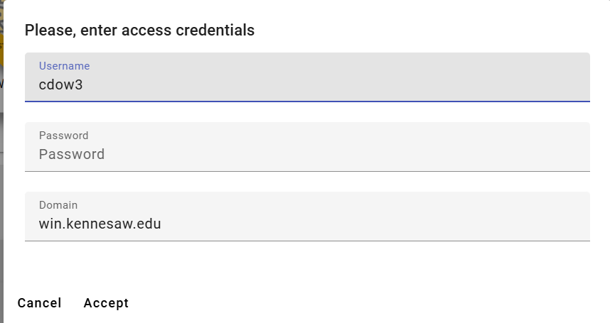
Browser Security Warning
If you attempt to access UDS during a maintenance window, you may see a message stating “Your connection is not private”.
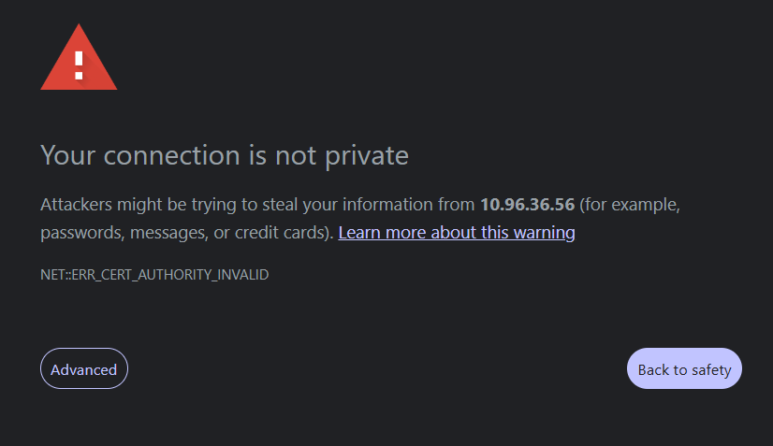
To continue:
- Click Advanced
- Select Proceed to <IP address> (unsafe)
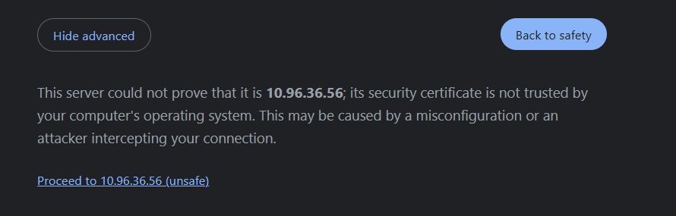Note: The appearance of this screen may vary depending on the web browser being used.

Once completed, you will be logged into the virtual machine.

First-Time Login Behavior
When logging in for the first time, the system may:
- Return you to the UDS Home Screen instead of launching the VM
If this happens: Simply repeat Steps 3 and 4 to complete the login.

VM Startup Behavior
- The VM may briefly display a black screen during startup.
- This indicates that the virtual desktop is still initializing.
Please wait—do not refresh the page or close the browser.
Once initialization is complete, the VM desktop will appear.
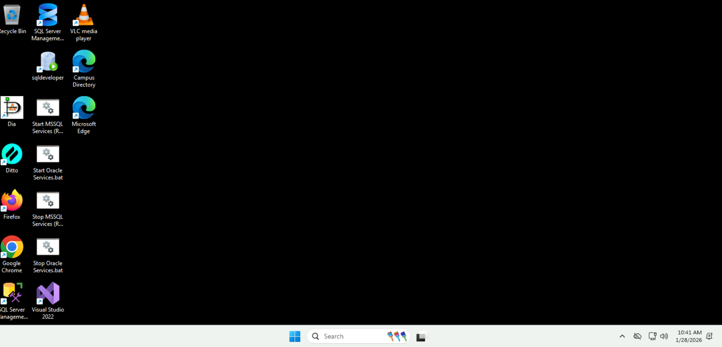
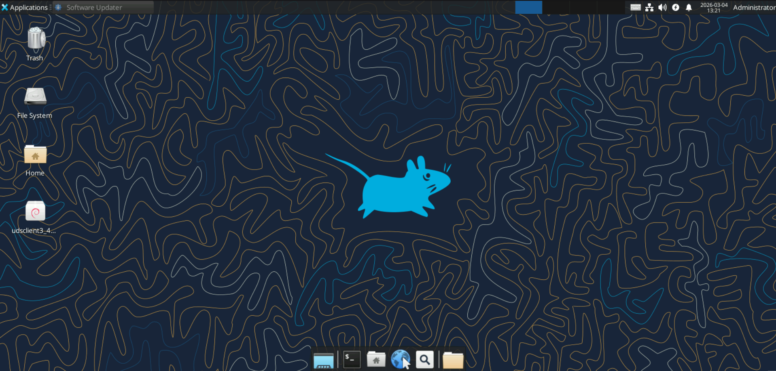

Incorrect Password Error
If an incorrect password is entered, an error message will appear.
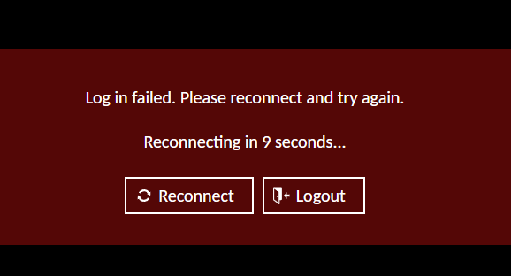
To resolve this:
- Click Logout
- You will be redirected to a page with a Re-login option.
- Click Re-login to return to the UDS Home Screen.
- Attempt to log in again using the correct credentials.
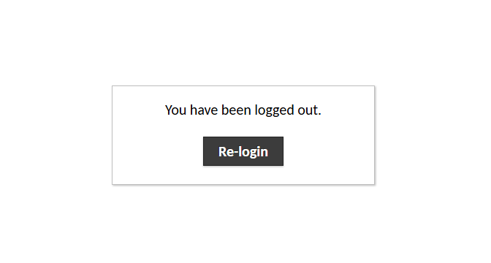

Logging Out and Disconnecting
When you are finished working, and you are on a Windows machine, sign out by:
- Left-clicking the Windows icon in the taskbar
- Clicking on your profile icon
- Selecting “Sign out”
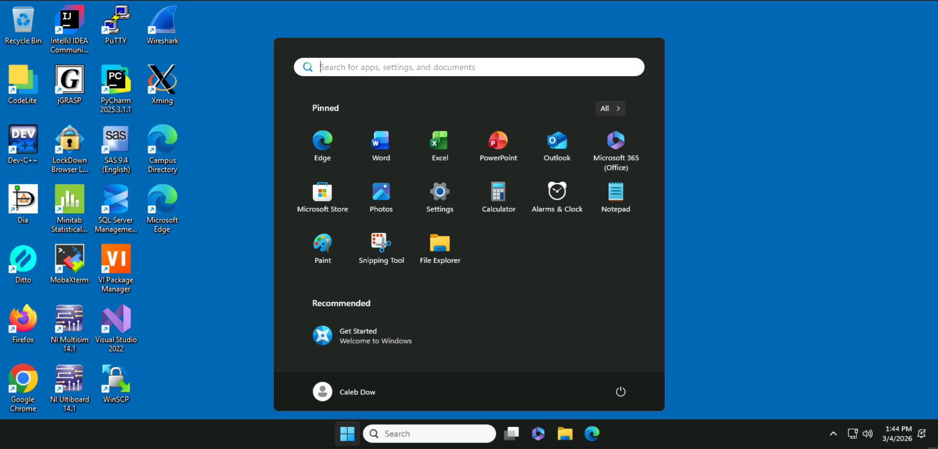
2.
1.
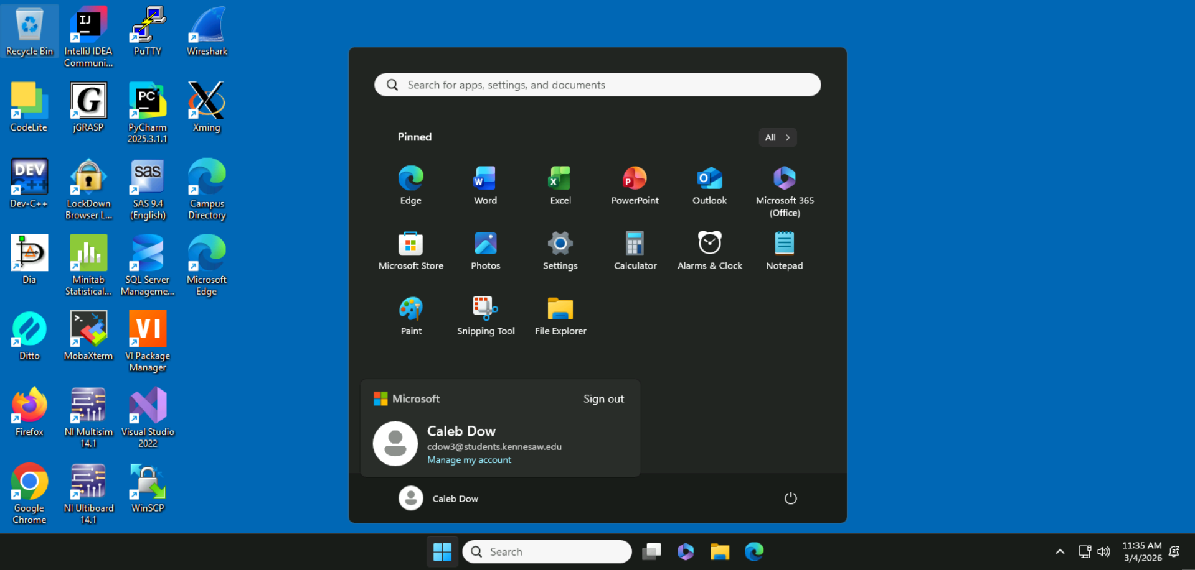

When you are finished working, and you are on a Linux machine, sign out by:
- Clicking on your profile name in the top right corner of the screen
- Selecting “Log Out”
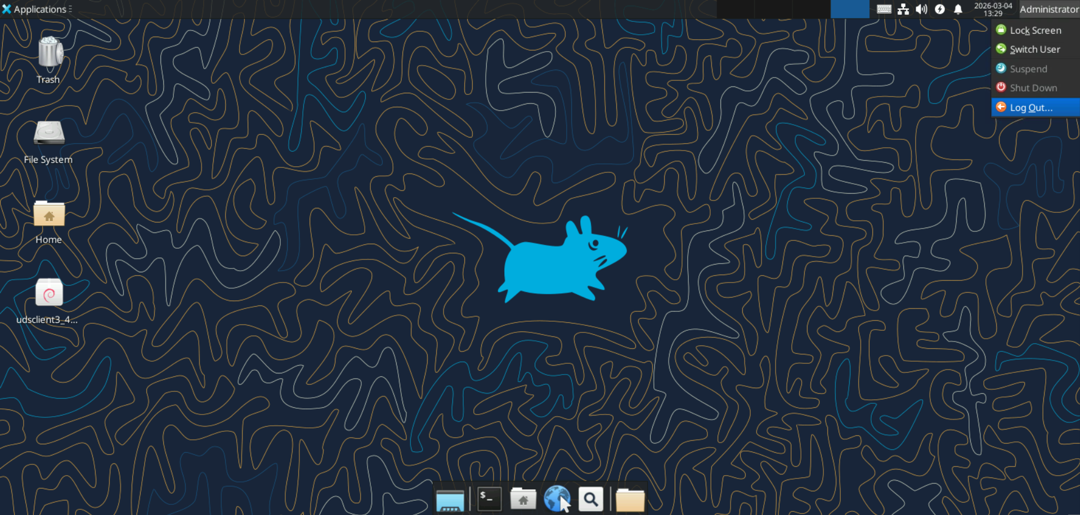
- Ensuring that “Save session for future logins” is unchecked
- Clicking on the “Log Out” button.
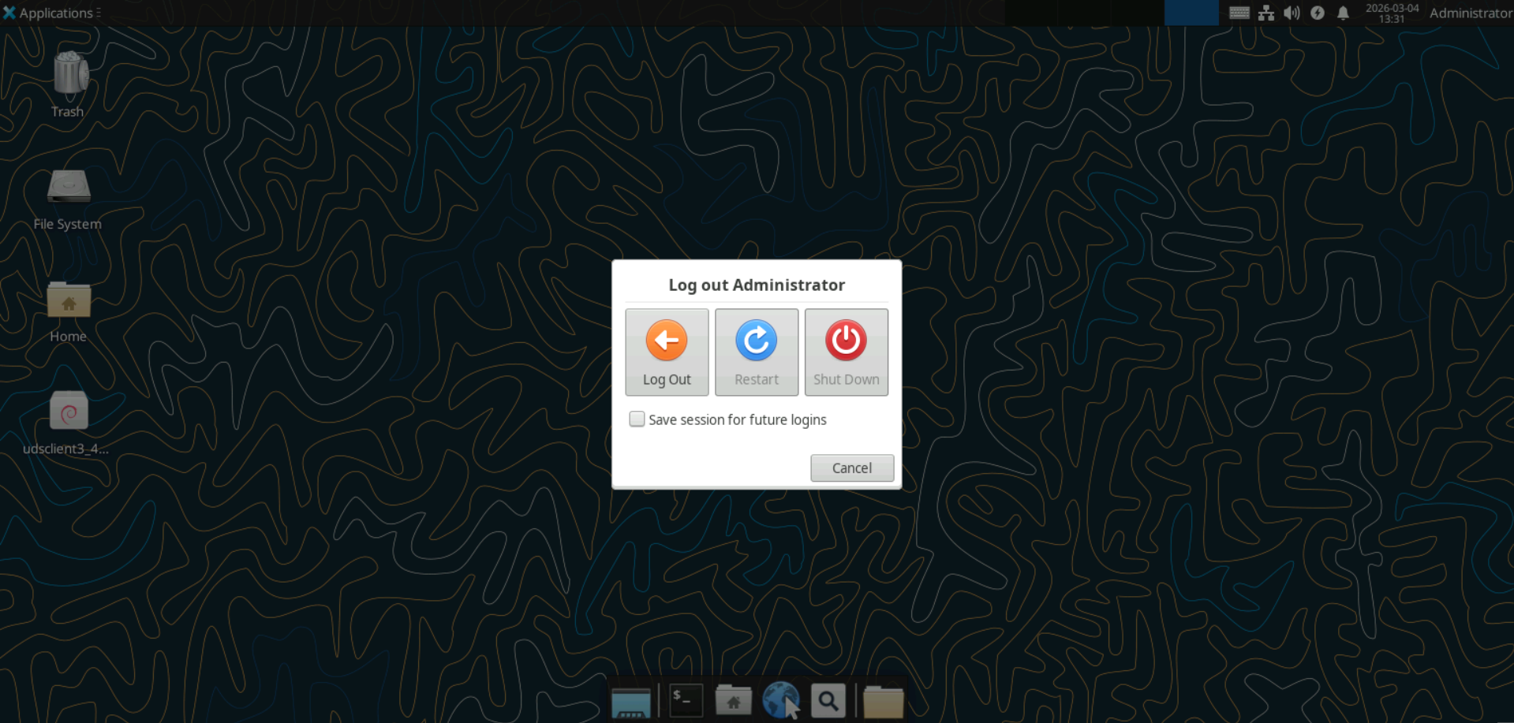

Important: Saving Your Work
Local storage on the CCSE Standard Image is temporary.
If you are using the CCSE Standard Image:
- Files saved directly on the VM will be deleted when you log off
- Always save your work to OneDrive An external USB device
- Failure to save files correctly will result in data loss.

VM Shutdown
If you accidentally Shut down your virtual machine your VM will be temporarily unavailable and you will be unable to access it.
Try to initiate a connection and wait for several minutes, the system should bring the VM back online.
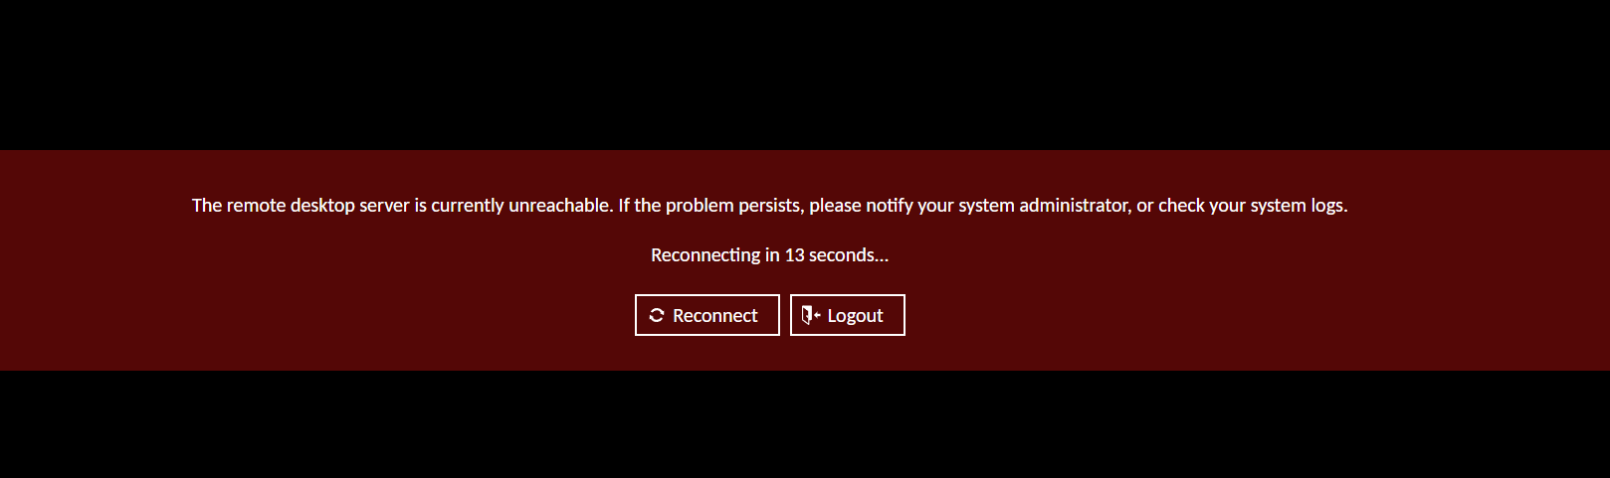
Note: If you’re using a non-persistent VM (like the CCSE Standard Image), you may see the error screen above. If that happens, click “Logout.” This will return you to the UDS home screen, where you can start a new VM session.

Final Notes
- All steps above are expected behavior and do not indicate a problem unless explicitly noted.
- If issues persist after following this guide, please contact ccsetech@kennesaw.edu
- Please provide your KSU ID, your course number and section number, and description of your issue.
- Providing Screenshots is optional but helpful.

