CCSE Online/Hybrid Course Development Rubric

Reviewer Name: _______________________________________ Review Date: ______________
This is [_] a unit leader review [_] a subject matter expert review
Course Prefix and Number: ________ Course Name: ________________________________________
Master course D2L link: https://kennesaw.view.usg.edu/d2l/home/______________________________
Course Developer: __________________________ Course Coordinator: ______________________
Anticipated Offering Date:_______________________________________________________________
Note: Include minor problems like missing words, misspellings etc. on the last page of the document.
Required Improvements – Must be corrected before the approval.
Yes/No questions – Must be answered Yes before the approval.
Desired Improvements – Not required to be completed prior to approval, only recommended.
Justification – Explain how the content meets the requirements.

Mandatory Content
- The course description, prerequisites, outcomes, and topics are approved by the academic unit. | Yes  If not, list all the required improvements
- The course has an adequate amount of content. | Required Improvements:  Desired Improvements:  Justification (if no improvements are listed):
- The content of the course is up to date. If the course uses a textbook, list the publication year and justifications if the edition is more than 3 years old. | Required Improvements:  Desired Improvements:  Justification (if no improvements are listed):
- Content is adequate to the level of the course and the mode of delivery | Required Improvements:  Desired Improvements:  Justification (if no improvements are listed):
- The course has adequate number of assignments and assessments | Required Improvements:  Desired Improvements:  Justification (if no improvements are listed):
- The assignments and assessments correspond to the level of the course | Required Improvements:  Desired Improvements:  Justification (if no improvements are listed):
- The content is stored inside approved LMS | Yes  If not, list all the required improvements
- The course has a module titled “Instructor Resources” hidden from students that includes:
- Instructor's Manual that includes directions for instructors to set up the course. | Yes  If not, list all the required improvements
  - Course Information – Must include:
- Version of the course – IE: Version 1.4, 2.5, 6, ect. | Version:
- Modality (hybrid %, online %, and synchronous or asynchronous) | Modality:
- Date when the original version was developed. | Date:
- Date when the current version was completed. | Date:
- Name of the previous course developer (for existing courses only) | Name:
- Name of the current course developer. | Name:
- Change Log - What changes have been made (for existing courses only) | Yes  If not, list all the required improvements
- Competencies are correctly mapped to assessments or grades. 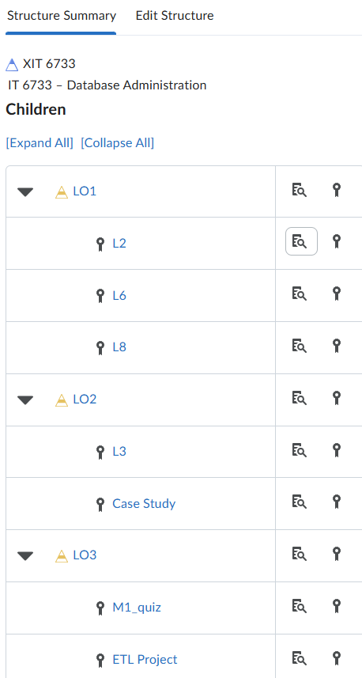 | Required Improvements:  Desired Improvements:  Justification (if no improvements are listed):
- The syllabus uses KSU approved template (see simple syllabus) | Yes  If not, list all the required improvements
- The course grading policy is clear and outlines how final grade is calculated. | Yes  If not, list all the required improvements
- Each assessment Includes a detailed rubric | Yes  If not, list all the required improvements
- Required course materials (textbooks, publisher packs, software, hardware) are listed in the syllabus. | Yes  If not, list all the required improvements
- Information is provided regarding how quickly emails will be answered and how soon students can expect assignment feedback. | Yes  If not, list all the required improvements
- The course includes opportunities for interaction: student-content, student-student, and/or student-instructor. | Required Improvements:  Desired Improvements:  Justification (if no improvements are listed):
- A gradebook embedded in an LMS is included where students can view all grades and help them understand how their assignments are evaluated. | Required Improvements:  Desired Improvements:  Justification (if no improvements are listed):
- Materials, assessments, tools, and technology in the course are clearly aligned with the course and module learning objectives. | Required Improvements:  Desired Improvements:  Justification (if no improvements are listed):
- Modules include measurable objectives that are in alignment with course goals. The module contents are in alignment with and support the module objectives. | Yes  If not, list all the required improvements
- Materials are organized in a way that creates an obvious path for the students by “chunking” content into sections. | Required Improvements:  Desired Improvements:  Justification (if no improvements are listed):
- Instructional activities and assessments are purposeful and align with the course learning objectives and goals. | Required Improvements:  Desired Improvements:  Justification (if no improvements are listed):
- Whenever possible, course materials make explicit how the material being learned can be applied in the real world and in real work situations. | Required Improvements:  Desired Improvements:  Justification (if no improvements are listed):
- The course must meet WCAG 2.1 Level AA accessibility standards. | Required Improvements:  Desired Improvements:  Justification (if no improvements are listed):

Minor Issues
Add any minor issues.

Accessibility Requirements
The course must meet WCAG 2.1 Level AA accessibility standards. For the review, the course developer must provide:
- Include a screenshot of the YuJa Panorama demonstrating compliance. The image should clearly show that the file with the lowest score still displays a green gauge.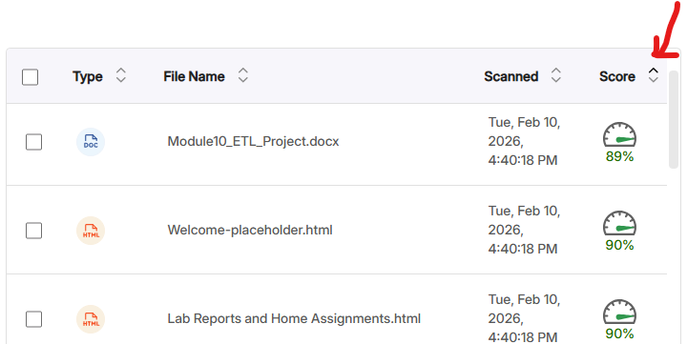
- Provide a complete inventory of external tools, videos, and URLs along with their accessibility status.
  - Use the Wave plugin to check for webpage accessibility. The score bar should be green.
  - Check that all external videos have closed captioning and audio descriptions. Audio description is required if your video includes visual elements that are not already described in the audio. For more detailed criteria, see the DLI audio description page.
If an audio description is available, the Audio Description Icon will be displayed next to the Closed Captioning Icon.

  - For the list of accessibility for common tools, check the DLI VPAT page. 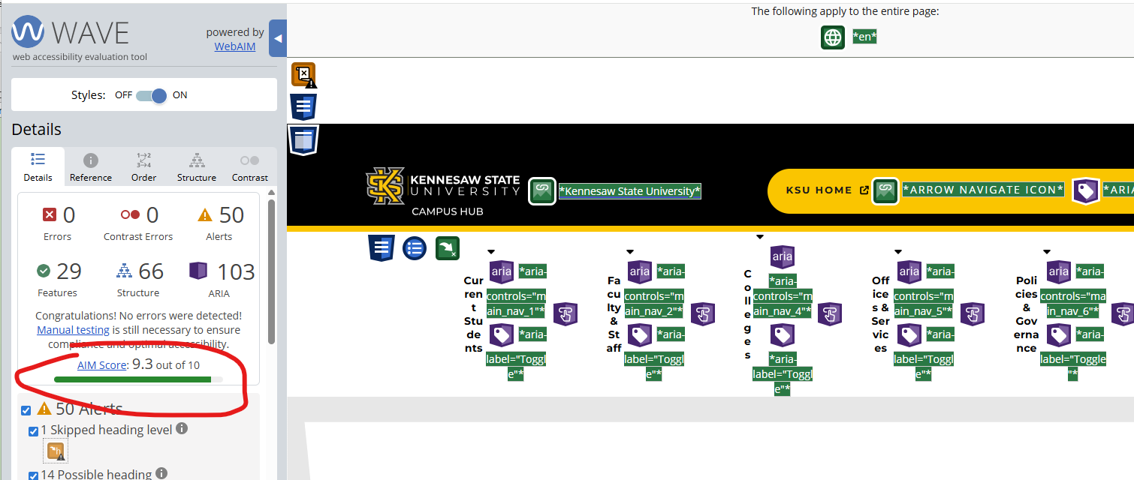
Example of the submitted list:
External Tool/Video/URL | Score or Justification or links to VPAT
https://campus.kennesaw.edu/colleges-departments/ccse/faculty-resources/ | Wave score 9.3/10
Video: Emma Vines, Tightrope, 2024, Digital Animation | CC and AD are provided
How to Use Narrator in Windows 11 | CC are provided and include descriptions of all relevant visual elements and on-screen actions, making the video accessible without the need for separate audio description.
SQL Server Management Studio 21 | WCAG 2.1 AA compliant https://www.microsoft.com/en-us/accessibility/conformance-reports

Resources
- Course Accessibility Checklist https://campus.kennesaw.edu/faculty-staff/academic-affairs/curriculum-instruction-assessment/digital-learning-innovations/academic-web-accessibility/basic-accessibility-solutions/course-accessibility-checklist.php (includes a checklist)
- WCAG Media Accessibility
- YuJa Panorama: accessibility tool go.kennesaw.edu/panorama
- Document Accessibility Reports go.kennesaw.edu/dochub
- WCAG Training Spring 2026

